**Sleep Study Protocol**

Part I: Somniseal Design Protocol 4

00.A. Somniseal EEG-recording Device Supplies 5

**01.** Logger Diagram 7

**02.** Custom PCB Wiring Diagram 8

**03.** Machined Housing Diagrams 9

**04.** Attachment Diagram 10

**05.** Wiring Diagram (Version 4) 11

**06.** ✍️ Check Previous Iterations 12

**07.** ✍️⚙️Order Supplies 12

**08.** ⚙️Create Templates and Molds 13

08.A. Laser-cut templates: 13

**09.** ✍️Prep Headcap and patches 13

**10.** ✍️Prep Cables for Assembly 13

10.A. Prep SUBCONN Connector 13

10.B. Prep TPU Wires 14

10.C. Solder TPU Wires to SUBCONN Connector 14

**11.** Electrode Prep 14

**12.** Electrode Prep 15

**13.** Potting Prep 16

**14.** Potting Supplies 16

**15.** Potting 16

**16.** Refining potting 17

**17.** Headcap Electrode Configuration 18

**18.** Finalizing Headcap and Patches 18

**19.** Preparing for Deployment 19

Part II: Tagging Protocol 57

**00.** Procedure Prep Checklist 58

**01.** Procedure Prep Checklist 59

**Sleep Study Metadata Entry Sheet** 59

**02.** Procedure Checklist 63

02.A. Gear Checklist 63

**03.** Detailed Attachment Protocol 64

**04.** Data Entry 64

04.A. Enter sleep datasheet information into individual datasheets “testNN_Nickname_00_Notes.xlsx” 64

Part III: Sleep Data Processing Pipeline 20

**00.**  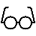 Metadata  and Video Scoring  20

00.A.   Notes  & Sleep_Study_Metadata  20

00.B.   Video Scoring  21

**01.**   Raw Data 23

01.A.   Download and convert data 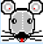 23

01.B.  Rearrange EDF 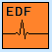 23

01.C. Visualize Raw Data in LabChart  26



01.D. Raw Scoring  29



**02.**   Processing Motion & Environmental Sensors 32

02.A. Read in Metadata  32



02.B.  Load Motion & Environmental Data  32

02.C.  Resample Data  33

02.D.  MAT File setup for CATS Processing  33

02.E.   Run CATS Toolbox  34

02.F.  Save Calibrated & Processed Data  37

**03.**   Pairing Motion & Video Data   38

03.A. Video Data Synchronization  38



03.B. Pairing Video Data to Motion Data (& Sleep Data)  39



**04.**  Behavioral Scoring Automation  40

04.A. Main Process  40



**05.**   ICA Processing for Electrophysiological Data  40

05.A.  Load data into EEGLAB  40

05.B.  Subset data  41

05.C.  Run ICA  41

05.D. Inspect & document results  41



05.E. Apply ICA weights to dataset  41



05.F.   Concatenate desired signals & Export EDF  42

**06.**  Qualitative Sleep Scoring  43

06.A.  Load processed megadata  43

06.B.  Identify scorable segments  44

06.C.  Score Heart Rate (HR) Patterns  44

06.D.  Score Sleep Patterns  45

**07.** Generate Hypnograms & Quantitative Sleep Scoring  48



07.A.  Load processed megadata  48

**08.**  3D Track Generation    48



08.A.  Export Rates & Power from LabChart  48

08.B.  Export LabChart Calculations  49

08.C.  Estimate speed from processed data  50

08.D.  Return to CATS Processing for 3D  51

08.E. Review track generation  51



08.F.  Rerun with corrected GPS points  52

**09.**  Hypnotrack Visualizations    52

09.A.  Generate Hypnotrack  52

09.B.  3D Sleep Maps in ArcGIS  53

09.C.  3D Sleep Animations in Maya  53

**10.** Data Aggregation & Standardization  53



10.A.  Generate standardized raw files 53

**11.** Restimates: quantifying measures of behavioral sleep  53



**00.**  Load Data 53

**01.**  Process Depth Data 54

01.A. **Depth Correction** 54

01.B. **Data Truncation** 54

01.C. **Data Alignment** 55

01.D. **Inputs:** MAT files, raw CSV dive data for Sleep, Kami/Stroke, or TDR-only recordings. 55

01.E.  Load Data 56

**02.** Appendix: Additional Sleep Scoring Examples 56

# Part I: Somniseal Design Protocol

For more information on protocol, read our methods paper, “Eavesdropping on the brain at sea: Development of a surface-mounted system to detect weak electrophysiological signals from wild animals”. [To see Tag Supplies needed, go here.](https://docs.google.com/spreadsheets/d/11YxVm2u1kR2LZOvjDeegGdl14d07t2NnDEpN34hOT68/edit#gid=0)

***Off-the-shelf or manual construction required:***

✍️ Hand-made or assembled / ⚙️ Automated/machine made / ✍️⚙️  Semi-automated process

|  |  |  |  |  |  |
| --- | --- | --- | --- | --- | --- |
| Somniseal EEG-recording Device Supplies | | | | | |
|  |  |  |  |  |  |
|  | **Item** | **Material** | **Current Supplier** | **Manufacturer** | **Part Number** |
| ✍️ **Headcap/patches** | Reusable Goldcup EEG Electrodes | "No Tangle" Silicone insulation | Natus Neurology | Genuine GRASS |  |
| Neoprene rubber | 1/16" 40A durometer neoprene rubber 12x24 | McMaster Carr |  | 1370N53 |
| Neoprene foam | 1/8 " | Amazon | Lazy Dog Warehouse |  |
| Silicone RTV Permatex Adhesive | Silicone | ACE Hardware | Permatex |  |
| Solder - LABOR |  |  | JKB |  |
| **Custom 3D-Printed Molds** | PLA 3D printed plastic | Patricio Guerrero | 3D printed | Custom design by Patricio Guerrero & Jessica Kendall-Bar |
| ✍️ **Cable Assembly** | Scotchkote / FlexSeal / Liquid Electrical Tape |  |  |  |  |
| Marine-grade heat shrink |  | McMaster Carr |  |  |
| Moisture-Seal Heat-Shrink Tubing, 2:1 Shrink Ratio, 0.25" ID Before Shrinking, 4 Feet long |  | McMaster Carr |  | 74965K63 |
| Moisture-Seal Heat-Shrink Tubing, 3:1 Shrink Ratio, 0.19" ID Before Shrinking, 4 Feet long |  | McMaster Carr |  | 7861K52 |
| Moisture-Seal Heat-Shrink Tubing, 2:1 Shrink Ratio, 0.5" ID Before Shrinking, 4 Feet Long |  | McMaster Carr |  | 74965K65 |
| P/N 103-063-012 .375 316L 316 Stainless Steel Microfilament Pull-On shielding material | 316 Stainless Steel | Glenair | Glenair | 103-063-012 |
| ✍️ **Connector** | SubConn 21 Contact, Female Micro Bulkhead Connector, Brass (WHITE WIRES) |  | Ocean Innovations | MacArtney | MCBH21F |
| SubConn, Micro Series, Inline, Male, 21 - Contact, w/2' of P21C20#OS |  | Ocean Innovations | MacArtney |  |
| Locking sleeve for connector |  | Ocean Innovations | MacArtney |  |
| Potting Compound |  |  | EPOXIES | 20-2180 (2-part) |
| Potting - LABOR |  | Ocean Innovations | JKB |  |
| Solder - LABOR |  | Ocean Innovations | JKB |  |
| ✍️⚙️ **PCB for Logger** | Omnetics Connector |  | Ethan Slattery/digikey | Omnetics | A79024 |
| PCB Fabrication |  | Ethan Slattery | OSH park PCB manufacturing | Custom designed by Ethan Slattery & Jessica Kendall-Bar |
| JST SRSS connectors for connection to bulkhead |  | Ethan Slattery |  |  |
| Design Time |  | Ethan Slattery |  |  |
| Fabrication Time |  | Ethan Slattery |  |  |
| ⚙️ **Neurologger** | Neurologger 3, 3D accelerometer, 3D gyroscope, 3D compass, microphone with sampling rate up to 200 kHz, microSD memory card 128GB, Real-time Clock and Watchdog Timer |  | EvoLocus | Alexei Vyssotski |  |
| Pressure Sensor 4LD |  | EvoLocus | Keller Druck | Transmitter PA(A)-4LD (Drawing #10-0425-140) |
| Neurologger Breakout board (optional) |  | EvoLocus | Alexei Vyssotski |  |
| Lithium Thionyl Chloride Batteries |  | PowerStream |  | ER34615M |
| Solder - LABOR |  |  |  |  |
| ⚙️ **Housing** | Housing tray insert (3D printed) | PLA 3D printed plastic | Patricio Guerrero | 3D printed | Custom design by Patricio Guerrero & Jessica Kendall-Bar |
| Machined Housing |  | Scripps UCSD Marine Science Development Center | Rob Klidy & Eric Browning |  |
| EST-001_Body 7075 T6 |  |  |  |  |
| EST-002_Lid 7075 T6 |  |  |  |  |
| EST-006 Eye Glass Polycarb |  |  |  |  |
| EST-005 Spacer |  |  |  |  |
| Hard Black Anodize (1 lot) |  |  |  |  |
| ✍️⚙️ **Housing Assembly Parts** | 316 Stainless Steel Nylon-Insert Locknut, M3 x 0.5 mm Thread | 316 stainless steel | McMaster Carr |  | 94205A220 |
| 316 Stainless Steel Hex Nut, Super-Corrosion-Resistant, M2 x 0.4 mm Thread | 316 stainless steel | McMaster Carr |  | 94150A305 |
| Super-Corrosion-Resistant 316 Stainless Steel Socket Head Screw, M3 x 0.5 mm Thread, 8mm long | 316 stainless steel | McMaster Carr |  | 92290A113 |
| Super-Corrosion-Resistant 316 Stainless Steel Socket Head Screw, M2 x 0.4 mm Thread, 8mm long | 316 stainless steel | McMaster Carr |  | 92290A015 |
| Fixed-Tip Retaining Ring Plier with Cushion Grip for Internal Rings, 0.038" Diameter 90 | 316 stainless steel | McMaster Carr |  | 57805A33 |
| Weed-whacker line |  |  |  |  |
| ✍️**Tagging Supplies** |  |  |  |  |  |
| Mesh netting |  |  |  |  |
| Epoxy for tagging |  |  |  |  |
| Velcro cable organizers |  |  |  |  |
| Stainless steel zipties |  |  |  |  |
| Tesa Tape |  |  |  |  |
| AquaSeal Neoprene Cement |  |  |  |  |
| Gorilla Glue Superglue |  |  |  |  |
|  |  |  |  |  |  |

### Logger Diagram

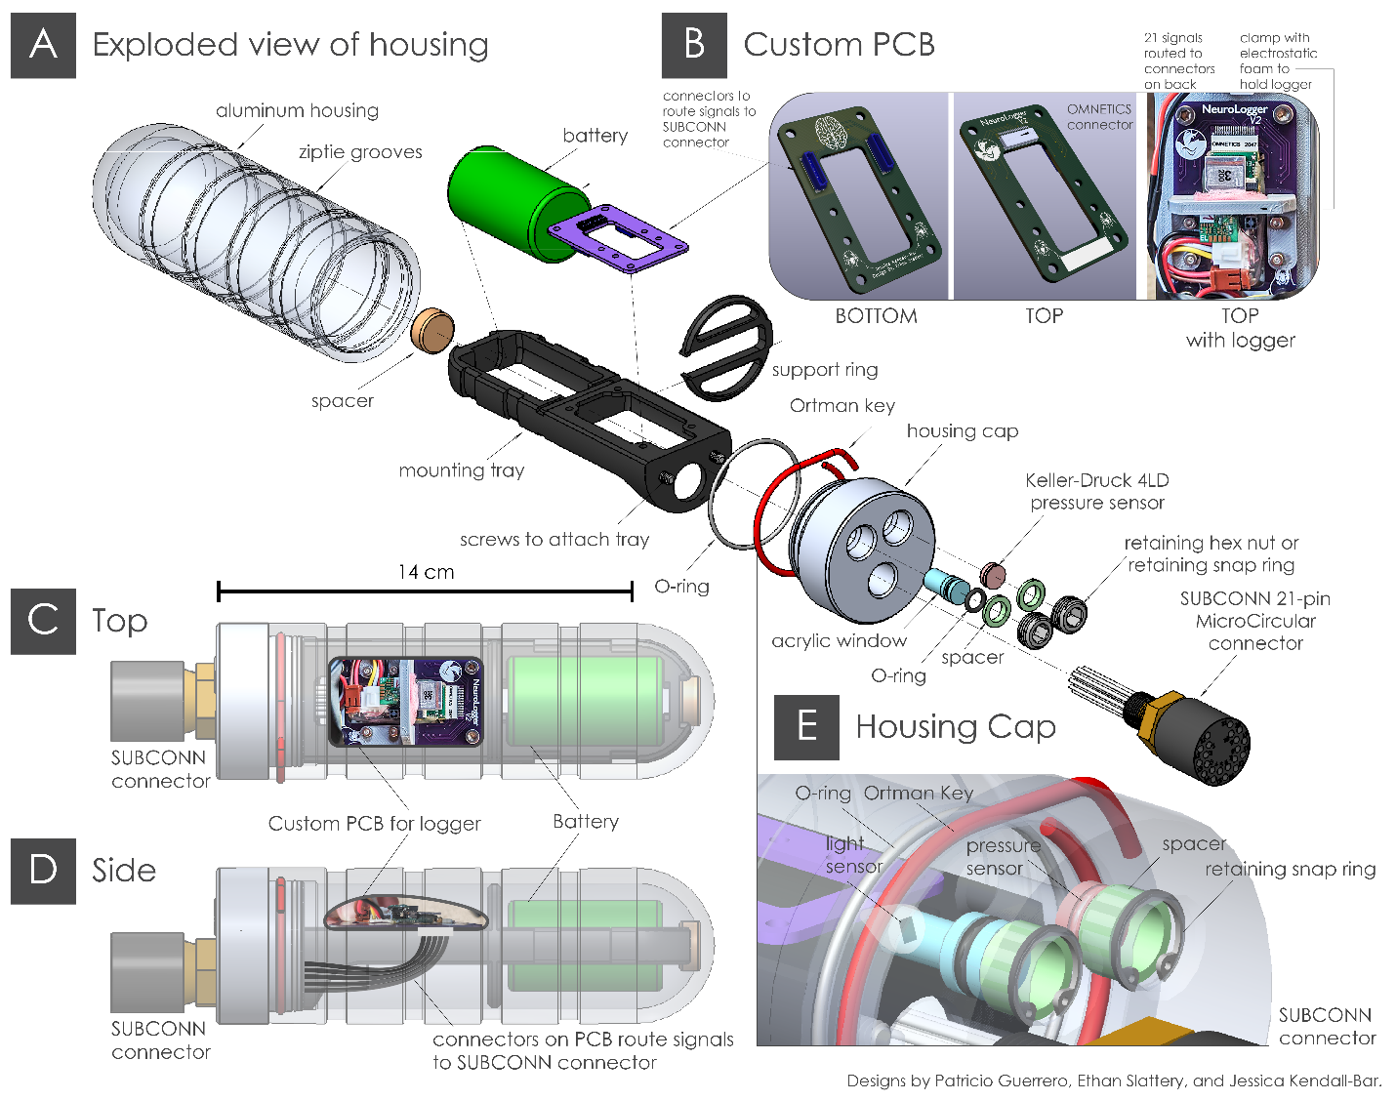

**Custom PCB Version 1-3**

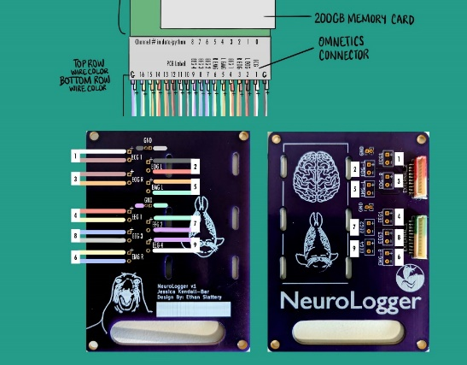 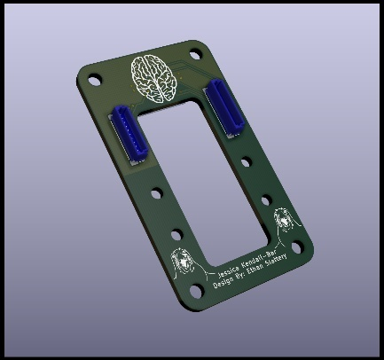 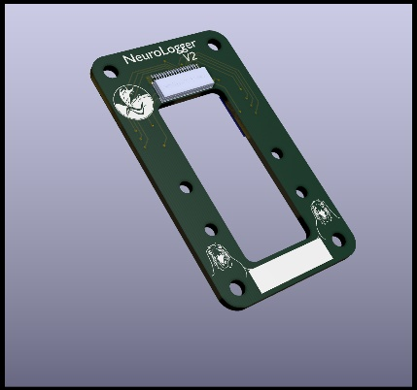

### Custom PCB Wiring Diagram

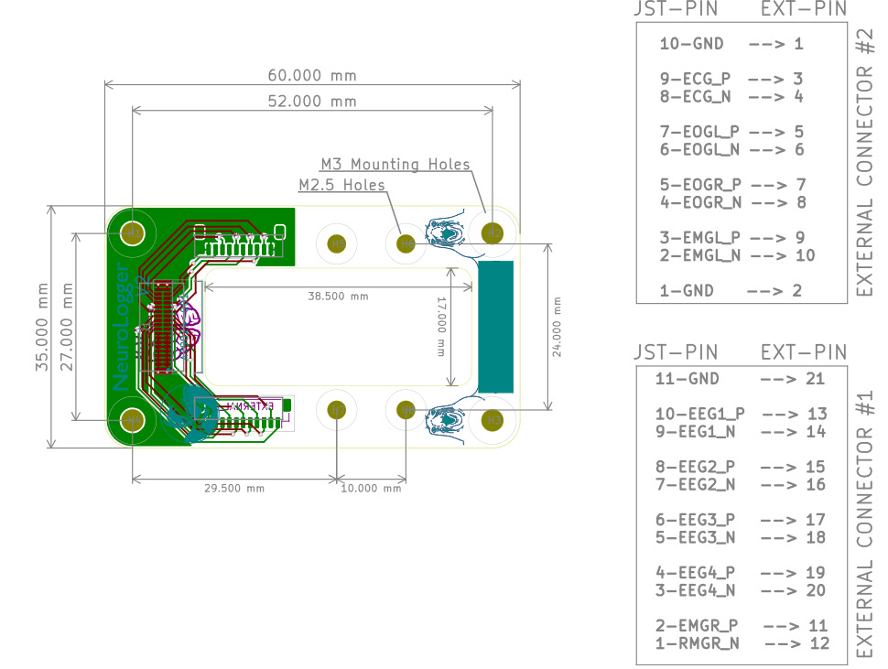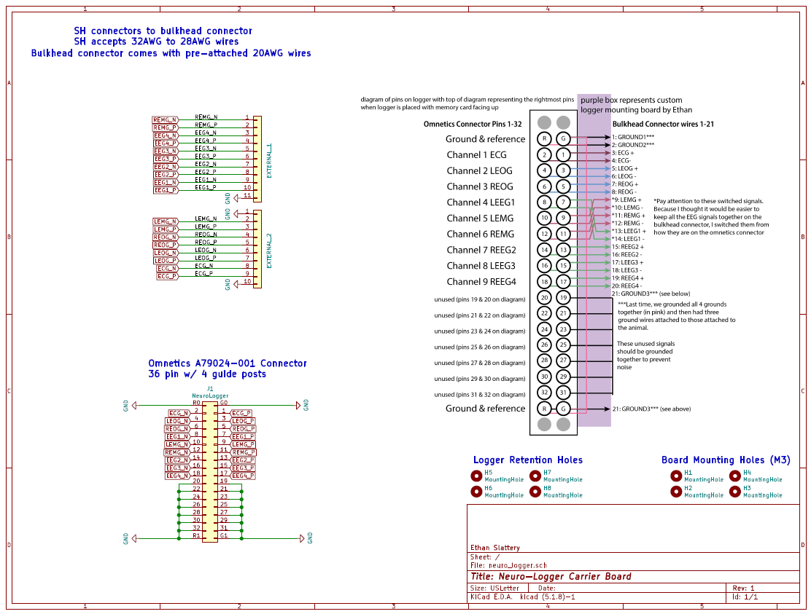

### Machined Housing Diagrams

***Housing Body:***

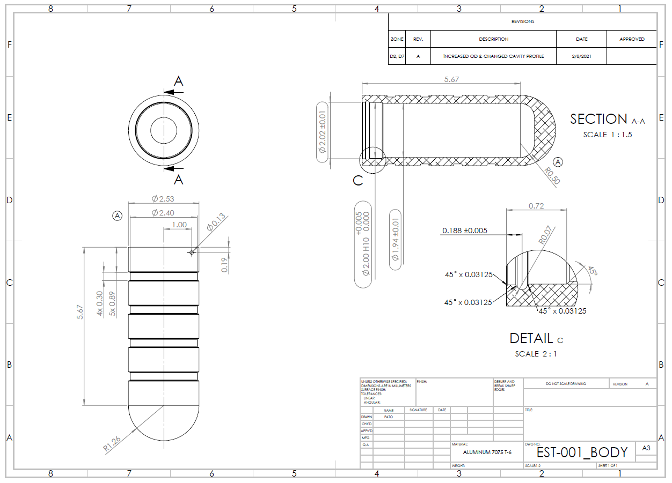

***Housing Lid:***

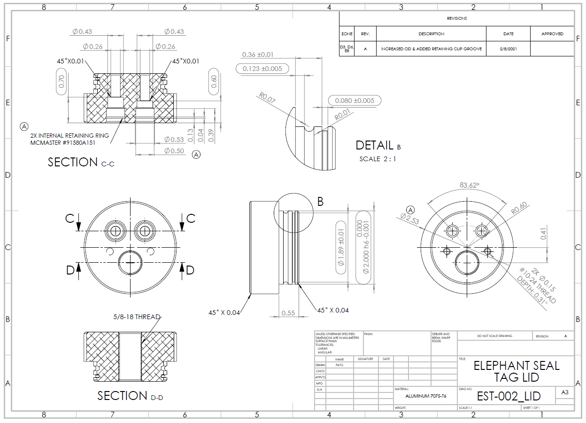

***Spacers*** to hold retaining rings away from acrylic windows:  
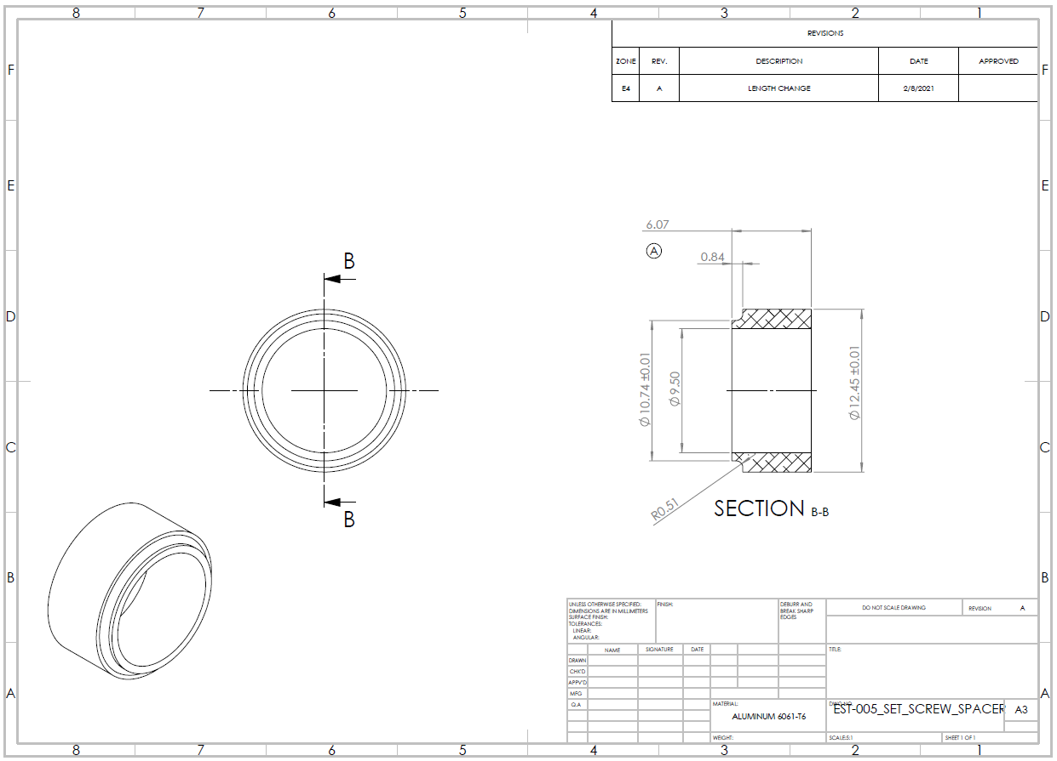

***Acrylic Windows:***  
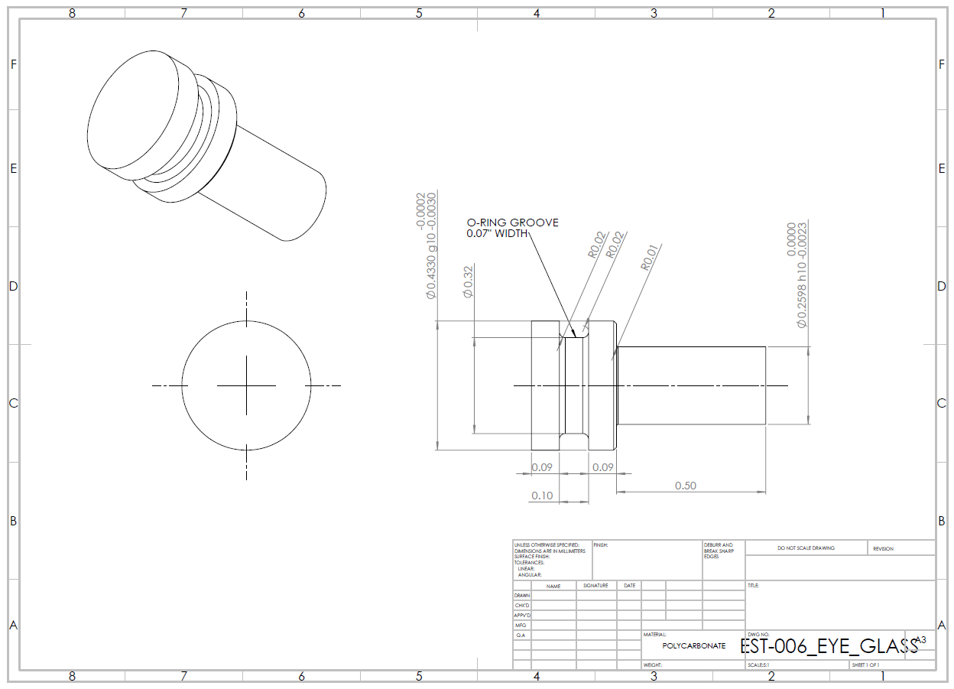

***Lid Close-up:*** Orientation of snap rings and Ortman Groove:  
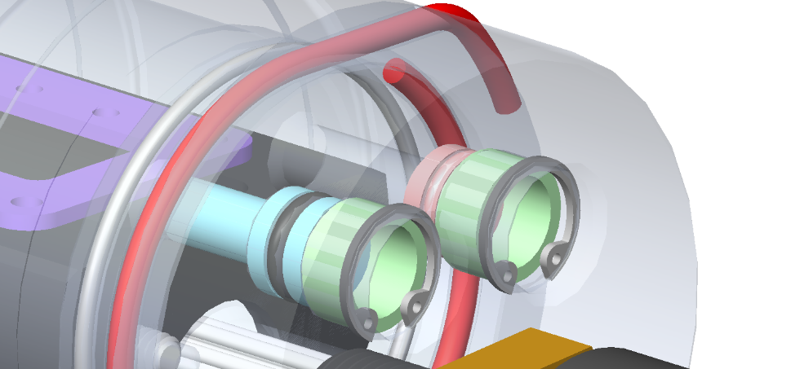

### Attachment Diagram

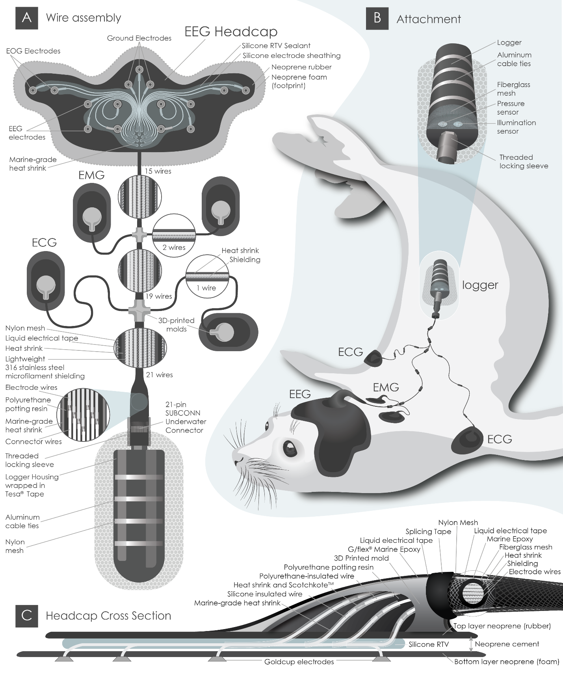

### Wiring Diagram (Version 4)

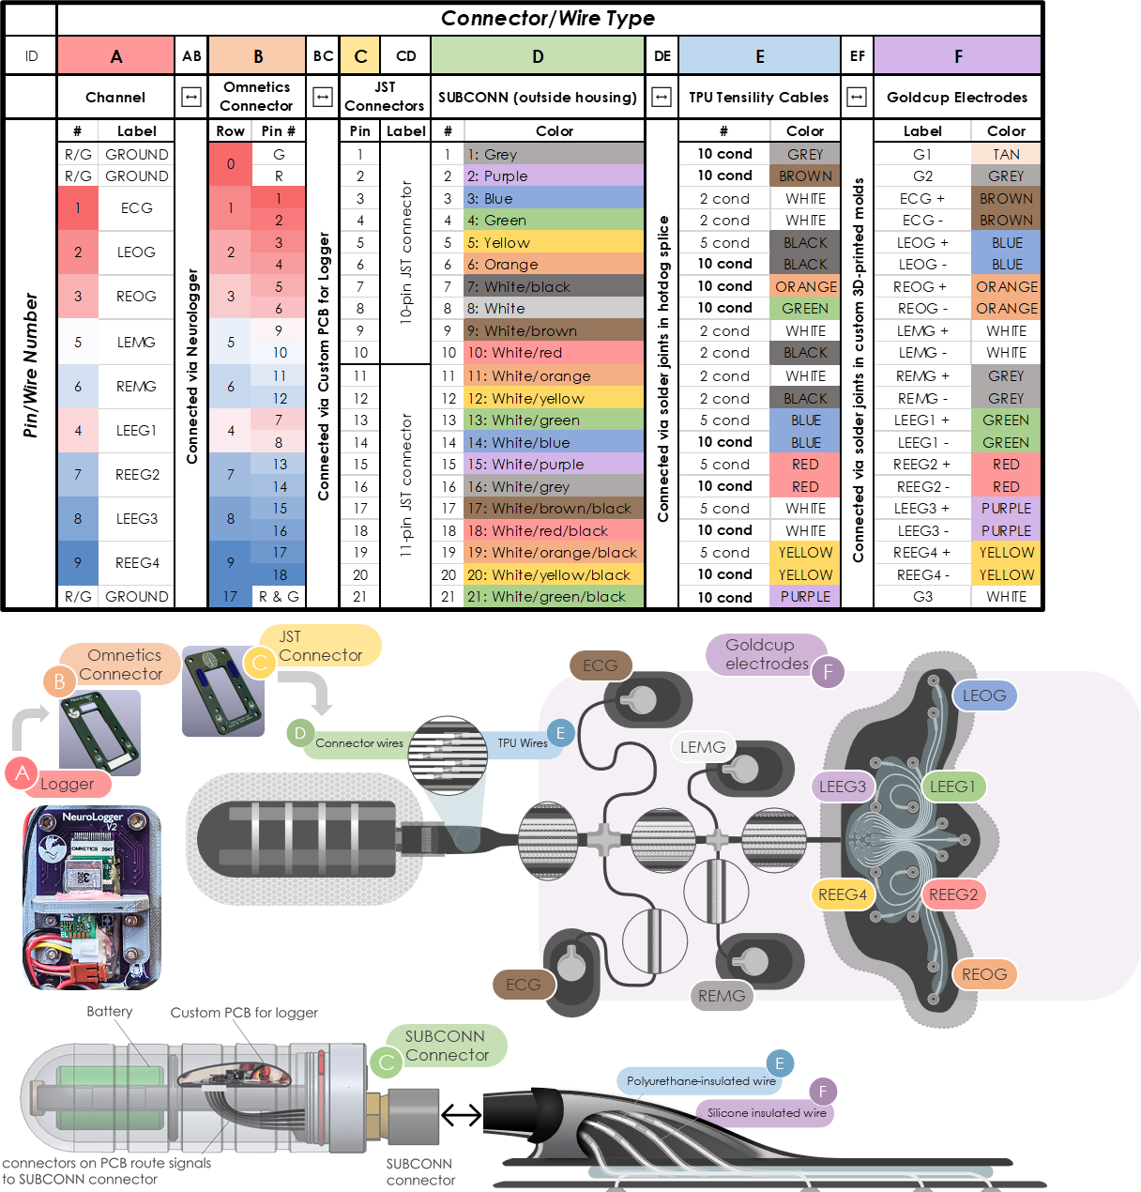

### ✍️ Check Previous Iterations

* 1. Using the wiring diagram, check the connection between the electrodes and wire pins to see where failure points in your design occur.
  2. Record which electrode and pin connections are still connected and record the resistance measured between the pin and the electrode.

### ✍️⚙️Order Supplies

* 1. Follow the Tag Supplies spreadsheet and the table above to order necessary supplies. Update supplies list to reflect desired changes and available suppliers/manufacturers.  
     <https://docs.google.com/spreadsheets/d/11YxVm2u1kR2LZOvjDeegGdl14d07t2NnDEpN34hOT68/edit#gid=0>
  2. Order custom PCB for mounting the logger according to this pin diagram:

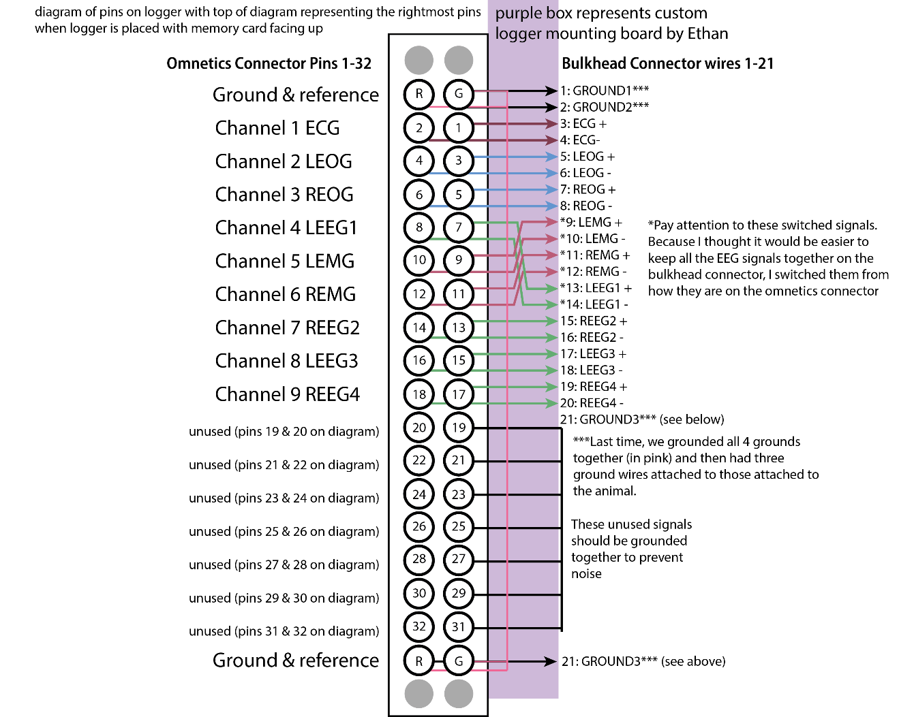

### ⚙️Create Templates and Molds

### Laser-cut templates:

* 1. Create laser-cut template of the headcap using this Illustrator design file.

### ✍️Prep Headcap and patches

* 1. 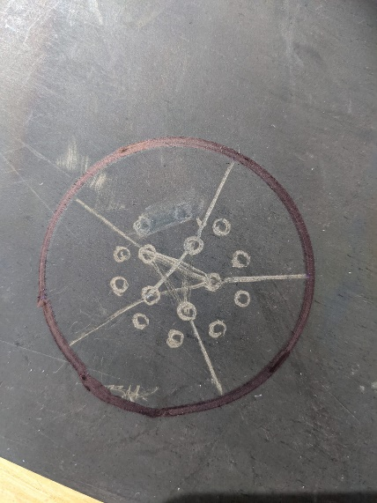Use laser cut headcap template to cut out neoprene rubber (3/32” 40A)
  2. Punch holes through neoprene rubber at electrode outputs
  3. Abrade the neoprene rubber
     1. Using sand paper, rub the neoprene rubber anywhere you are trying to bond other substances to it (e.g. around the edges and the electrode output holes)
     2. If you have a dremel, attach an abrasive tip and use automated sanding tool (don’t sand more than 1/4 of the material away).

### ✍️Prep Cables for Assembly

### Prep SUBCONN Connector

* 1. Using a box cutter, carefully cut cable jacket ~ 2-3 cm from where it tapers to the connector
  2. Remove cable jacket (try to maintain the aluminum foil sheath to ensure wires are not damaged)
  3. Using sandpaper or a Dremel, abrade the cable jacket until the end of the tapered segment (excluding the cylinder with the SUBCONN label).
  4. 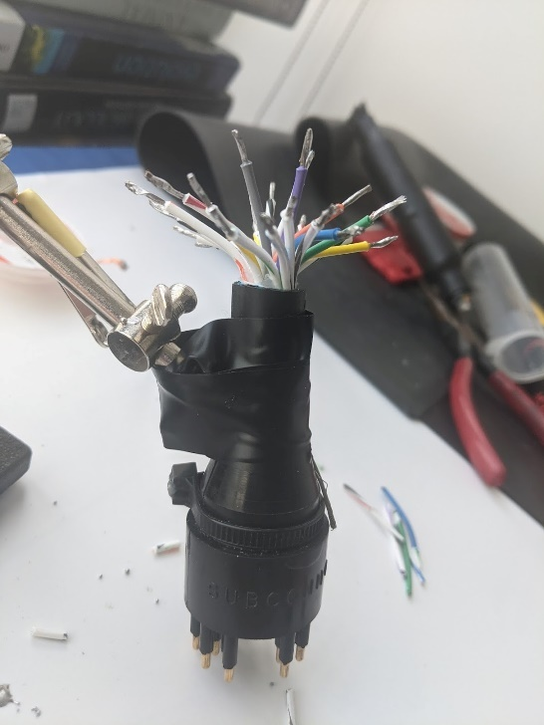Cut SUBCONN wires ~ 1.5cm from the end of the cable jacket.
  5. Strip (0.5 cm) & immediately tin cables with solder to protect the conductors.  
     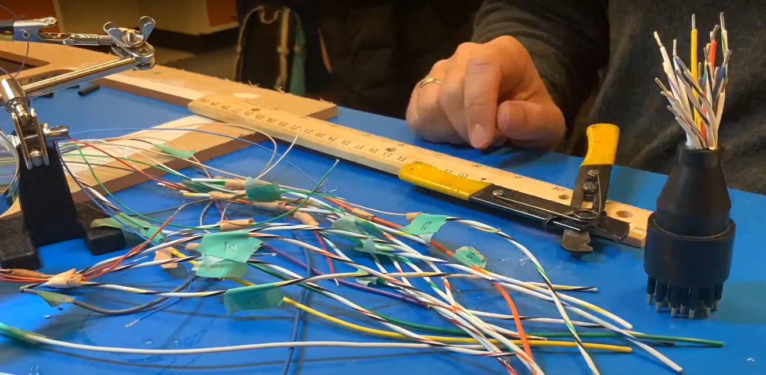

### Prep TPU Wires

* 1. Label Tensility TPU wires & SUBCONN wires with their electrode output
  2. Cut Tensility cables to the correct length (comparing with a previous iteration).
  3. 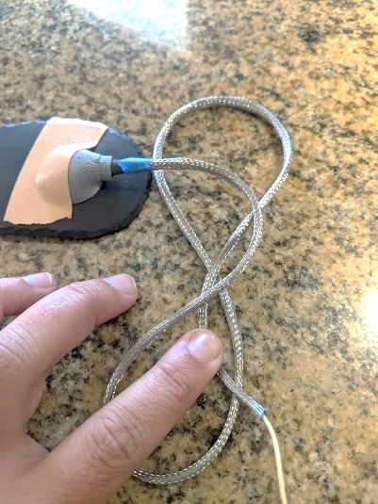Add micro filament shielding to the wire bundles, then add ¼” heat-shrink around wire shielding.

### Solder TPU Wires to SUBCONN Connector

* 1. Strip tensility wires and attach to the subconn pin wires following the guideline of which colors will attach to which electrodes.
  2. Tips for soldering:
     1. Always remember to slide on the heat shrink!
     2. Use marine-grade heat shrink if wires are very different gauges.
     3. Can tin both wires beforehand and then very quickly introduce the solder tip to the wires while holding them against each other (useful for tricky angles).
     4. Check resistance on each wire after soldering
     5. Stripping preferences:
        1. Tensility wires: 22 AWG setting (medium grip)
        2. Silicone Goldcup wires: 14 AWG setting (strong grip)
        3. Teflon Goldcup wires: 20 AWG setting (soft grip)
  3. Post-soldering: inspect connections and apply FlexSeal, liquid electrical tape, or Scotchkote, especially if any conductors were accidentally knicked (check cable jacket region as well as insulation damage/shrinkage from heat).S
  4. 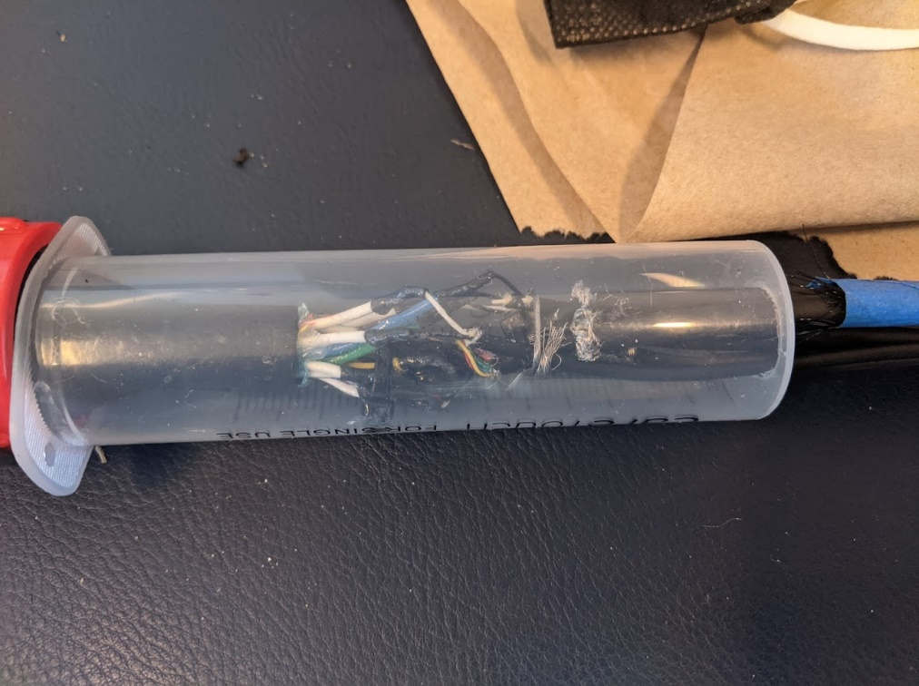Check resistance on each pin after soldering. Write down values.

### Electrode Prep

* 1. Remove heat shrink from electrode-wire connection.
  2. Cover connection in G-Flex (protect electrode from Gflex to avoid obscuring the sensor head/electrode region)
  3. 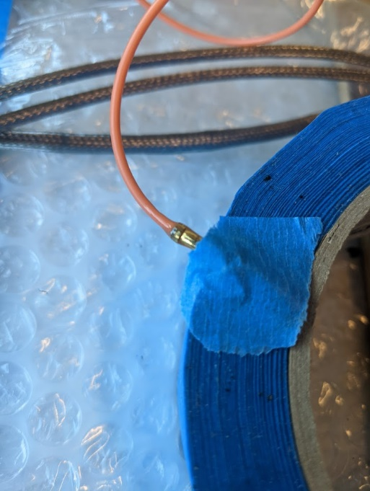While it’s mixed, apply a layer of G-flex over the 3D printed molds  
     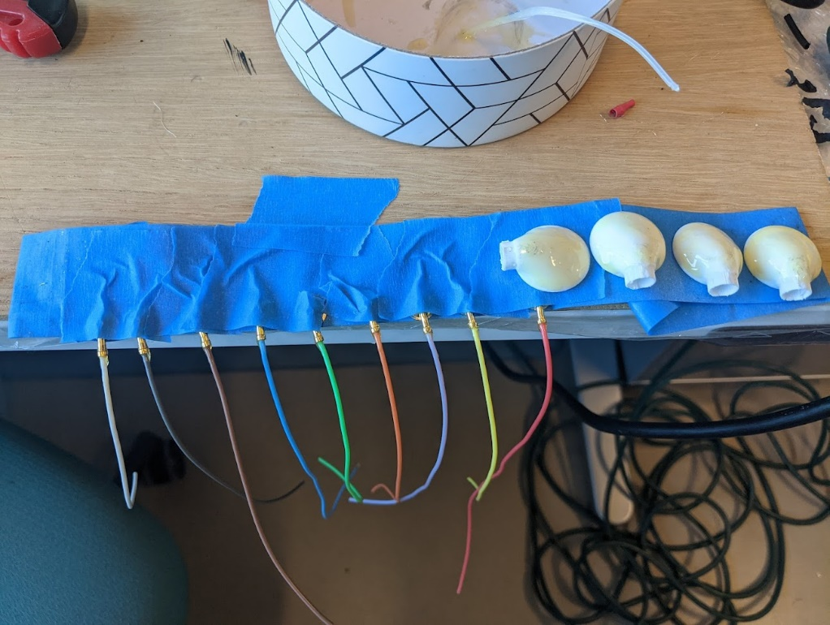
  4. Apply marine grade heat shrink over electrode-wire connection (make sure to use a heat shrink that will bind well with the polyurethane potting epoxy)
  5. Measure and cut electrodes.

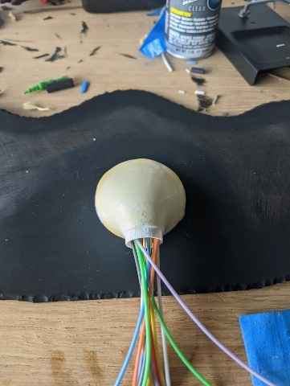 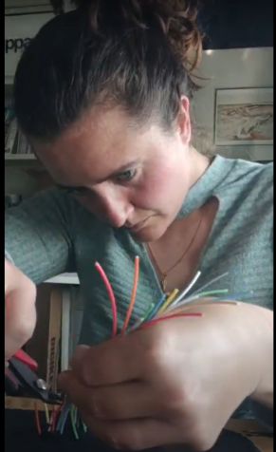 

* 1. Place electrodes where you would like them to rest on the neoprene head cap
  2. Cut the wires so that the solder joint will rest within the molds
  3. String on the 3D printed mold & two pieces of marine-grade heat shrink (one larger gauge to go over all marine grade heat shrink and one to go over individual splice joints)

### Electrode Prep

* 1. 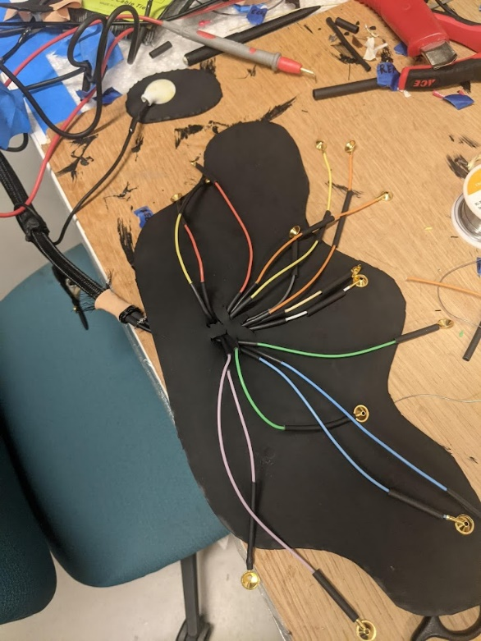Solder the electrode wires to the Tensility wires  
     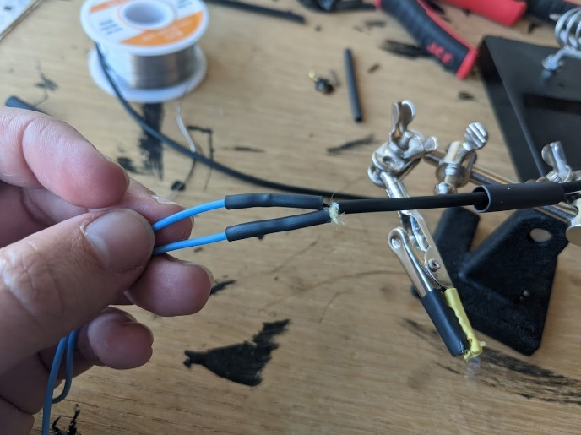
  2. Put g-flex over tensility - shielding - heat shrink junction (just for EMG/ECG wires) so that you prevent water from flowing up into the heat shrink/shielding.
  3. Once you solder all the headcap wires, push them through the holes you created earlier- you may have to cut between the holes to allow electrodes to come through
  4. Fill the holes with g flex to prevent water intrusion into the cap and to prevent potting compound from running into the headcap/patch  
     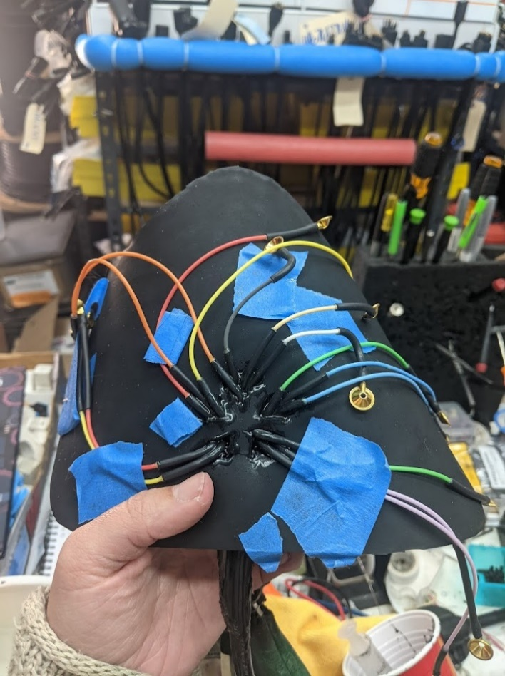

### Potting Prep

* 1. Create molds for waterproofed connections at solder joints:
     1. We used piece of clear, large-gauge heat shrink to create a tapered mold for headcap wire output.

### A picture containing person, blue Description automatically generatedPotting Supplies

* Gloves
* Plastic cup
* Paint mixer
* “A” Solution (Black)
* “B” Solution (Yellow)
* Power drill
* Cotton rag
* Ratio A:B is 1:0.6 or 100:60
* Check weight (calibrate with 500g weight)

### Potting

* 1. 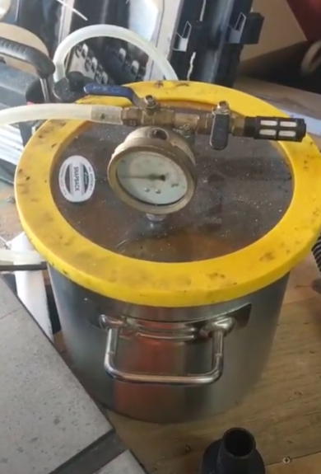Sit flat on table/scale
  2. Use tall 60mL syringe to fill with epoxy
  3. Lab grade isopropyl alcohol (90% or more)
  4. Plastic tip/laur tip for 60mL syringe
  5. Tare/0 weigh the cup
  6. Mix “A” and “B” with the ration 100 A: 60 B
  7. E.g. A=poured 70.5g, B=aim for 42.36g
  8. Power drill attached with paint mixer, mix for one minute, spin bouncing off the walls of cup
  9. Use cotton rag to clean mixer
  10. 45 minutes total to complete pour, put in dispensing syringe
  11. Place cup in vacuum and let set for 5 minutes
  12. Pour down the side of the syringe, piston in, flip over, get rid of any air bubbles in the syringe.
  13. Pour into mold, 5-10% shrinkage. Watch as the epoxy rises to ensure no bubbles are trapped below.

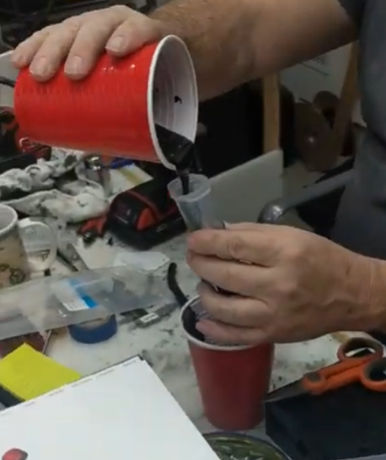 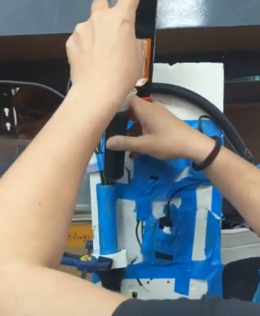 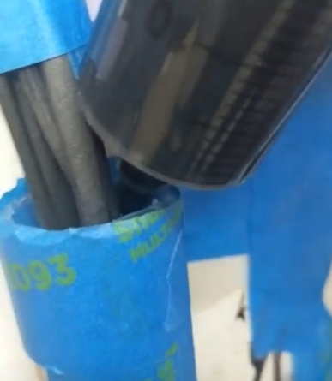 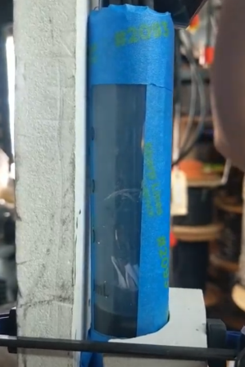

### Refining potting

* 1. Wait 24 hours for potting compound to cure fully – OK to remove syringe etc. the next morning.
  2. Peel off syringe, remove heat shrink, inspect for bubbles.  
     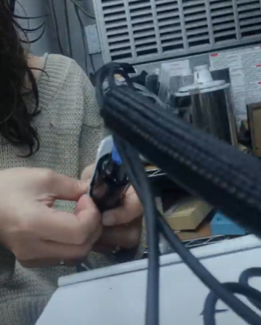 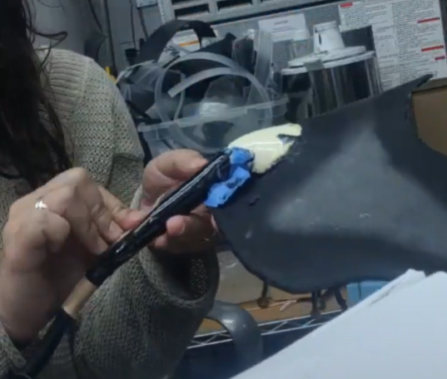
  3. Throughout: check for bubbles in mold, if they are deep, will need to fill holes with more epoxy
  4. Cut, whittle, sand potting compound to a streamlined shape (but take care to not make your cuts too smooth so that epoxy will be able to bond to the surface)
  5. Put a layer of Gflex and fiberglass mesh over your potting compound at any vulnerable connection points (near subconn connector, headcap wire output, and small wire outputs.
  6. Put a 2 inch piece of marine grade heat shrink over the hot dog splice at the subconn connector end, but verify that this won’t inhibit the motion of your locking sleeve, which needs to come back slightly in order to see and connect your pins.
  7. Once the Gflex has cured, use a Dremel to fade the extent of the epoxy-reinforced material (where you would like the material to start conforming to the motion of the animal).
  8. Abrade the Gflex to promote adhesion to its surface.
  9. Cover wire outputs, 3D molds, and exposed cable with liquid electrical tape:  
     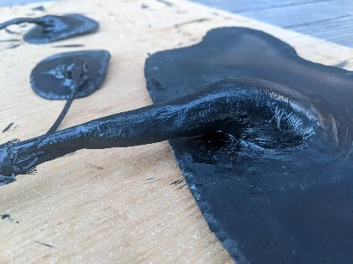 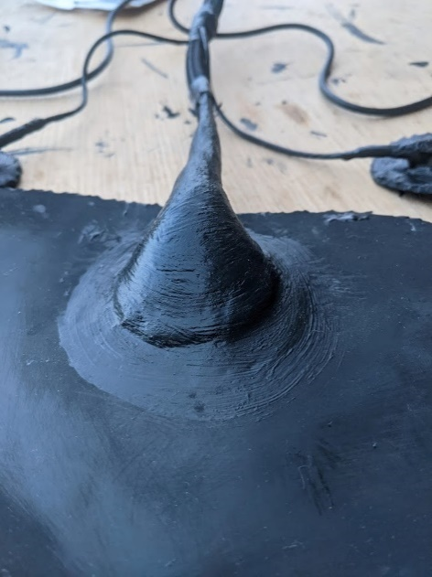 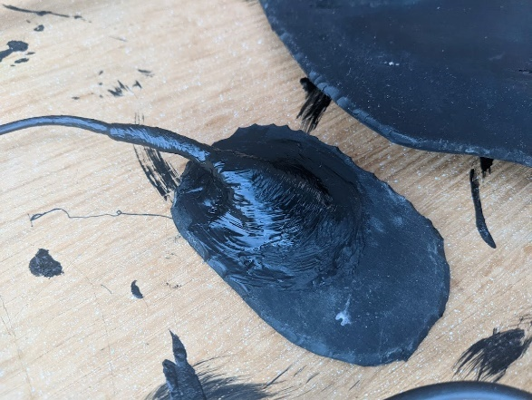

### Headcap Electrode Configuration

* 1. Use silicone RTV adhesive to position your electrodes. Put an initial layer down, wait ten minutes and then place each electrode down. They will (hopefully) stick but you might get your hands all yucky and then have to use a bunch to keep the electrode down against the headcap and then you become a sticky mess. Don't use water to clean up- it will only make things worse. Use (a lot of) alcohol and a rag.

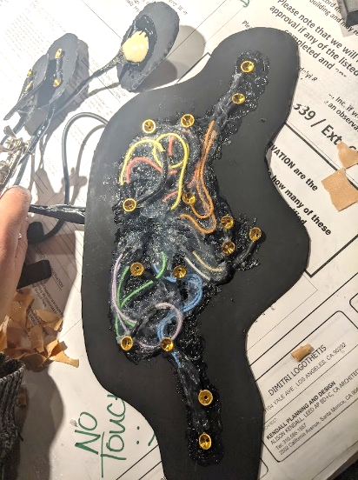 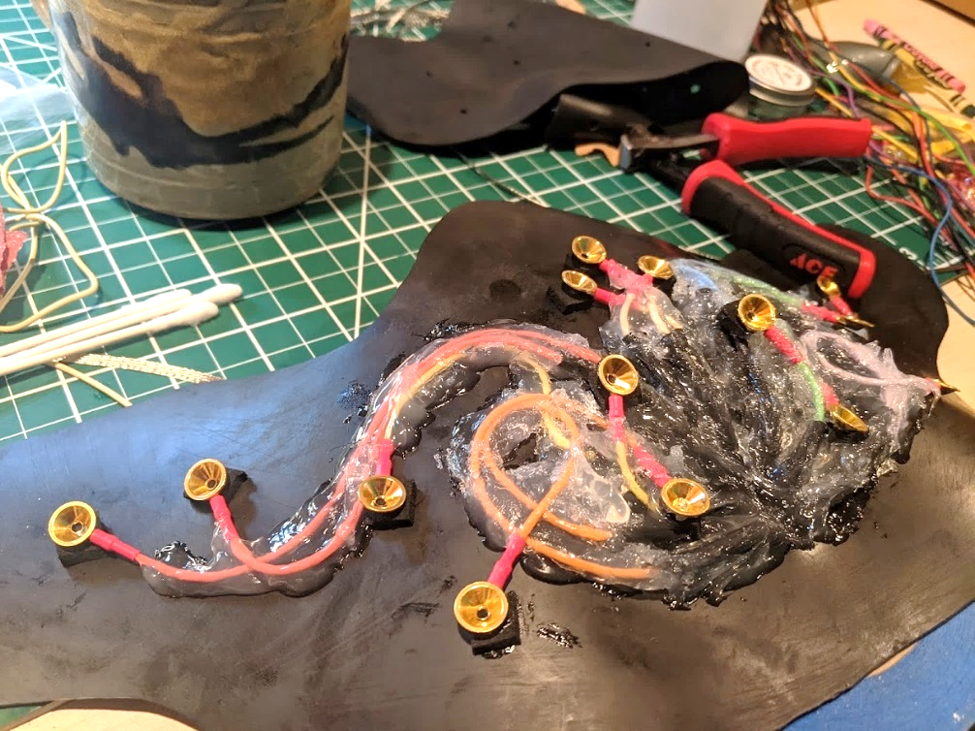

### Finalizing Headcap and Patches

* 1. Prepare neoprene foam layer:
     1. Use template (~3/4 inch larger than neoprene rubber/Illustrator template footprint from Design Step 08) and box-cutter to cut the neoprene foam.
     2. Use ovular template (3/4 inch larger than neoprene rubber patches) for EMG/ECG patches
  2. Prime the silicone for better adhesion:
     1. Around each electrode, use the Silicone RTV adhesive and a brush or Q-tip to create a ring of Silicone RTV for better adhesion to the neoprene. Without this uncured ring, the cured silicone RTV will not bond at all to the neoprene cement and water may be more likely to travel between electrodes and short out signals.
  3. Attach sacrificial layer of neoprene foam:
     1. Slather (a lot) of neoprene cement on both the patches with electrodes and the neoprene foam.
     2. **IMPORTANT: for the headcap, ***before you attach the full-size footprint,*** it is important to attach two layers of thicker neoprene foam on either side of the wire output (which is rigid) to better conform to the round shape of the head (see photos below of first layer [left] and second layer [right]):  
        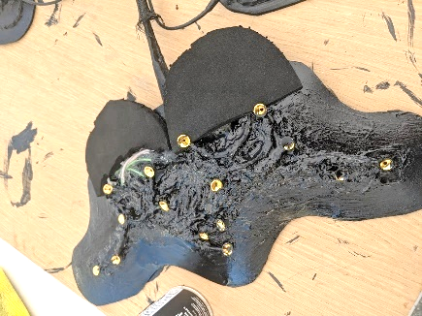 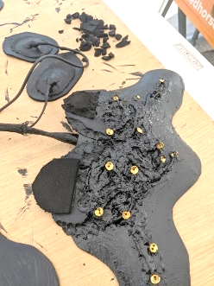
     3. 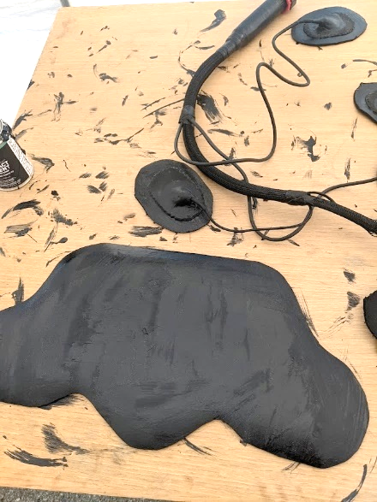Wait at least 4 min for the neoprene cement on either side to solidify/tack-ify. Before the glue is ready, it will come off on your fingers and smear when you touch it. When it is ready, you will touch it and feel it pull on your finger. It should look like this when it is ready:  
          
        *Note: you will notice there are no holes in this neoprene foam layer- that is intentional. You will be able to push each goldcup electrode through the neoprene foam after it is stuck, and this will give you a tighter waterproof seal around each electrode.
     4. 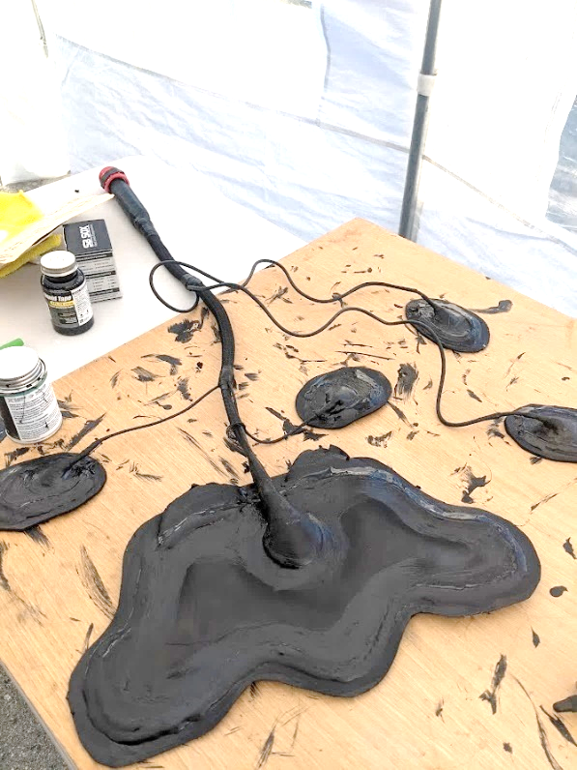Carefully place the neoprene layers together (once they are stuck they are really stuck). It helps to start forward to back, making sure to minimize air bubbles along the way.
     5. Before too long (will become difficult the longer you wait), push each goldcup up and through the neoprene foam. This is a good opportunity to remove any residual neoprene cement on the gold sensor heads (should come off fairly easily).
     6. Place small dots of superglue around the periphery of the cap, where the neoprene rubber meets the neoprene foam. This is a spot where the two layers are most likely to come undone.
     7. To ensure some flexibility, paint a contour of neoprene cement over the dots of superglue (with a brush you are ready to throw away).
     8. Next, place a contour layer of E6000 around the edge of the neoprene foam/rubber interface.
     9. 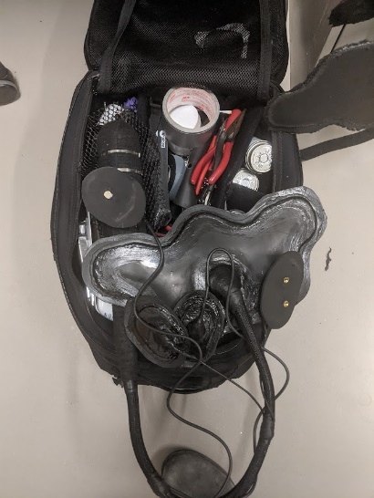Before the E6000 dries, paint another layer of neoprene cement over the E6000. Without this, the E6000 does not make a good enough seal with the neoprene cement and starts to peel off after prolonged water submersion.

### Preparing for Deployment

* 1. Cover exposed cables with nylon sheathing to protect from abrasion
  2. Use splicing tape and/or liquid electrical tape for additional abrasion resistance and attachment
  3. Set up cable-organizing Velcro bridges and prime with a layer of neoprene cement to facilitate adhesion upon attachment.
  4. Follow steps in Part II to prepare logger for deployment and attachment.

# Part III: Sleep Data Processing Pipeline

For more information on Data Analysis steps and current progress, see GDrive 🗀 Sleep_Analysis > 🗀 Scripts > 00_Data_Analysis_Tracking.xlsx). Generally, all scripts or settings files used to generate subsequent data steps are in 🗀 Sleep_Analysis > 🗀 Scripts and inputs/outputs for each step are stored in 🗀 Sleep_Analysis > 🗀 Data. To improve clarity about which tools and filetypes are required and used by different programs, we are using the following icons to represent different file extensions:

* Text file (.csv or .txt)
* RStudio (.R script)
* Excel (.xlsx worksheet)
* BORIS Behavioral Program ([download here](https://boris.readthedocs.io/en/latest/))
* Neurologger Software
* EDF Browser ([download here](https://www.teuniz.net/edfbrowser/index.html))
* LabChart (ADInstruments download here)
* MATLAB v2020b  
   EEGLAB MATLAB toolbox for EEG research ([download here](https://eeglab.org/download/))  
   CATS MATLAB toolbox for Biologging tools ([download here](https://github.com/wgough/CATS-Methods-Materials))
* ArcGIS Pro (ESRI)
* Autodesk Maya

***Automated or manual review required:***

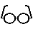 Manual review required  
 Automated process  
  Semi-automated process

### RPA Robotic Process Automation icon PNG and SVG Vector Free Download Glasses Icon | Line Iconset | IconsMind Metadata Microsoft Excel logoRStudio logo and Video Scoring Logo, company name Description automatically generatedRStudio logo

### RPA Robotic Process Automation icon PNG and SVG Vector Free Download Glasses Icon | Line Iconset | IconsMind Notes Microsoft Excel logo & Sleep_Study_Metadata RStudio logo

* 1. **Overview:** Enter metadata manually and then transform metadata into long format CSV (less readable but more ideal across programming languages)
     1. Script:  **00_Metadata.R** **\***
     2. Input: **00_Sleep_Study_Metadata.csv**
     3. **Output: testNN_Nickname_00_Metadata.csv**for each seal
     4. **Output 2: 01_Sleep_Study_Metadata.csv** **–** Long format metadata for use in other programs
     5. Save **00_Sleep_Study_Metadata.xlsx**  with necessary fields filled in (see Tagging Protocol for more lab-specific information) as **00_Sleep_Study_Metadata.csv** **.**
     6. **Run** Script:  **00_Metadata.R** **\* Use RStudio to open** 🗀 Sleep_Analysis > Sleep_Analysis.Rproj (if you don’t have it; install R and RStudio first)
        1. **Will save: 01_Sleep_Study_Metadata.csv**in Data folder for subsequent steps.

### RPA Robotic Process Automation icon PNG and SVG Vector Free Download Glasses Icon | Line Iconset | IconsMind Location Data Processing

* 1. **Overview:** Use [Wildlife Computers Data Portal](https://my.wildlifecomputers.com/data/) to process GPS data.
     + 1. **Scripts:** None; manual. Must wait until file processes todownload processed CSVs.
       2. **Input:** testNN_Nickname_01_TAGSERIAL.wch (Wildlife Computers file)
       3. **Output:** testNN_Nickname_01_GPShits.csv 🡪 testNN_Nickname_01_GPShits_UserModified.xlsx
  2. **Important steps:** Upload data into data portal, add metadata (including start and stop date/times and latitude/longitudes), then begin Location Processing by “Creating New Process” below.

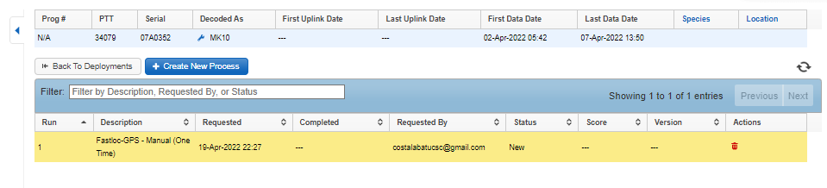

### RPA Robotic Process Automation icon PNG and SVG Vector Free Download Glasses Icon | Line Iconset | IconsMind Video Scoring Logo, company name Description automatically generatedRStudio logo

* 1. **Overview:** Video data is scored and turned into an Ethogram to be paired with motion/environmental sensor data and sleep data.
     + 1. **Scripts:**  **00_Ethograms.R** 
       2. **Input:** Scored data output from  **BORIS** Behavioral Scoring software:   
          filename: testNN_Nickname_CameraType_StartYearMonthDay_StartTime-EndYearMonthDay_EndTime.csv  
          example:  test20_SnoozySuzy_DryWebcam_20200421_105230-20200423_142530.csv
       3. **Output:**  testNN_Nickname_00_VideoScoringData.csv
  2. On a parallel timeline with sleep processing, video files are scored by trained experts. Detailed steps, tutorials, and presentations can be found in 🗀 **Scripts >** 🗀 **00_Video Scoring Materials**. These steps include:
     1. **Create a copy of video files** on Google Drive (🗀 Sleep_Analysis > 🗀 Video Footage > 🗀 testNN_Nickname_Video > 🗀 Camera type (e.g. Dry Recording Webcam for land webcam recording; Wet Recording Webcam for pool webcam recording; or High Resolution DSLR Videos)
     2. **Rename video files** with systematic names, following naming convention such that all files from a single camera can be stored in the same folder:
        1. **Webcam:** 2019102515 (43).mp4 (25-Oct-2019 15:43:00 – 15:43:59)
        2. **DSLR or GoPro:** 10_27_2019___16_08_00.MP4 (27-Oct-2019 16:08:00 – end time)
        3. **BBC Animal-Borne Camera:** 20200412_110730.MP4 (12-Apr-2020 11:07:30)
     3. Score video files using BORIS ([download here](https://boris.readthedocs.io/en/latest/)) using the Boris Project File (🗀 Sleep_Analysis > 🗀 Scripts > **00_BorisProject.boris** ) and according to the **00_Ethogram.xlsx** (this file also stores output for Machine Learning Model Runs with files like testNN_Nickname_03_VideoMotionData_25Hz.csv):  
        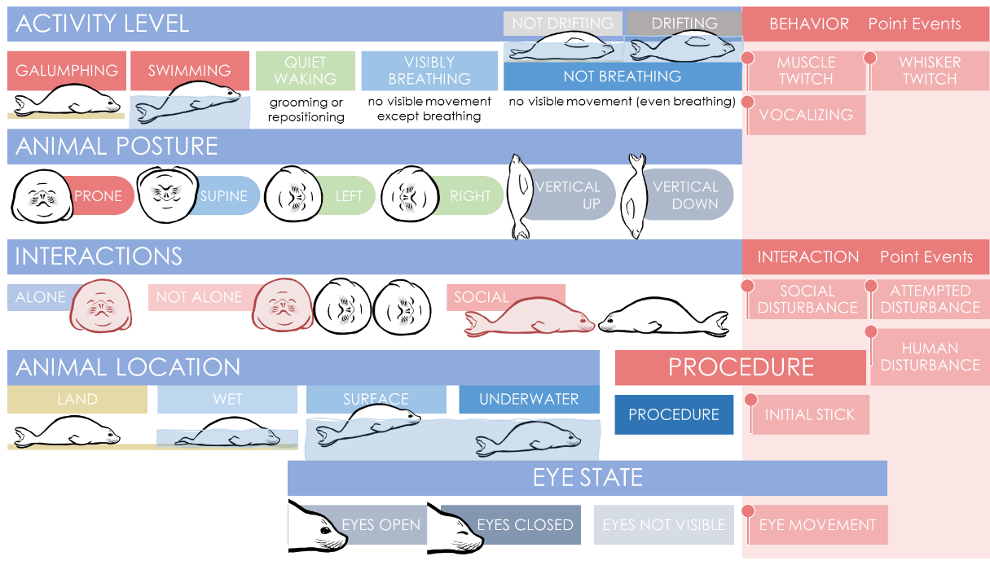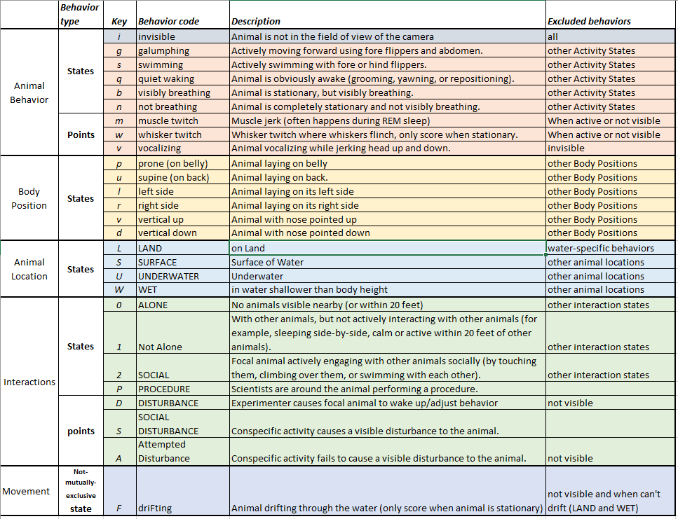

### RPA Robotic Process Automation icon PNG and SVG Vector Free Download Glasses Icon | Line Iconset | IconsMind Raw Data

### RPA Robotic Process Automation icon PNG and SVG Vector Free Download Glasses Icon | Line Iconset | IconsMind Download and convert data

* 1. Overview:
     1. **Script:**   **GUI through** Matlab app (Neurologger3ConverterAndVisualizer.exe )
     2. **Input:** testNN_Nickname_01_ALL.dat - Binary data straight from the tag
     3. **Output:** testNN_Nickname_01_ALL.edf - Converted EDF file with all data
  2. Plug memory card into the USB microSD card reader.
  3. **Read data:**
     1. Open “ReadDisk.exe” utility. 
     2. Allow the application to make changes, but DO NOT format the drive.
     3. Make copies of binary file “.dat” in “Data” folder in Documents, on external drive, AND Google Drive folder.
     4. **Output:** testNN_Nickname_01_ALL.dat - Binary data straight from the tag
  4. **Convert data:**
     1. Open Neurologger3Converter&Visualizer MATLAB App (C:\Users\Jessie\Documents\Dissertation Sleep\Neurologger Software 2021\Neurologger3ConverterVisualizer_2021-05-15\Neurologger3Converter&Visualizer\for_redistribution_files_only\Neurologger3ConverterAndVisualizer.exe 
     2. Open Configuration – default script configuration is “Int32ch250Hz_I2C36Hz_IR8K_IPT_eSD”
     3. Open “.dat” binary file, press “Convert” to EDF file (using start time from Real-Time Clock and “Insert Restart Delays”).
  5. **Wait & monitor computer performance.** 😊 Open the task manager to keep track of how much memory this task is requiring of your computer. This will take ~30-40 GB of Memory for a ~10-day file. You could convert data in chunks but start times must be manually entered for each section and that may introduce data synchronization issues.

### Glasses Icon | Line Iconset |

* 1. 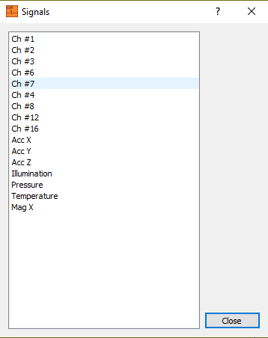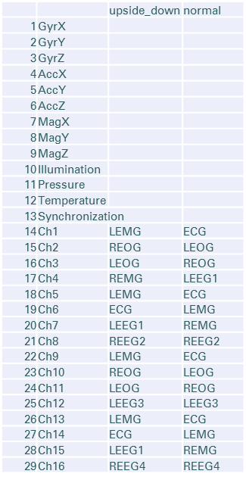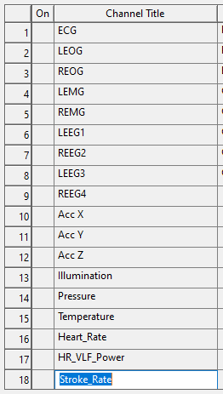**Overview:** Processing step 01.B rearranges EDF in EDF Browser  ([download here](https://www.teuniz.net/edfbrowser/index.html)) to achieve standardized channel configuration in LabChart . Open signals from original EDF (output in step above) and add them to a new file in the order shown to the right:  
     **Original EDF: Rearranged in EDF Browser (original names): Desired channel order:**

|  |  |  |  |
| --- | --- | --- | --- |
|  |  | upside_down | normal |
| 1 | GyrX |  |  |
| 2 | GyrY |  |  |
| 3 | GyrZ |  |  |
| 4 | AccX |  |  |
| 5 | AccY |  |  |
| 6 | AccZ |  |  |
| 7 | MagX |  |  |
| 8 | MagY |  |  |
| 9 | MagZ |  |  |
| 10 | Illumination |  |  |
| 11 | Pressure |  |  |
| 12 | Temperature |  |  |
| 13 | Synchronization | |  |
| 14 | Ch1 | LEMG | ECG |
| 15 | Ch2 | REOG | LEOG |
| 16 | Ch3 | LEOG | REOG |
| 17 | Ch4 | REMG | LEEG1 |
| 18 | Ch5 | LEMG | ECG |
| 19 | Ch6 | ECG | LEMG |
| 20 | Ch7 | LEEG1 | REMG |
| 21 | Ch8 | REEG2 | REEG2 |
| 22 | Ch9 | LEMG | ECG |
| 23 | Ch10 | REOG | LEOG |
| 24 | Ch11 | LEOG | REOG |
| 25 | Ch12 | LEEG3 | LEEG3 |
| 26 | Ch13 | LEMG | ECG |
| 27 | Ch14 | ECG | LEMG |
| 28 | Ch15 | LEEG1 | REMG |
| 29 | Ch16 | REEG4 | REEG4 |

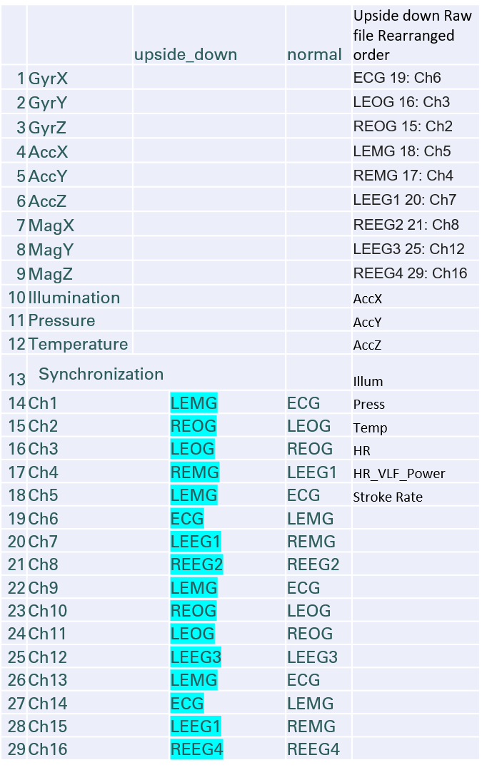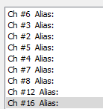

* + 1. **Script:**  None; manual
    2. **Input:** testNN_Nickname_01_ALL.edf - Converted EDF file with all data
    3. **Output:** ***testNN_Nickname_01_ALL_Rearranged.edf*** – Rearranged & Named EDF file with ECG, LEOG, REOG, LEMG, REMG, LEEG1, REEG2, LEEG3, REEG4, AccX, AccY, AccZ, Illum, Pressure, Temp, MagX, MagY (placeholders for HR/SR calculation)
       1. **Note:** Default units for pressure are in bars. After Motion & Environmental processing, units for Depth will be in meters.

### Visualize Raw Data in LabChart



* 1. **Overview**: Processing Step 01.C Appends rearranged EDF file generated in “Rearrange EDF” step above (filename below) and adds settings to view the resulting file in LabChart:
     1. **Script**: None; manual.
     2. **Input:** testNN_Nickname_01_ALL_Rearranged.edf – Rearranged & Named EDF file
     3. **Output:** testNN_Nickname_01_ALL_Raw.adicht - LabChart file with unprocessed data
  2. Visualize raw electrophysiological and motion/environmental signals to preview data and manually identify animal behavior and location (calm in water; enter/exit water)
  3. Open LabChart settings file: 🗀 Sleep_Analysis > 🗀 Scripts > **01_Raw_Settings.adiset** 
  4. **File> Append** Rearranged EDF file  generated in previous step. 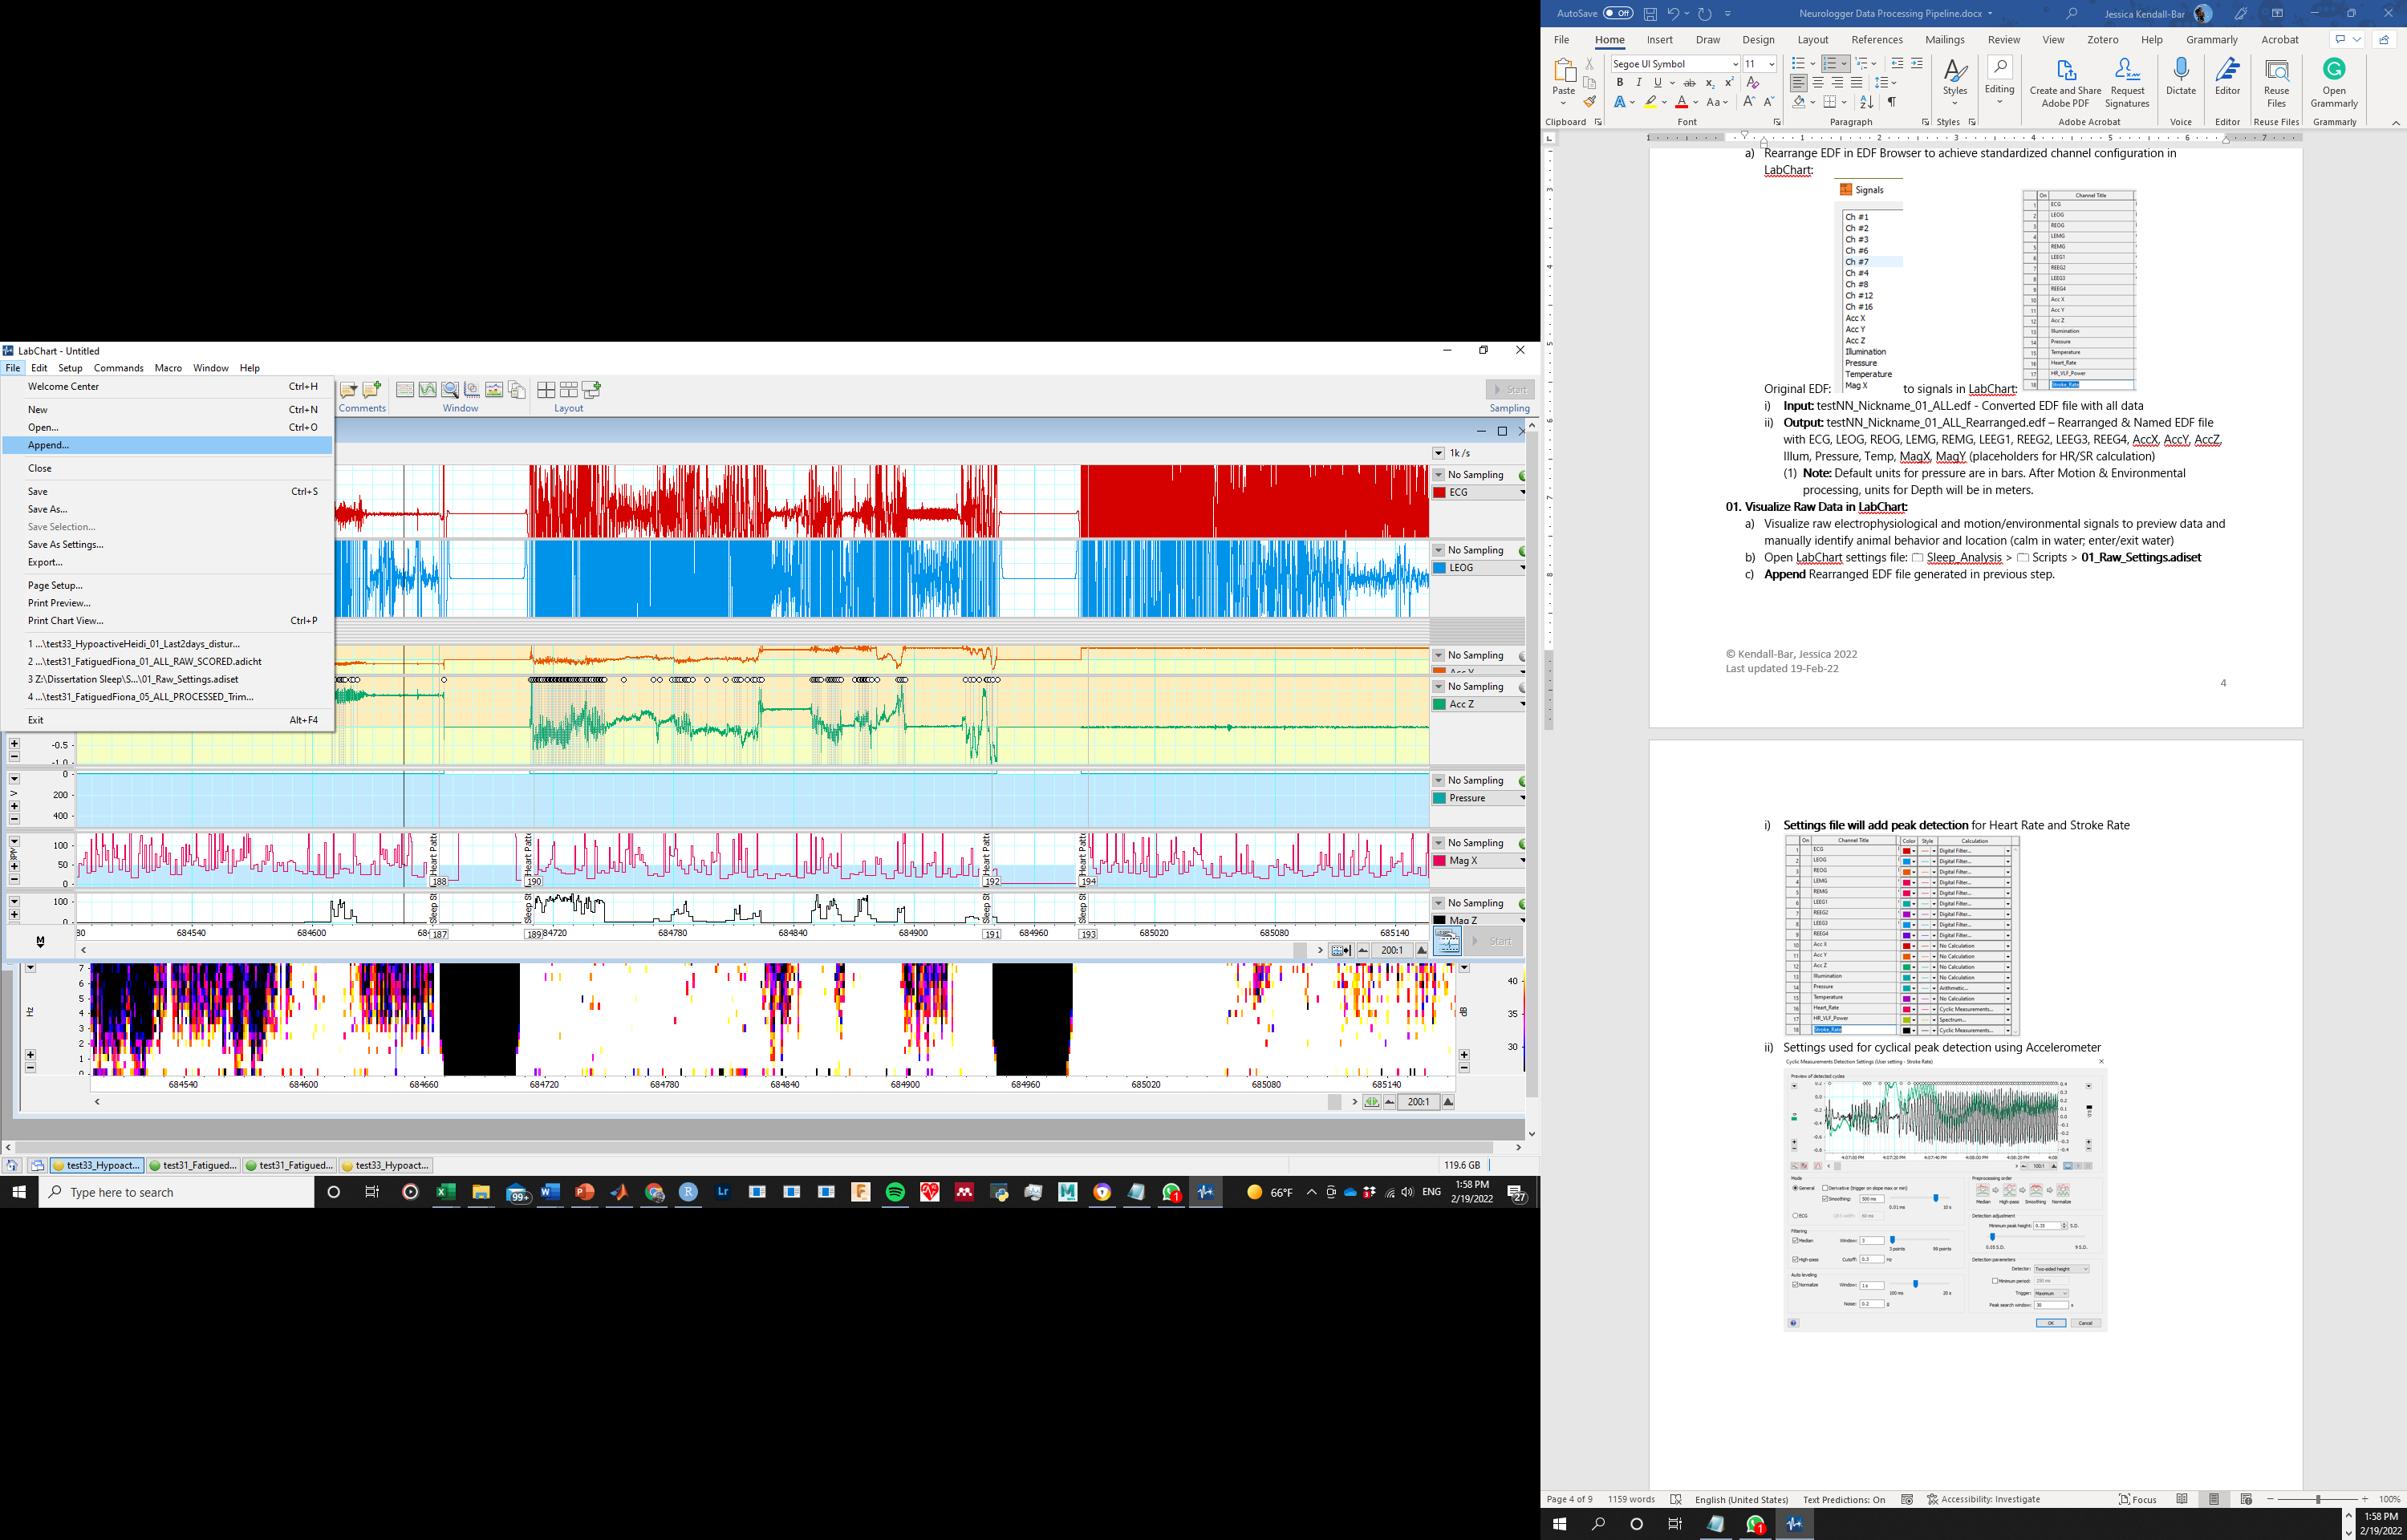
  5. Settings file will add peak detection for Heart Rate and Stroke Rate  
     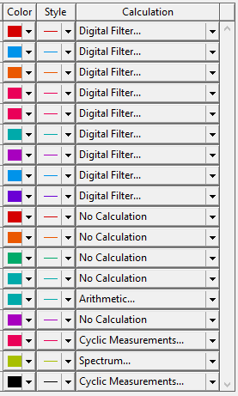
     1. Settings used for cyclical peak detection using Accelerometer  
        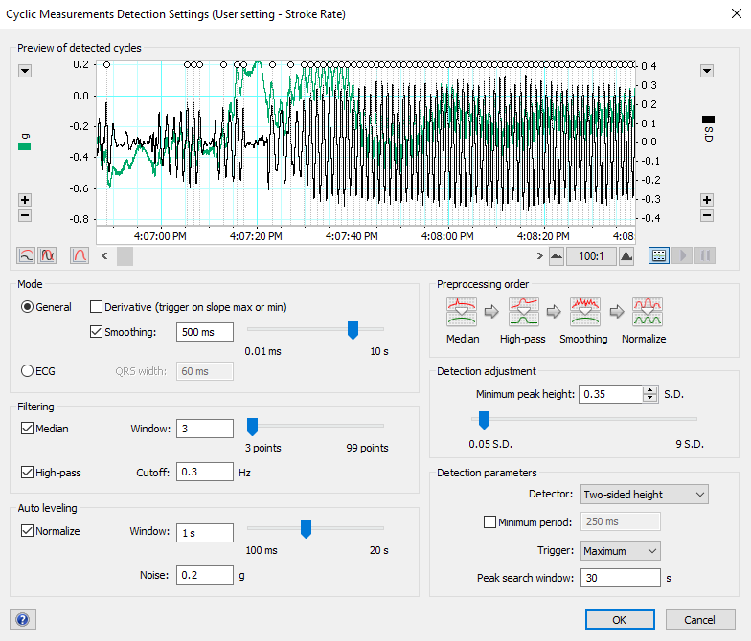
     2. Settings used for cyclical peak detection using ECG signal  
        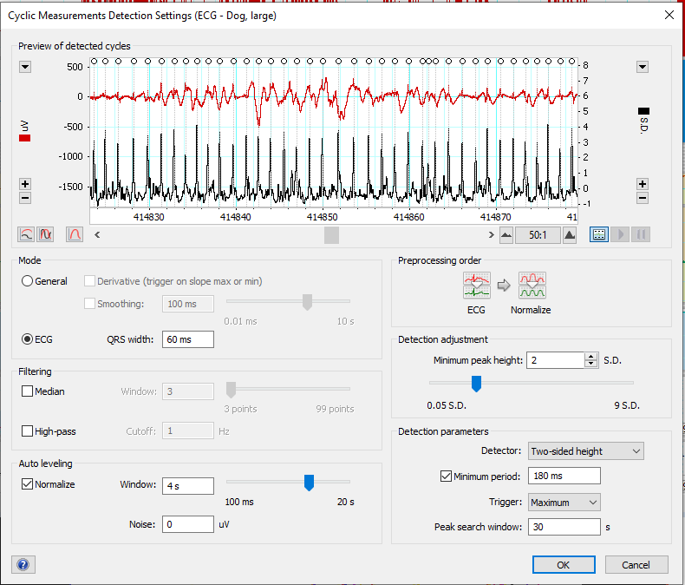

### Glasses Icon | Line Iconset | IconsMind Process Raw Data in LabChart

1. Remove transmitter pings using LabChart:
   1. Method from: adinstruments.com/support/videos/labchart-mastery-removing-ecg-artifacts-emg-data
   2. Using two arithmetic channels:
      1. First one: abs(Threshold(SmoothSec(Window(Ch1,-500,500),3),1))*Bandpass(Ch1,0.3,75)
         1. Window function makes anything within the given range (-500 to +500 uV – units must be specified) = 1; if it exceeds that range, the value is changed to 0
         2. SmoothSec widens this gap slightly, smooths the area so that you can get rid of 0 values where the channel passes back through the window briefly.
         3. Threshold creates sharp edges again to be used to delete the data in the wider window
         4. Abs()*Bandpass() then removes any data where the value in the first channel is 0 and where it is one, it keeps the bandpass filtered values from Ch1.
      2. Second channel: Shift(Shift(Threshold(0.9999,SmoothSec(Window(Ch1,-500,500),3)),-5)*abs(Threshold(SmoothSec(Window(Ch1,-500,500),3),1))*Bandpass(Ch1,0.3,75),5)
         1. Threshold makes it so that the data is 1 wherever it deleted data from Ch1 and 0 everywhere else.
         2. Shift shifts this square pulse backwards by 5 seconds.
         3. Multiplying back the equation from the first bullet points replaces all 1s with data from Ch1
         4. Shifting it forward by 5 seconds shifts the data so that it fits the gap.
   3. Finally, add the two together: Shift(Shift(Threshold(0.9999,SmoothSec(Window(Ch1,-500,500),3)),-5)*abs(Threshold(SmoothSec(Window(Ch1,-500,500),3),1))*Bandpass(Ch1,0.3,75),5) + abs(Threshold(SmoothSec(Window(Ch1,-500,500),3),1))*Bandpass(Ch1,0.3,75)
   4. All in one:
      1. ECG: Shift(Shift(Threshold(0.9999,SmoothSec(Window(Ch1,-1500,1500),3)),-5)*abs(Threshold(SmoothSec(Window(Ch1,-1500,1500),3),1))*Bandpass(Ch1,0.3,75),5) + abs(Threshold(SmoothSec(Window(Ch1,-1500,1500),3),1))*Bandpass(Ch1,0.3,75)
         1. Chose -1500 to +1500 to filter out only largest artifacts- does not remove all transmitted signal but removes less of high artifact signals.
      2. L EOG: Shift(Shift(Threshold(0.9999,SmoothSec(Window(Ch2,-800,800),6)),-8)*abs(Threshold(SmoothSec(Window(Ch2,-800,800),3),1))*Bandpass(Ch2,0.3,35),8) + abs(Threshold(SmoothSec(Window(Ch2,-800,800),6),1))*Bandpass(Ch2,0.3,35)
         1. Chose -800 to +800 to filter out only largest artifacts- some clipping but EOG channel not critical for scoring
      3. L EMG: Shift(Shift(Threshold(0.9999,SmoothSec(Window(Ch4,-500,500),6)),-8)*abs(Threshold(SmoothSec(Window(Ch4,-500,500),3),1))*Bandpass(Ch4,10,100),8) + abs(Threshold(SmoothSec(Window(Ch4,-500,500),6),1))*Bandpass(Ch4,10,100)
      4. EEG (all): Shift(Shift(Threshold(0.9999,SmoothSec(Window(Ch6,-500,500),6)),-8)*abs(Threshold(SmoothSec(Window(Ch6,-500,500),3),1))*Bandpass(Ch6,0.3,35),8) + abs(Threshold(SmoothSec(Window(Ch6,-500,500),6),1))*Bandpass(Ch6,0.3,35)

### Raw Scoring



* 1. **Overview**: Processing Step 01.D identifies critical time points and provides a first look at the quality and scope of the data.
     1. **Script:**  None; manual
     2. **Input:** testNN_Nickname_01_ALL_Raw.adicht  - LabChart file with unprocessed data
     3. **Output:** testNN_Nickname_01_ALL_Raw_SCORED.adicht  - LabChart file with scored water entry/exits
     4. **Output 2:** 00_Raw_Scoring_Metadata.xlsx
        1. **Copy/paste comments from Raw_SCORED** LabChart file into Excel spreadsheet, insert Seal ID (testNN_Nickname). Export as **00_Raw_Scoring_Metadata.csv** for use in: **06_Hypnograms.R** in Processing Step 06.
  2. Identify recording start and end:
     1. **Instrument ON Animal:** First sign of heart rate in ECG (instrument attached to animal)  
        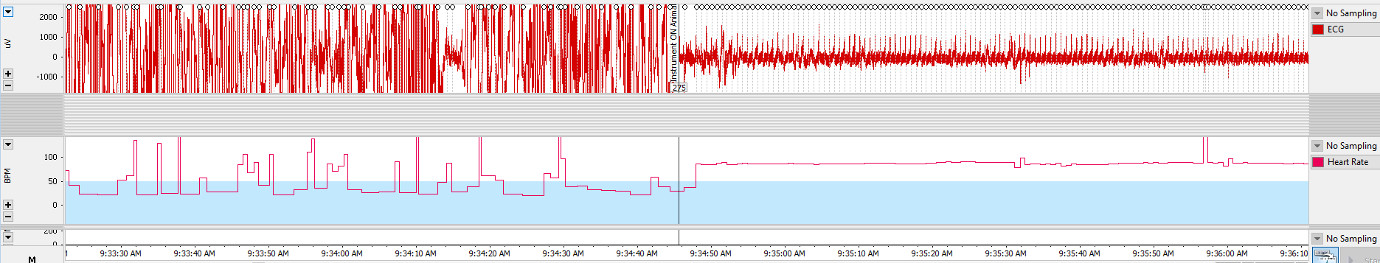
     2. **Instrument OFF Animal:** Last sign of heart rate in ECG (instrument removed)  
        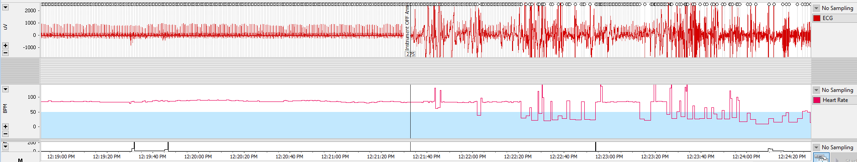
     3. \***NOTE:** The exact position of these timestamps is not critical, but these timestamps will be used to TRIM the data file in later processing steps, so keep their position consistent across files. Enter these ON.ANIMAL and OFF.ANIMAL Date Times in **“00_Sleep_Study_Metadata.xlsx”.**
  3. **Identify animal location**   
     LAND v. SHALLOW WATER v. CONTINENTAL SHELF v. OPEN OCEAN
     1. **Animal Enters Water:** Animal enters water (defined by accelerometer motion and increase in pressure) *LAND -> SHALLOW WATER*
     2. **Animal Leaves Shallow Water:** Animal enters water >10 m. *SHALLOW WATER -> CONTINENTAL SHELF*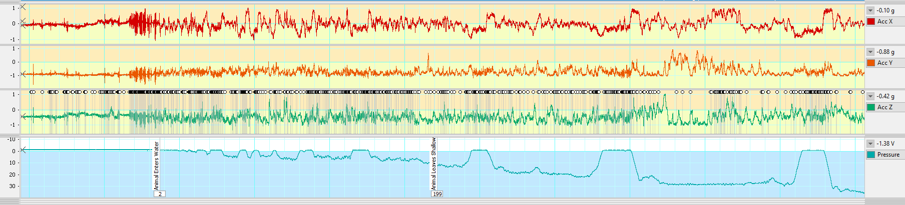
     3. **Animal Leaves Continental Shelf Water:** Animal enters water >~200 m (no longer is following the benthic contour). *CONTINENTAL SHELF -> OPEN OCEAN*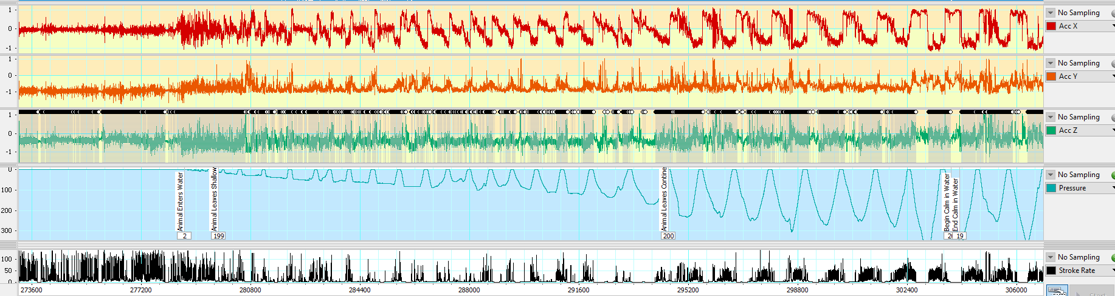
     4. **Animal Returns to Continental Shelf Water:** Animal returns to water <~200 m (returns to following benthic contour). *OPEN OCEAN -> CONTINENTAL SHELF*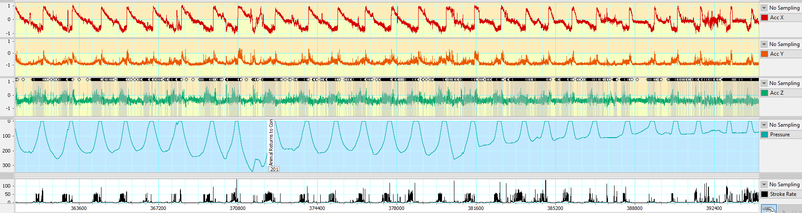
     5. **Animal Returns to Shallow Water:** Animal returns to water <~10 m (returns to following benthic contour). *CONTINENTAL SHELF -> SHALLOW WATER*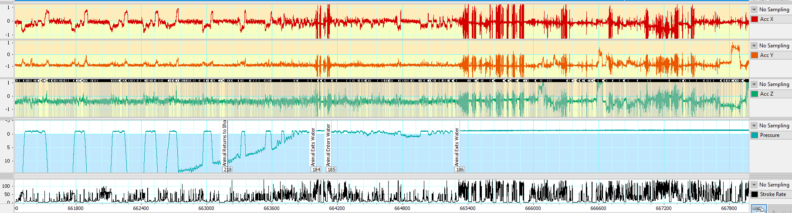
     6. **Animal Exits Water:** Animal exits water (defined by accelerometer flattening and pressure) *SHALLOW WATER -> LAND*
  4. **Identify calm segments** in water without motion artifacts that might be useful for ICA analysis and/or contain sleep segments.
     1. **Begin Calm in Water:** beginning of non-stroking segment in water
     2. **End Calm in Water:** end of non-stroking segment in water  
        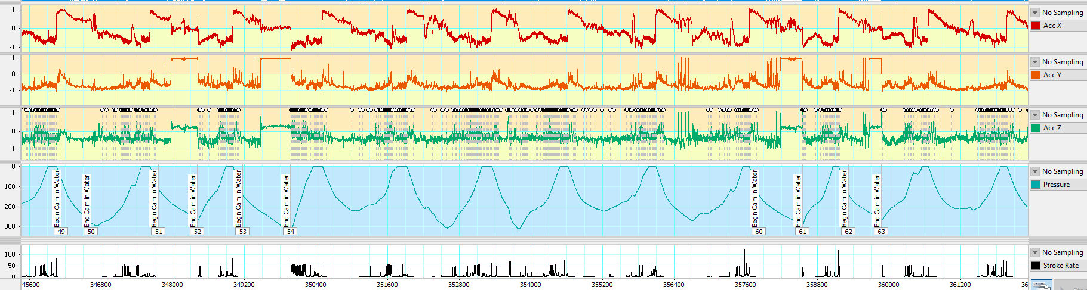
     3. **NOTE:** Stroke identification is based on unprocessed accelerometer data- not quite as good as with processed Gyroscope data in later Processing Step 06.
  5. **Identify logger restarts** where data is not available
     1. Sleep State Unscorable & Heart Patterns Unscorable: at beginning of restart
     2. Sleep State Unscorable & Heart Patterns Unscorable: at beginning of restart  
        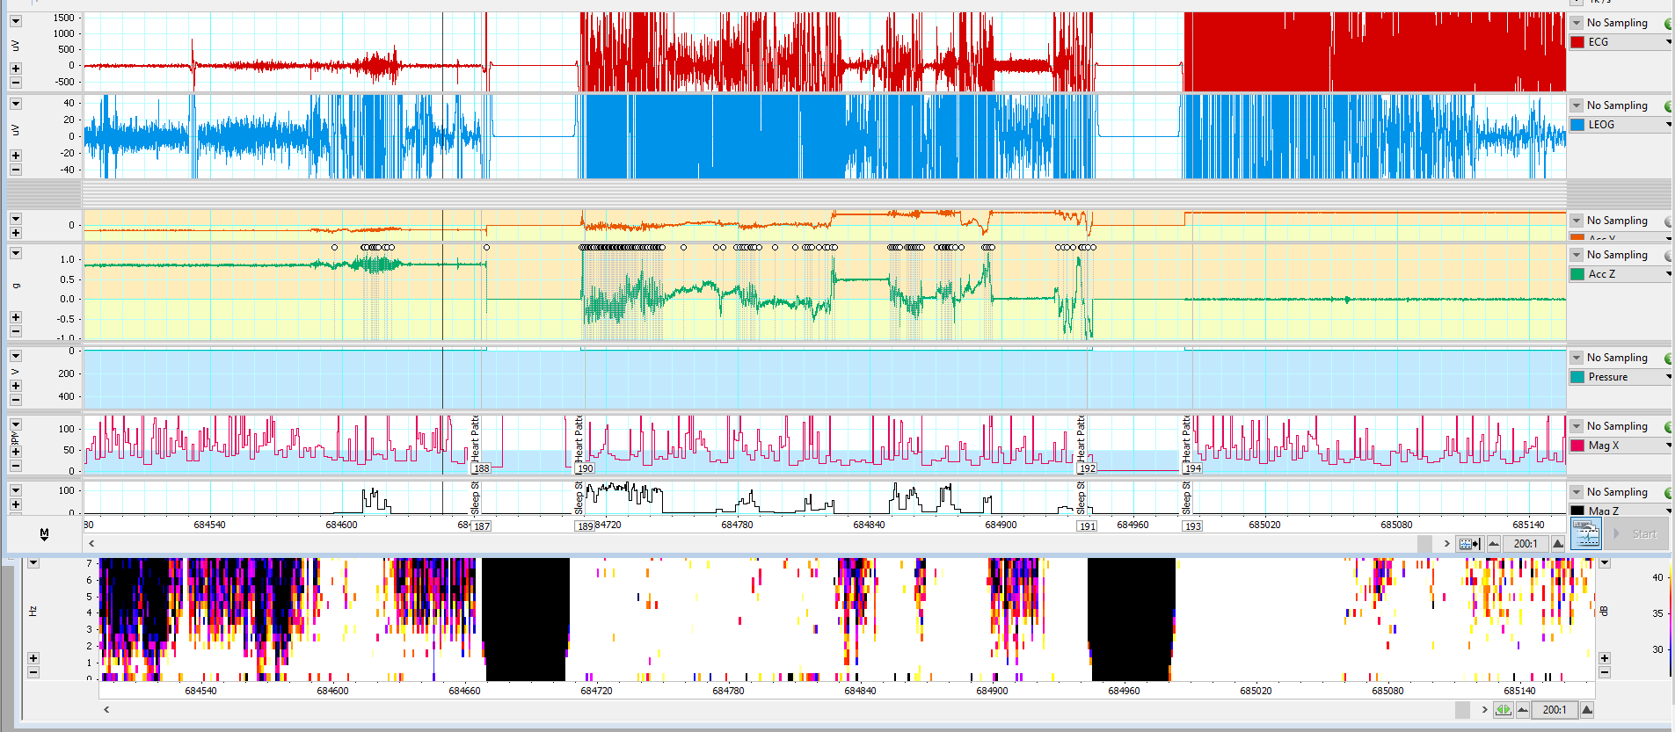
     3. **Note:** These comments are for your reference only, these comments will be most important in the Step 06 Sleep Scoring file, which dictates the “Unscorable” sections of the Hypnogram.

### RPA Robotic Process Automation icon PNG and SVG Vector Free Download Glasses Icon | Line Iconset | IconsMind Processing Motion & Environmental Sensors

MATLAB v2020b: 🗀 Sleep_Analysis > 🗀 Scripts > 02_ProcessingMotionEnvSensors.m 



The script 02_ProcessingMotionEnvSensors.m  refers to sections in the CATS Toolbox’s MainPRHTool.m (<https://github.com/wgough/CATS-Methods-Materials>) which should be run simultaneously. We have made slight changes to the original code to work with our study system (available as MainPRHTool_JKB.m)

* 1. **Overview:** Script resamples Motion & Environmental Sensor data from 250/7 to desired sample rate (25Hz), calibrates depth, accelerometer, and magnetometer signals to get pitch, roll, and heading.

**Import data from EDF:** Use EEGLAB

### Read in Metadata



* 1. **Overview**: Processing Step 02.A reads in seal metadata, converts to usable MATLAB formats and stores important variables.
     1. **Script:**  02_ProcessingMotionEnvSensors.m Section 02.A
     2. **Input:** **01_Sleep_Study_Metadata.csv**from **00_Metadata.R**
     3. **Output:** MATLAB variables for subsequent steps

### RPA Robotic Process Automation icon PNG and SVG Vector Free Download Load Motion & Environmental Data

* 1. **Overview:** Processing Step 02.B reads in motion & environmental sensor data into a MATLAB variable called Raw
     1. **Script:**  02_ProcessingMotionEnvSensors.m Section 02.B
     2. **Input:** Channels 1-12 from testNN_Nickname_01_ALL.edf (or CSV or MAT file)
     3. **Output:** ‘Raw’ MATLAB variable with gyroscope, accelerometer, magnetometer, illumination, pressure, & temperature.
  2. Options:
     1. **Import data from EDF:** Use EEGLAB Toolbox and BIOSIG toolbox to import EDF file into Matlab via EEGLAB. You can use the code provided to do it in command line or use the graphical interface as shown below:
        1. **Step 1:** Load file using BIOSIG toolbox through EEGLAB  
           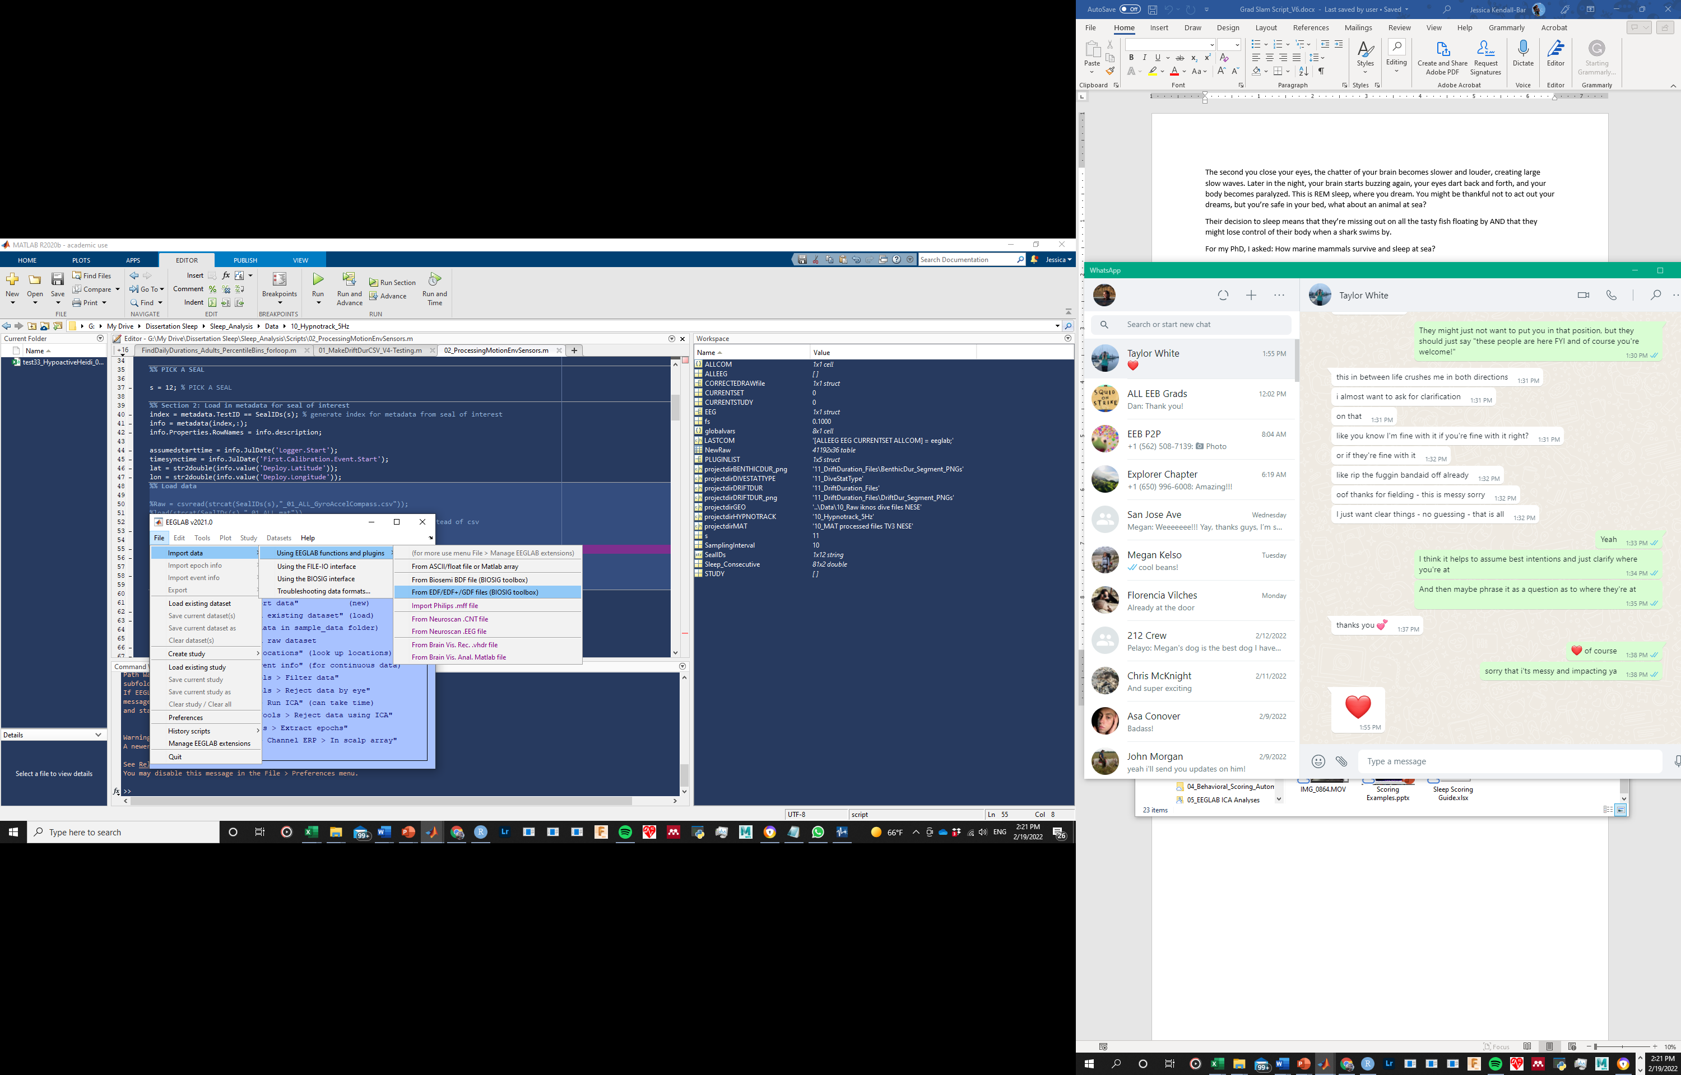
        2. **Select un-rearranged EDF file output from Converter/Visualizer:** testNN_Nickname_01_ALL.edf
        3. **Select channels 1 through 12:** [1 2 3 4 5 6 7 8 9 10 11 12]
     2. **Import data from MAT (MATLAB) file:**load(strcat(SealIDs(s),"_01_ALL.mat"))  
        Raw= double(Data.GyroAccelCompass);
     3. **Import data from CSV (storage in CSV format is least efficient):**Raw = csvread(strcat(SealIDs(s),"_01_ALL_GyroAccelCompass.csv"));

### RPA Robotic Process Automation icon PNG and SVG Vector Free Download Resample Data

* 1. **Overview:** Processing Step 02.C uses MATLAB’s ‘resample’ function to resample default decimal motion/env sensor frequency (250/7 Hz) to a desired integer frequency (currently 25 Hz).
     1. **Script:**  02_ProcessingMotionEnvSensors.m Section 02.C
     2. **Input:** ‘Raw’ Motion/Env Sensor data at 250/7 Hz
     3. **Output:** ‘Out’ Motion/Env Sensor data at desired integer frequency (25 Hz).
        1. **Optional:** can output re-sampled data to CSV or skip step 02.C by reading in CSV with already resampled data (can save time with long files).

### RPA Robotic Process Automation icon PNG and SVG Vector Free Download MAT File setup for CATS Processing

* 1. **Overview:** Processing Step 02.D creates variables needed for CATS Toolbox processing based on ‘Out’ generated in Step 02.C. This step also adds interpolated data where restarts occurred and non-sensical data was inserted (and saves these timestamps in ‘restarts’).
     1. **Script:**  02_ProcessingMotionEnvSensors.m Section 02.D
     2. **Input:** ‘Out’ Motion/Env Sensor data at 25 Hz
     3. **Output:** **testNN_Nickname_RawMotionData.mat**  saved with additional variables and metadata

### RPA Robotic Process Automation icon PNG and SVG Vector Free Download Glasses Icon | Line Iconset | IconsMind Run CATS Toolbox

* 1. **Overview:** Processing Step 02.E contains instructions for running CATS Toolbox according to data with other tags. After running up to Section 8b in CATS toolbox, you can return to 02_ProcessingMotionEnvSensors.m to save your processed data.
     1. **Script:**  02_ProcessingMotionEnvSensors.m Section 02.E & CATS Toolbox MainCATSprhTool_JKB.m or unmodified original [MainCATSprhTool.m](https://github.com/wgough/CATS-Methods-Materials/blob/master/CATSMatlabTools/MainCATSprhTool.m). To run this toolbox, you will have to clone the Github repository and add it to your MATLAB path.
     2. **Input:** **testNN_Nickname_RawMotionData.mat**  & customized header file according to [this template](https://github.com/wgough/CATS-Methods-Materials/blob/master/CATSMatlabTools/templates/spYYMMDD-tag%23.xlsx).  
        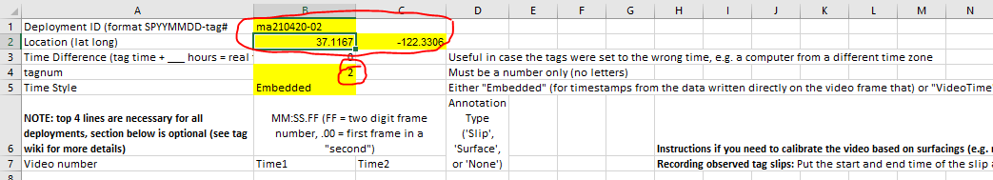
     3. **Output:** **Several MATLAB variables saved in next step** 
  2. **The following steps refer to actions/sections in MainCATSprhTool_JKB.m:**
     + 1. **Section 1:** DON’T RUN.
       2. **Section 2:** Run to load in data.
          1. **Select CATS data** (imported mat file): **testNN_Nickname_RawMotionData.mat** 

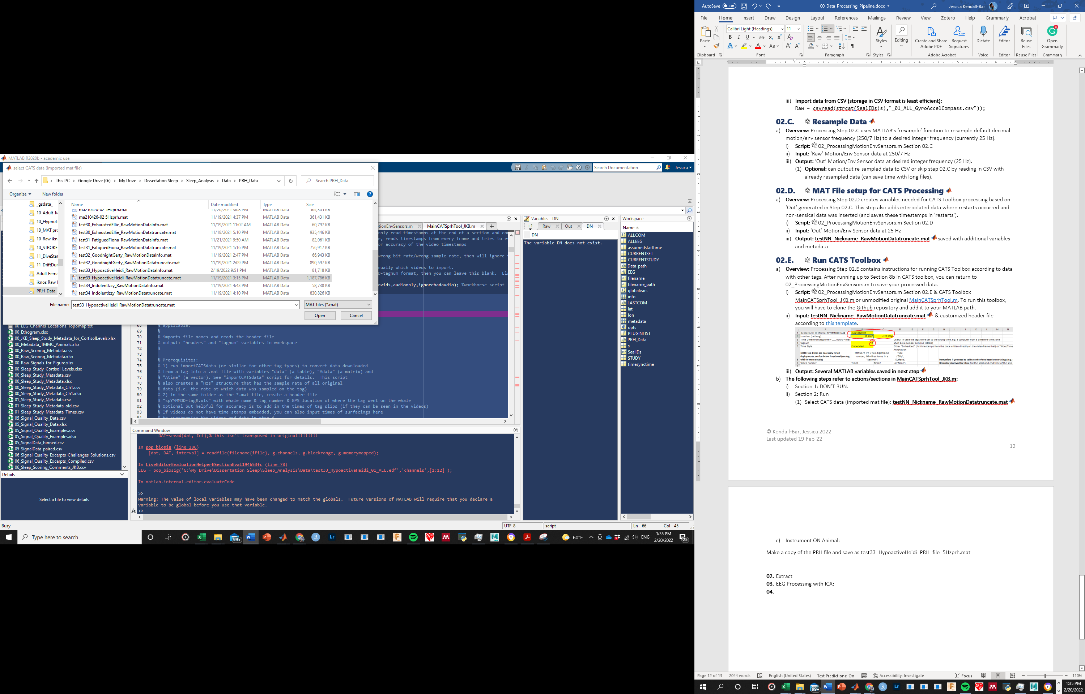  
*Pro tip: if the file ends with ‘truncate.mat’ it will automatically assume it’s been truncated already. You can do this if there are issues with the truncate step.

* + - * 1. **Select header file**: Customized header file according to [this template](https://github.com/wgough/CATS-Methods-Materials/blob/master/CATSMatlabTools/templates/spYYMMDD-tag%23.xlsx)

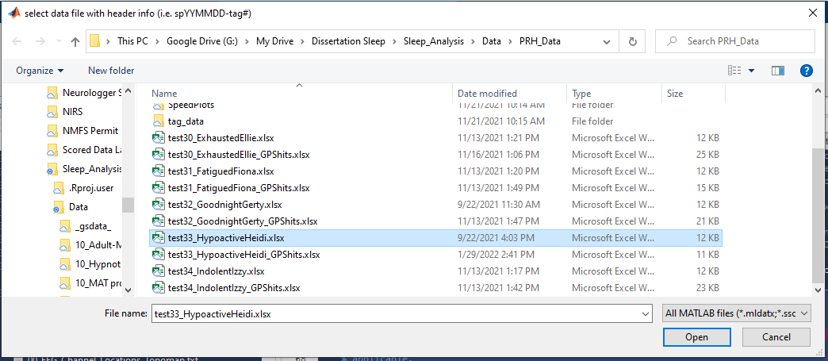

* + - 1. **Section 3:** Run and will use file uploaded in Section 2.
         1. **Select CATS cal file**: 01_CATS_calibration_file_for_Neurologger_L2.mat   
            (instrument-specific calibration file)

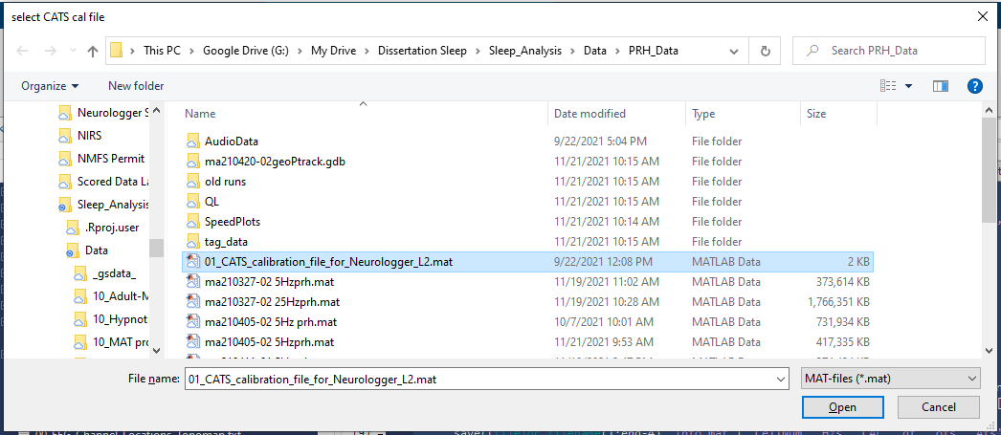

* + - 1. **Section 4**: Run (even without video files)
      2. **Section 5**: Run to get tagon and tagoff times.
         1. **IF (like I do)** you want your own tagon and tagoff times (based on previously identified ON.ANIMAL & OFF.ANIMAL times stored in ‘info’):  
            You will be using the 4 lines I’ve inserted into Step 5 (as opposed to the commented-out “gettagon” function used in the whale CATS processing pipeline.  
            % In step 5, run cell 5, ctrl-c out of the process, then run:

tagon = false(size(data.Pressure));

[~,a] = min(abs(DNorig-info.JulDate('ON.ANIMAL')));

[~,b] = min(abs(DNorig-info.JulDate('OFF.ANIMAL')));

tagon(a:b) = true;

* + - 1. **Section 6:** Run pressure calibration & preliminary bench calibration to other sensors.
         1. Select best option for depth correction (in-situ [2] is usually best)
         2. Other figure will pop up; can close and wait for “Section 6 done”
      2. **Section 7:** Run in-situ cals.
         1. **7a:** Select best option for Acc calibration (spherical cal [2] usually better than bench)
         2. **7b:** Mag spherical calibration will process (results should be low residual <5% and axial balance >20% - I usually get ~3.3% & 24.8%)
      3. **Section 8:** Tag orientation v animal orientation
         1. **8a:** Tag slip identification: does not apply to my data with a fixed tag location, so press Enter.
         2. **8b:** Identify:

**1 segment of time where animal is stationary on belly**

**1 segment of time where animal is galumphing** (~ only pitch is changing)

**Zoom into a dive to check the results**

Pitch should be a high negative value during the beginning of a descent.

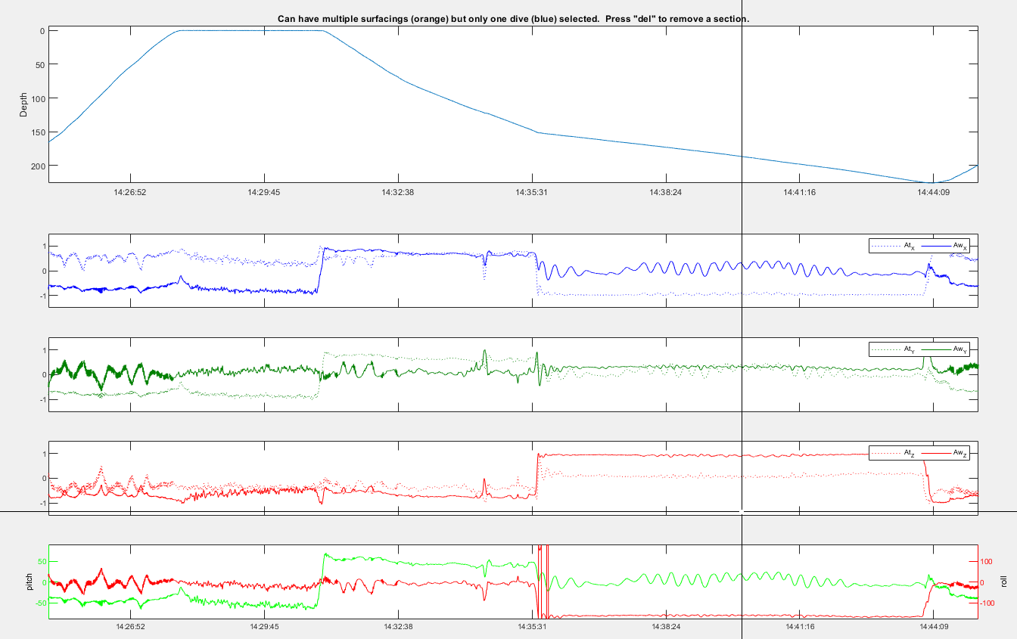

Roll should be minimal during galumphing (whereas pitch should change more).

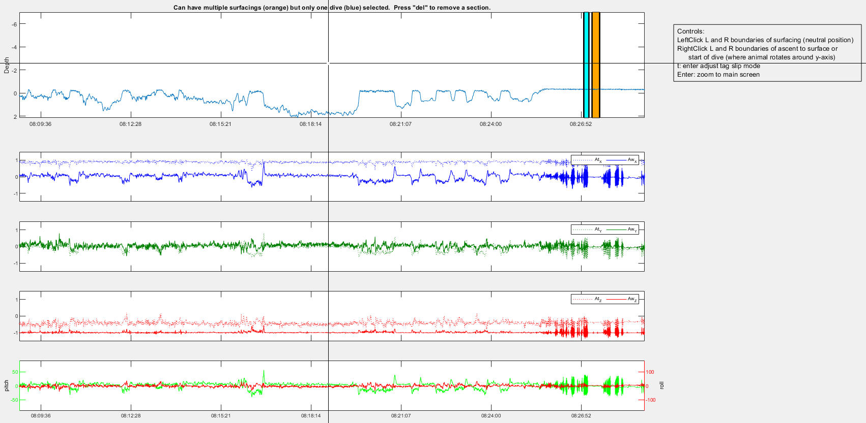

Follow instructions closely to avoid losing your work! Press enter 2X when finished, then wait. After all figures pop up, press Enter again to accept all calibrations.

Wait until “Section 8.2 done” visible and then can move on.

* + - * 1. At this point, you want to save your calibrated data (next step). Your Info MAT file generated by the CATS Toolbox should keep track of where you are so that you can go back and resume at Section 9 later.

### RPA Robotic Process Automation icon PNG and SVG Vector Free Download Save Calibrated & Processed Data

* 1. **Overview:** Processing Step 02.F After running up to Section 8b in CATS toolbox, you can return to 02_ProcessingMotionEnvSensors.m to save your processed data.
     1. **Script:**  02_ProcessingMotionEnvSensors.m Section 02.F
     2. **Input:** **Several MATLAB variables from previous step** 
     3. **Outputs:**
        1. **CSV: testNN_Nickname_02_Calibrated_Processed_MotionEnvSensors_5Hz_StartDate-StartTime.csv**
        2. **MAT file:**  **testNN_Nickname_02_Calibrated_Processed_MotionEnvSensors_5Hz_StartDate-StartTime.mat** 
        3. **EDF file**
           1. **With GUI:**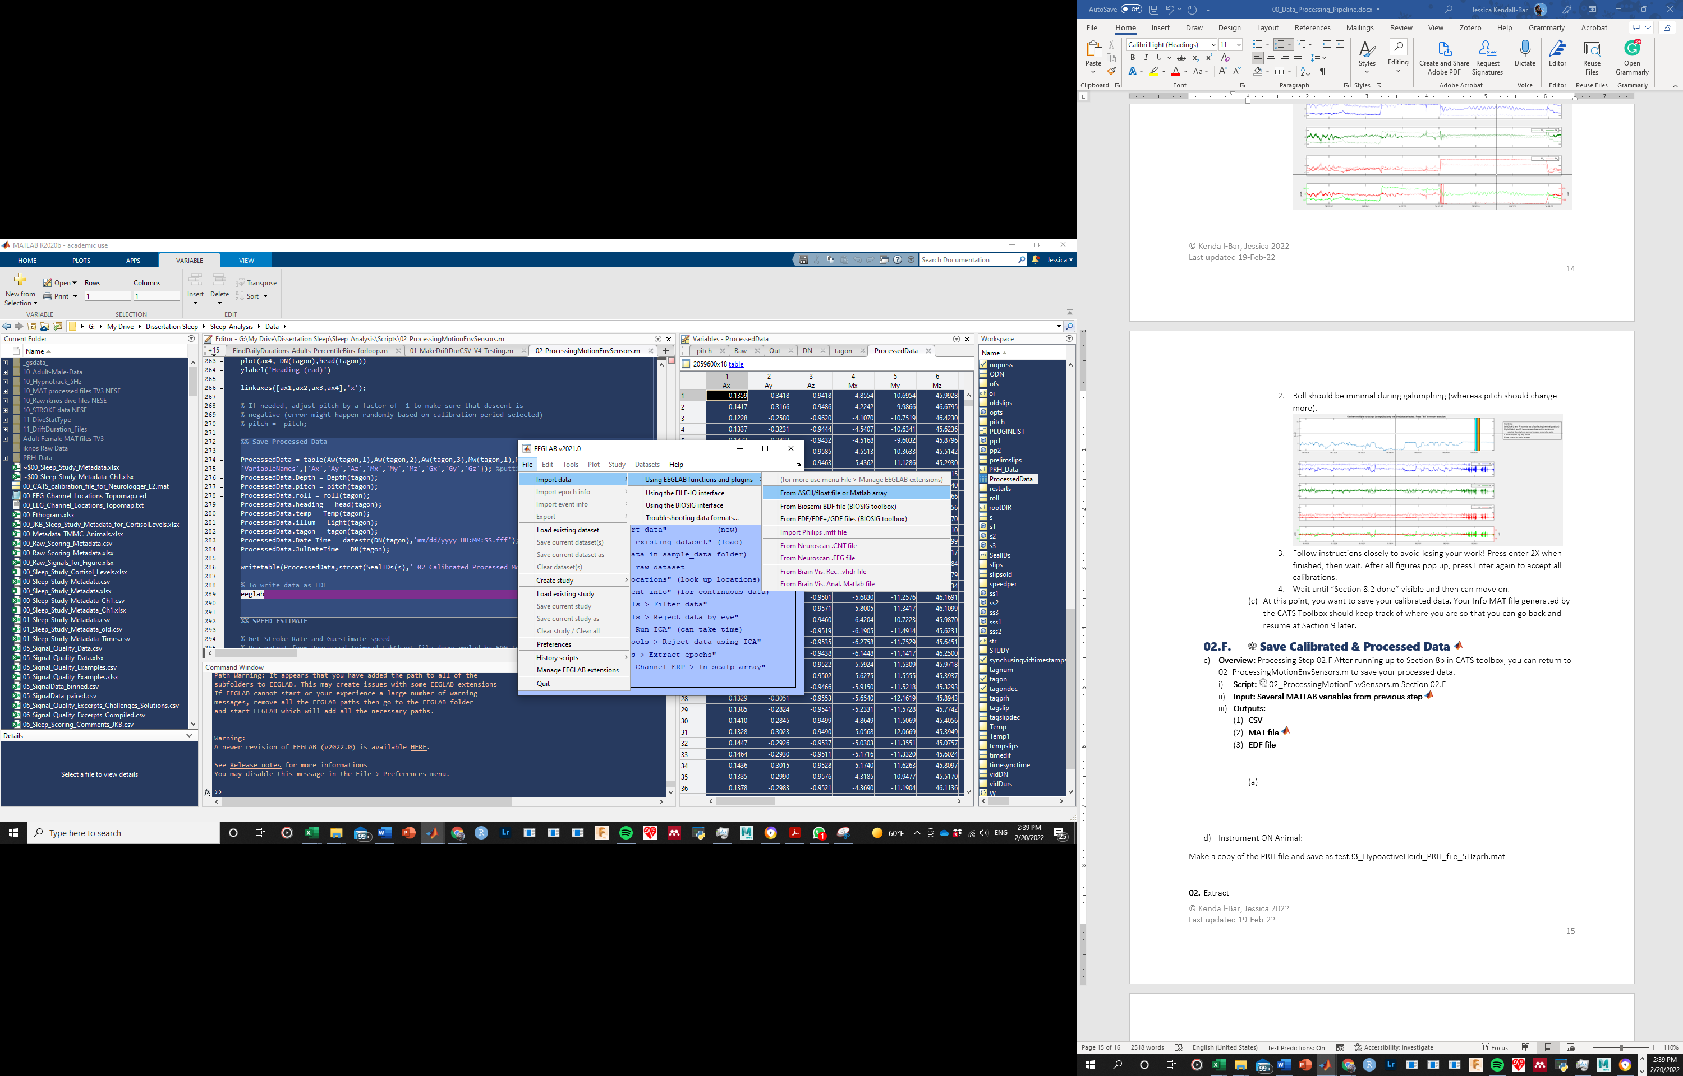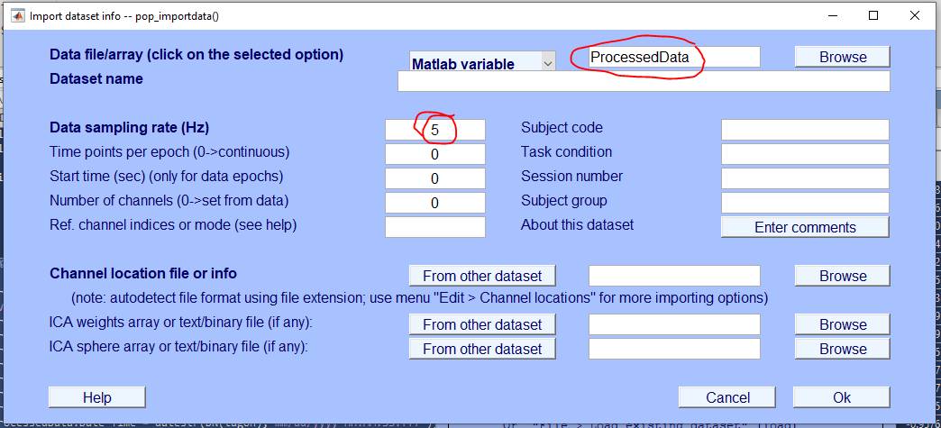
           2. **With command line** (example provided in-line)

### RPA Robotic Process Automation icon PNG and SVG Vector Free Download Glasses Icon | Line Iconset | IconsMind Pairing Motion & Video Data Microsoft Excel logo

### Video Data Synchronization Microsoft Excel logo



* 1. **Overview:** Processing Step 03.A After having scored the video data, find synchronization points to adjust time points (ideally 2 between each logger restart) to use so that video data aligns with motion data.
     1. **Script:**  None; manual.
     2. **Input/Reference:** 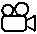 Video files & testNN_Nickname_00_VideoScoringData.csv
     3. **Outputs: 00_Video_SyncPoints.xlsx & 00_Video_SyncPoints.csv** See example spreadsheet below; after Restart 9 the animal entered the water 19 seconds later in the video than in the Logger Data.

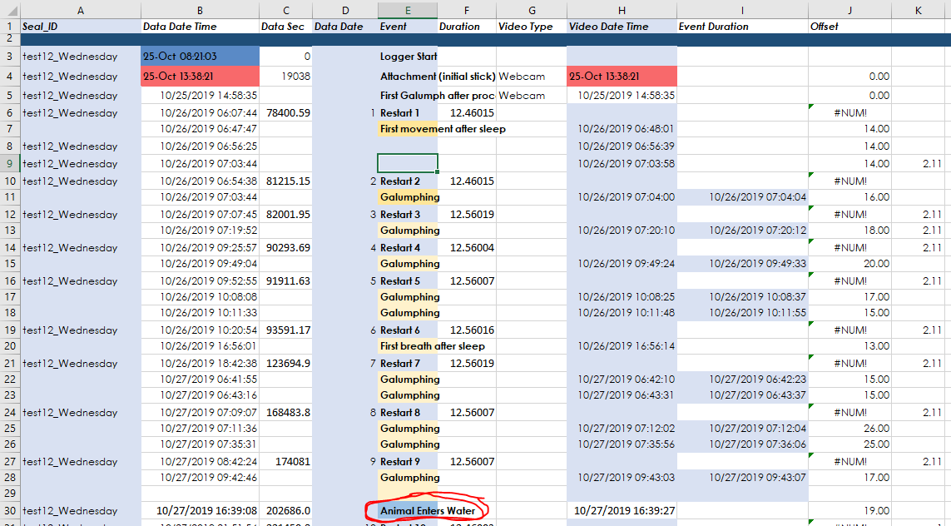

* + 1. Create a simplified version of the sheet above that will be used to align timestamps between each restart.  
       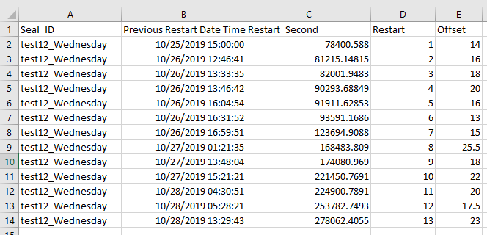  
       For example, this sheet means that, based on the two sync points (offset durations 17s & 19s) between Restart 9 and 10, the logger was OFF and not recording for an average of 18s (in addition to already added default ~12.5 second correction per restart).
    2. Save this simplified sheet as a .CSV to be used in R: **00_Video_SyncPoints.csv** 

### Pairing Video Data to Motion Data (& Sleep Data) RStudio logo



* 1. **Overview:** Processing Step 03.A After having scored the video data, find synchronization points to adjust time points (ideally 2 between each logger restart) to use so that video data aligns with motion data.
     1. **Script:**  03_Video_and_Motion.R 
     2. **Inputs:**  **00_Video_SyncPoints.csv** & **testNN_Nickname_00_VideoScoringData.csv**
     3. **Output:**  **testNN_Nickname_03_VideoMotionData_1Hz.csv & testNN_Nickname_03_VideoMotionData_25Hz.csv (to match Motion/Env Sensor frequency)**
  2. **What does the script do?** 
     1. **Loads seal metadata & critical timestamps**
     2. **Loads**  **00_Video_SyncPoints.csv** & **testNN_Nickname_00_VideoScoringData.csv**
     3. **Creates “Restart-ogram”** with a row for each seconds with the value that should be subtracted from the Video R.Time timestamp to align it to the motion data.
     4. **Aligns video & motion data** at full 25Hz resolution for Behavioral Automation (Step 04).
     5. **Group by 1s & 30s time-bins** to match with lower resolution or Sleep Scoring Data.

### RPA Robotic Process Automation icon PNG and SVG Vector Free Download Behavioral Scoring Automation

### Main Process



* 1. **Overview:** Processing Step 04.A: After pairing video and motion data, this labeled dataset can be used to train and test a machine learning algorithm.
     1. **Script:**  main_process.m (original written by Ding Zhang from University of Michigan)
     2. **Input:** Labeled dataset, for example: **testNN_Nickname_03_VideoMotionData_25Hz.csv**
     3. **Outputs:** Accuracy scores & confusion matrices- at some point : deployable model (in progress).
     4. **Note :** Model outputs and outcomes are stored in **00_Ethogram.xlsx**  
        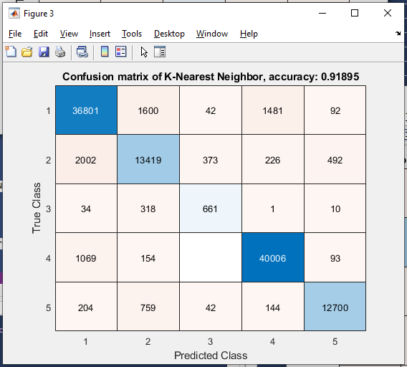

### RPA Robotic Process Automation icon PNG and SVG Vector Free Download Glasses Icon | Line Iconset | IconsMind ICA Processing for Electrophysiological Data

### RPA Robotic Process Automation icon PNG and SVG Vector Free Download Load data into EEGLAB

* 1. **Overview:** Processing Step 05.A: Opens EDF file Rearranged_ALL and only imports 9 electrophysiological channels
     1. **Script:**  ICA_Automation.m
     2. **Input:** ***testNN_Nickname_01_ALL_Rearranged.edf*** 
     3. **Outputs:** EEG variable through EEGLAB

### RPA Robotic Process Automation icon PNG and SVG Vector Free Download Subset data

* 1. **Overview:** Processing Step 05.B: subset your full EDF file into a short ~10 minute segment where (i) the animal is calm, (ii) the artifact you’d like to remove is apparent (for me: ECG signal), and (iii) there is an apparent signal of interest (for me: a clear change in underlying brain activity from waking to SWS to REM EEG activity).
     1. **Script:**  ICA_Automation.m
     2. **Input:** Dataset 1 : whole EDF file
     3. **Outputs:** Dataset 2 : subset EEG data for a segment of time underwater

### RPA Robotic Process Automation icon PNG and SVG Vector Free Download Run ICA

* 1. **Overview:** Processing Step 05.C: Run ICA on the subset of your data. Use the runica function in EEGLAB.
     1. **Script:**  ICA_Automation.m
     2. **Input:** Dataset 2 (subset for underwater)
     3. **Outputs:** something.

### Inspect & document results



* 1. **Overview:** Processing Step 05.D: Examine ICA outputs, save images and topomaps.
  2. **Plot topomaps: Loads in the channel locations here:**   
     Data > **00_EEG_Channel_Locations_Topomap.ced**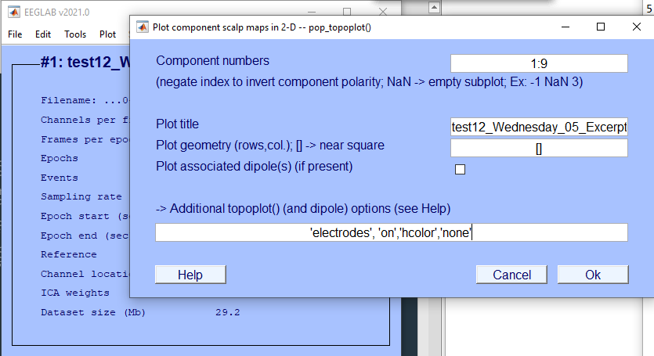

### Apply ICA weights to dataset



* 1. **Overview:** Processing Step 05.E: Apply ICA weights to the rest of the dataset.
  2. 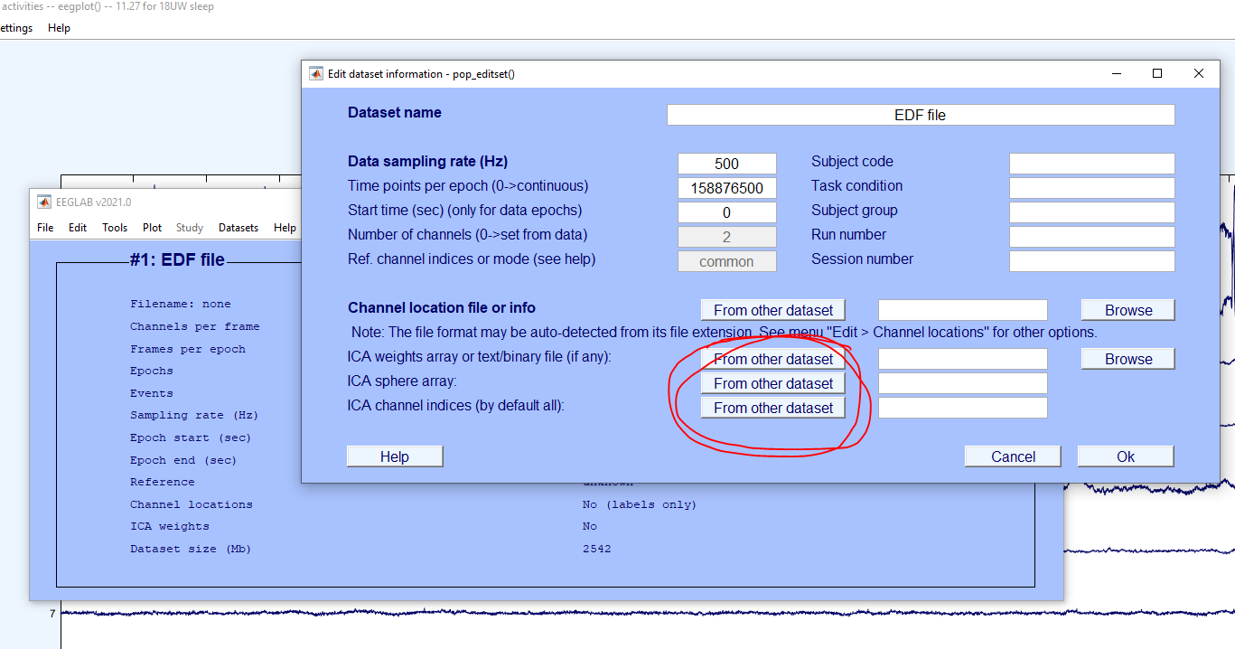

### RPA Robotic Process Automation icon PNG and SVG Vector Free Download Glasses Icon | Line Iconset | IconsMind Concatenate desired signals & Export EDF

* 1. Step 1: Open excerpt with ICA weights
  2. Step 2: Open EDF file Rearranged_ALL; only import 9 electrophys
  3. Step 3: Apply ICA weights in Edit Dataset – load from 1st dataset
  4. Step 4: Identify and save brain_ica_data = EEG.icaact(n,:);  
     where n = component with maximal brain activity
  5. Step 5: Identify and save heart_ica_data = EEG.icaact(n,:);  
     where n = component with maximal heart activity (in case better than raw ECG)
  6. Step 6: Save raw data raw_data = EEG.data;
  7. Prune data with 2 maximal HR artifact components
  8. Save pruned data pruned_data = vertcat(EEG.data(2,:), EEG.data(4,:), EEG.data(7,:), EEG.data(8,:)); for LEOG, LEMG, REEG2, LEEG3 (use best)
  9. Create variable megadata with all, read into EEGLAB as matlab variable at 500Hz and save as EDF file. Merge EDF file with motion/env sensors in EDF browser (or in matlab before write edf…)
  10. Column descriptions for resulting Processed Megadata file:
      + 1. **ECG_Raw_Ch1 :** raw heart rate data.
        2. **ECG_ICA2** : ICA component which maximally expressed heart signals. I think this may be worthwhile in recordings where the ECG raw signal is noisy, and we may be able to recover the heart beat from the artifact it leaves in the other channels, especially when the animal is in water.
        3. **LEOG_Pruned_Ch2** : LEOG channel with ICA components 1 and 2 removed (to get rid of the heart beat artifact).
        4. **LEMG_Pruned_Ch4** : LEMG channel with ICA components 1 and 2 removed.
        5. **REEG2_Pruned_Ch7** : REEG2 channel with ICA components 1 and 2 removed.
        6. **LEEG3_Pruned_Ch8** : LEEG3 channel with ICA components 1 and 2 removed.
        7. **REEG2_Raw_Ch7** : REEG2 channel for reference (may have heart beat artifact in water but not on land).
        8. **LEEG3_Raw_Ch8** : LEEG3 channel for reference (may have heart beat artifact in water but not on land).
        9. **EEG_ICA5** : ICA component 5 which, in this case, seemed to maximally express brain activity. In other words, you can use this channel to score sleep on land and in water. The signal amplitude of this channel is slightly lower than the pruned or raw EEG channels, but they should represent very similar patterns. Feel free to check this and let me know if you find inconsistencies.
        10. **Pitch** - the pitch of the animal (I believe this is positive 90 degrees for an animal pitched upward in the "Vertical Up" position)
        11. **Roll** - the roll of the animal (180 degrees would mean the animal is on its back, 90 degrees on one of her sides - can check axes conventions)
        12. **Heading** - the heading of the animal (compass heading of the animal from 0 to 180)
        13. **GyrZ** - the Z-axis of the gyroscope which captures angular acceleration around the Z axis
        14. **MagZ** - magnetometer/compass to compare to heading
        15. **ODBA** - overall dynamic body acceleration.
        16. **Pressure** - in meters of sea water
        17. **Heart Rate** - calculated with raw heart rate data currently (could also be based on #2 if helpful)
        18. **Stroke Rate** - calculated with gyroscope currently

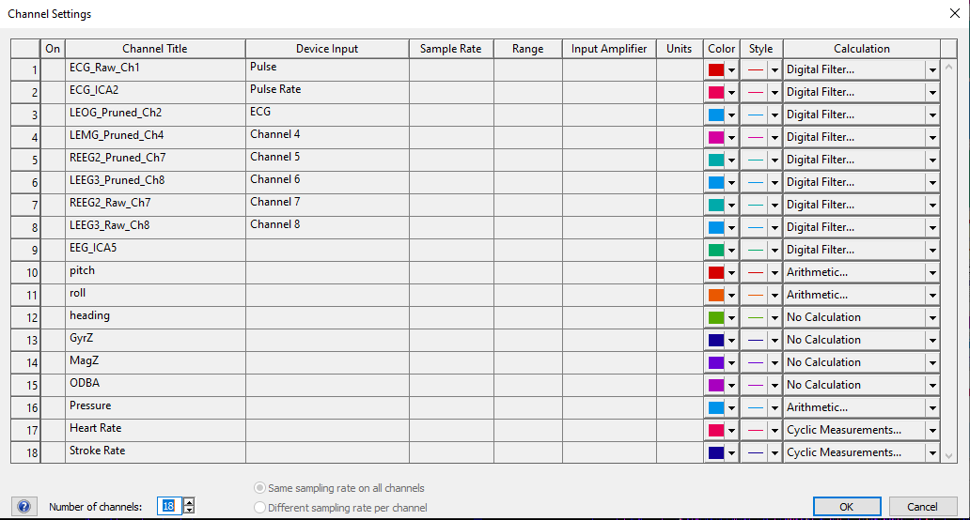

### Glasses Icon | Line Iconset | IconsMind Qualitative Sleep Scoring

### RPA Robotic Process Automation icon PNG and SVG Vector Free DownloadGlasses Icon | Line Iconset | IconsMind Load processed megadata

* 1. Overview: Processing Step 06.A: does this.
     1. **Script:** .adiset    ( None; manual)
     2. **Input:** testNN_Nickname_01_ALL_PROCESSED.adicht/ testNN_Nickname_01_ALL_PROCESSED_Trimmed.adicht
     3. **Outputs:** testNN_Nickname_01_ALL_PROCESSED_Trimmed_scored.adicht
        1. **Copy/paste comments from** PROCESSED_Trimmed_scoredLabChart file into Excel spreadsheet, insert:

Seal ID (testNN_Nickname)

Date_Time (dd/mm/yyyy hh:mm:ss)

Channel_clean (if Channel column shows * - input All; otherwise input whatever is written in Channel column)

Export as **06_Sleep_Scoring_Comments_Initials of the scorer.csv** for use in: **06_Hypnograms.R** in Processing Step 06.

### Glasses Icon | Line Iconset | IconsMind Identify scorable segments

* 1. **Identify unscorable segments** in the data that are contaminated with artifacts:
     1. **Sleep State Scorable**: Place comment when the sleep state becomes scorable: at the beginning of the recording once artifact-free brain signals are present AND whenever an unscorable section ends (see below).
     2. **Sleep State Unscorable**: Place comment when the sleep state becomes unscorable: when the animal is calm, but it is impossible to tell whether the animal is asleep or not due to artifacts in the signal.
     3. **Heart Patterns Scorable**: Place comment when the heart rate patterns become scorable: at the beginning of the recording AND whenever an unscorable section ends (see below).
     4. **Heart Patterns Unscorable**: Place comment when the heart rate patterns become unscorable: when there is too much error in the peak detection due to artifact to see when a period of eupnea or apnea begins.

### Glasses Icon | Line Iconset | IconsMind Score Heart Rate (HR) Patterns

* 1. **Score Heart Rate (HR) Patterns**: Be sure to maintain the order in which the following four comments are placed in an apnea-eupnea cycle, for this is critical for the hypnogram generation step. (Add these comments only to the HR channel)
     1. **Anticipatory HR Increase:** Place comment at the start of the gradual increase to tachycardia during eupnea.
     2. **First Breath**: Place comment at the first breath detected by accelerometer channel (or if obvious in HR channel). Sometimes the gyroscope channel or the overall dynamic body acceleration (ODBA) channel also pick up distinct breathing peaks. The amplitude of these peaks is lesser than those caused due to gross movement. Compare with neighboring segments having movement-related activity before scoring using gyroscope or ODBA channel.
     3. **Last Breath:** Place comment at the last breath detected by accelerometer channel (or if obvious in HR channel).
     4. **Start Apnea:** Place comment at the start of the low, bradycardic heart rate.

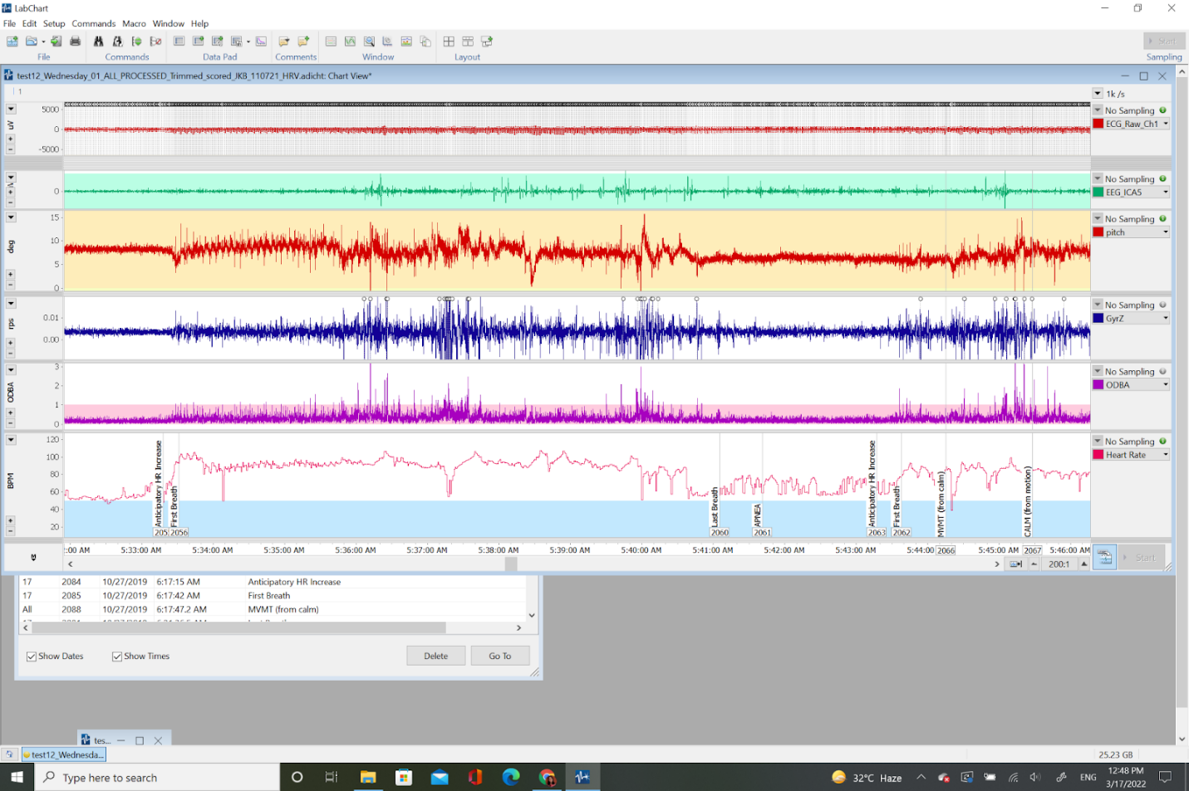

### Glasses Icon | Line Iconset | IconsMind Score Sleep Patterns

* 1. **Score Sleep Patterns** by placing comments at points of transition from one sleep state to another. Here pick an epoch size based on the minimum convenient duration of an individual scorable/quantifiable sleep stage.  (Add these comments to ALL channels)
     1. **CALM (from motion):** Place comment at a transition from movement to calm (and at the beginning of the recording).
     2. **LS (light sleep)/Drowsiness:** Place comment at a transition from waking to light sleep, where there are oscillations with 10s periods of high amplitude slow waves followed by ~10s of low amplitude waking activity- primarily in the 1-7Hz frequency band.
     3. **SWS:** Place comment at a transition from waking or light sleep to slow wave sleep 1 or 2 depending on the amount of maximal amplitude slow waves in the segment.
        1. **SWS1:** Place comment at a transition from waking or light sleep to slow wave sleep 1 when continuous high amplitude, low frequency EEG (0.5-4Hz) waves are seen. The amplitude is nearly 2-fold as compared to waking or REM parameters, but the waves of maximal amplitude (when compared to neighboring sleep cycles) do not occupy >50% of the epoch. Sleep spindles often mark the transition to SWS1. K-complexes are also seen.
        2. **SWS2:** Place comment at a transition from waking, light sleep or SWS1 to slow wave sleep 2 when continuous high amplitude, low frequency EEG (0.5-4Hz) of maximal amplitude occupies >50% of the epoch duration. No sleep spindles or K-complexes are seen.
           1. **Note:** SWS1 often precedes SWS2 (especially if the spectrogram shows a crescendo-shaped slug.)
     4. **REM:** Place comment at a transition from slow wave sleep (or waking if SURE) to REM sleep 1 or 2 depending on extent of accompanying HR variability. REM1 and/or REM2 may also coincide with eye movements and low EMG activity.
        1. **REM1 (Putative REM):**  Place comment at a transition from slow wave sleep (or waking IF SURE) to REM1 when low amplitude, high frequency EEG activity with low HR variability during apnea is seen.
        2. **REM2 (Certain REM):** Place comment at a transition from slow wave sleep (or waking IF SURE) to REM2 if low amplitude, high frequency EEG activity with high, low frequency HR variability during apnea is seen.
     5. **WAKE (from sleep):** Place comment at a transition from sleep (light sleep, slow wave sleep, or REM sleep) to waking activity, where low frequency brain activity coincides with lower and higher frequency oscillations in heart rate or large oscillations in heart rate which are directly linked to respiratory patterns.
     6. **JOLT (from sleep):** Place comment at a transition from sleep (light sleep, slow wave sleep, or REM sleep) to motion artifacts (active waking). If the arousal does not cause a change in sleep state, the animal may go directly back into the previous state.
     7. **MVMT (from calm):** Place comment at a transition from calm or waking to movement with the presence of motion artifacts.

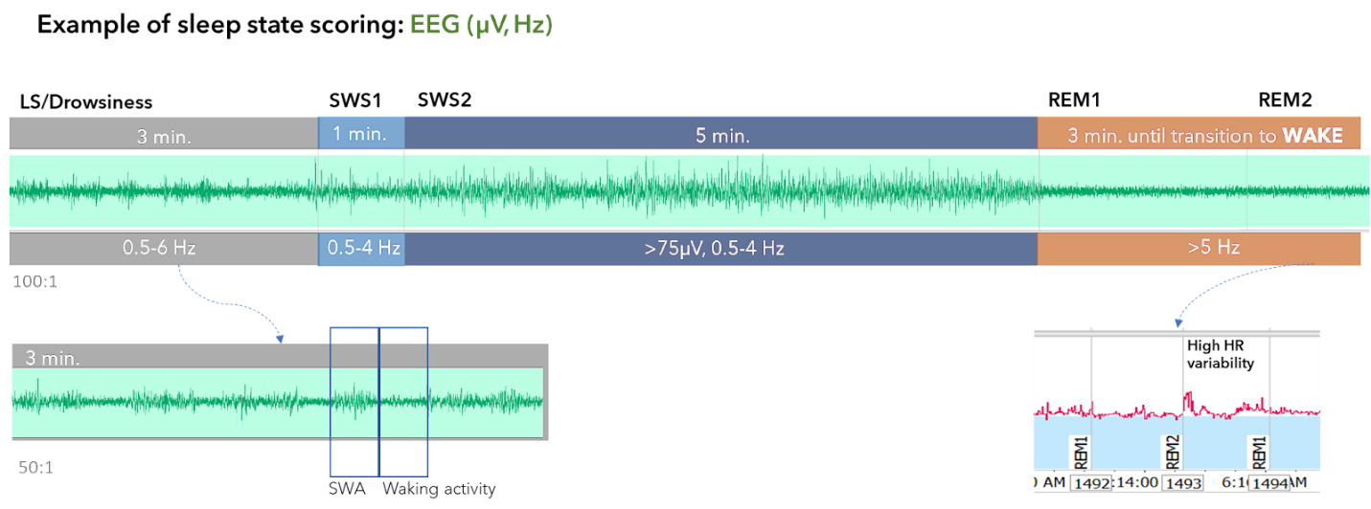

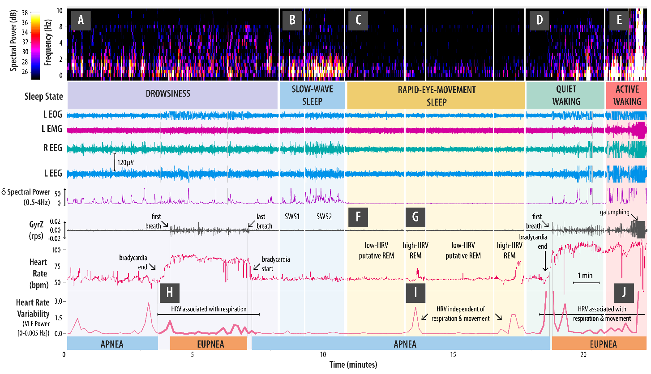

|  |  |  |  |
| --- | --- | --- | --- |
| ***Sleep Scoring Guide*** | | | |
| Steps for scoring sleep (do these in the order provided). | | | |
|  |  |  |  |
| ***Shortcut*** | ***Comment Text*** | ***Channel*** | ***Description*** |
| **1. INSTRUMENT ATTACHMENT** | | | |
| **Alt+1** | Instrument ON Animal | ECG | Place comment where **ECG trace begins** because electrodes have just been attached to animal |
| **Alt+2** | Instrument OFF Animal | ECG | Place comment where **ECG trace ends** because electrodes have just been removed from animal |
| **2. IS THE ANIMAL IN THE WATER?** | | | |
| **Alt+3** | Animal Enters Water | Pressure | Place comment when the **pressure sensor goes from -0.1 to a higher value.** Also will be accompanied by a change in accelerometer signals from mostly flat to lots of up and down. |
| **Alt+4** | Animal Exits Water | Pressure | Place comment if **(A) pressure sensor returns to -0.1 AND (B) accelerometer trace returns to on-land patterns** (mostly flat in between galumphing, as opposed to constant motion in shallow water). |
| **3. IS THE SLEEP DATA SCORABLE?** | | | |
| **Alt+{** | Sleep State Scorable | All | Place comment when the **sleep state becomes scorable:** at the beginning of the recording once artifact-free brain signals are present AND whenever an unscorable section ends (see below). |
| **Alt+}** | Sleep State Unscorable | All | Place comment when the **sleep state becomes unscorable:** when the animal is calm, but it is impossible to tell whether the animal is asleep or not due to artifacts in the signal. |
| **4. FIND SECTIONS OF DATA TO USE IN INDEPENDENT COMPONENT ANALYSIS (OPTIONAL)** | | | |
| **Shift+<** | Begin Calm in Water | Pressure | Place comment where **underwater data is clean, the animal stops stroking, and is not moving** (from accel/pressure) to send to ICA for analysis. |
| **Shift+>** | End Calm in Water | Pressure | Place comment at the **end of a section** where the animal has been calm according to criteria above. |
| **5. IS THE HEART RATE DATA SCORABLE?** | | | |
| **Shift+{** | Heart Patterns Scorable | HR | Place comment when the **heart rate patterns become scorable:** at the beginning of the recording AND whenever an unscorable section ends (see below). |
| **Shift+}** | Heart Patterns Unscorable | HR | Place comment when the **heart rate patterns become unscorable:** when there is too much error in the peak detection due to artifact to see when a period of eupnea or apnea begins. |
| **6. SCORE HEART RATE PATTERNS** | | | |
| **Alt+B** | ***Anticipatory HR Increase*** | HR | Place comment at the **start of the gradual increase to tachycardia** during eupnea. |
| **Alt+F** | ***First Breath*** | HR | Place comment at the **first breath detected** by accelerometer channel (or if obvious in HR channel). |
| **Alt+L** | ***Last Breath*** | HR | Place comment at the **last breath detected** by accelerometer channel (or if obvious in HR channel). |
| **Alt+A** | ***Start Apnea*** | HR | Place comment at the **start of the low, bradycardic heart rate** |
| **7. SCORE SLEEP PATTERNS** | | | |
| **Alt+C** | ***CALM (from motion)*** | All | Place comment at a transition **from movement to calm** (and at the beginning of the recording). |
| **Alt+I** | ***LS (light sleep)*** | All | Place comment at a transition **from waking to light sleep,** where there are oscillations with 10s periods of high amplitude slow waves followed by ~10s of low amplitude waking activity- primarily in 1-7Hz frequency band. |
| **Alt+S** | ***SWS*** | All | Place comment at a transition **from waking or light sleep to slow wave sleep:** continuous high amplitude slow waves- primarily in the 0.5-4Hz frequency band. |
| **Alt+R** | ***REM*** | All | Place comment at a transition **from slow wave sleep (or waking if SURE) to REM sleep** where low voltage electrical activity coincides with **high power, low freqency (0.1Hz) irregular oscillations in heart rate.** May also coincide with eye movements and low EMG activity. |
| **Alt+W** | ***WAKE (from sleep)*** | All | Place comment at a transition **from sleep (light sleep, slow wave sleep, or REM sleep) to waking activity,** where low frequency brain activity coincides with lower and higher frequency oscillations in heart rate or large oscillations in heart rate which are directly linked to respiratory patterns. |
| **Alt+J** | ***JOLT (from sleep)*** | All | Place comment at a transition **from sleep (light sleep, slow wave sleep, or REM sleep) to motion artifacts (active waking).** If the arousal does not cause a change in sleep state, the animal may go directly back into the previous state. |
| **Alt+M** | ***MVMT (from calm)*** | All | Place comment at a transition **from calm or waking to movement** with the presence of motion artifacts. |

### Generate Hypnograms & Quantitative Sleep Scoring RStudio logo



### RPA Robotic Process Automation icon PNG and SVG Vector Free DownloadGlasses Icon | Line Iconset | IconsMind Load processed megadata

* 1. **Overview:** Processing Step 06.A: does this.
     1. **Script:**  07_Hypnograms.R 
     2. **Input:** something.
     3. **Outputs:** something.

### Glasses Icon | Line Iconset | IconsMind 3D Track Generation RStudio logo ArcGIS logo



### RPA Robotic Process Automation icon PNG and SVG Vector Free DownloadGlasses Icon | Line Iconset | IconsMind Export Rates & Power from LabChart

* 1. **Overview:** Export 1Hz data on Heart Rate, Stroke Rate, and Delta EEG Power (L & R) data exported from LabChart.
     1. **Script:**  None; manual.
     2. **Input:** **testNN_Nickname_05_ALL_PROCESSED_Trimmed.**adicht
     3. **Output: testNN_Nickname_06_ALL_PROCESSED_Trimmed_withRATES_POWER.txt** Exported LabChart Text File (downsampled 500X from original) 
  2. **Verify ‘Heart_Rate’ & ‘Stroke_Rate’ channels are properly named (after ‘Pressure’)**
  3. **Create new channels:** 
     1. **L_EEG_Delta** (best L EEG channel spectral power calculation between 4 Hz & 0.5Hz)
     2. **R_EEG_Delta** (best R EEG channel spectral power calculation between 4 Hz & 0.5Hz)
     3. **HR_VLF_Power** (spectral power calculation between 0.005 Hz & 0 Hz)

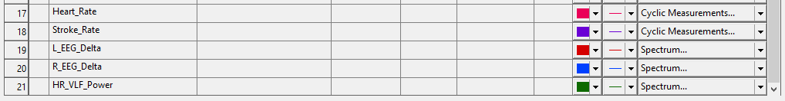

* + 1. **HR_VLF_Power** Spectrum settings:  
       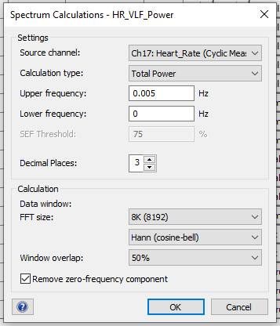
    2. **EEG_Delta** Spectrum settings:   
       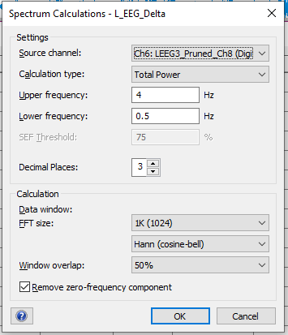
  1. **Export as LabChart text file with these settings (will save first column as Time of day in seconds):  
     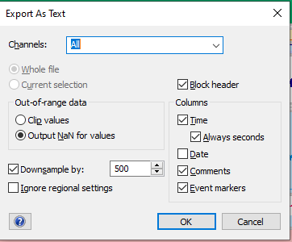**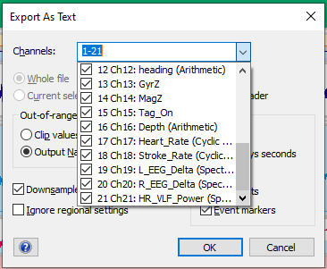

### RPA Robotic Process Automation icon PNG and SVG Vector Free DownloadGlasses Icon | Line Iconset | IconsMind Export LabChart Calculations

* 1. Open data pad
  2. Delete all existing information from data pad
  3. Make sure that the best EEG channel is chosen for the EEG analysis
  4. Make the following changes/additions in Columns X, Y, Z

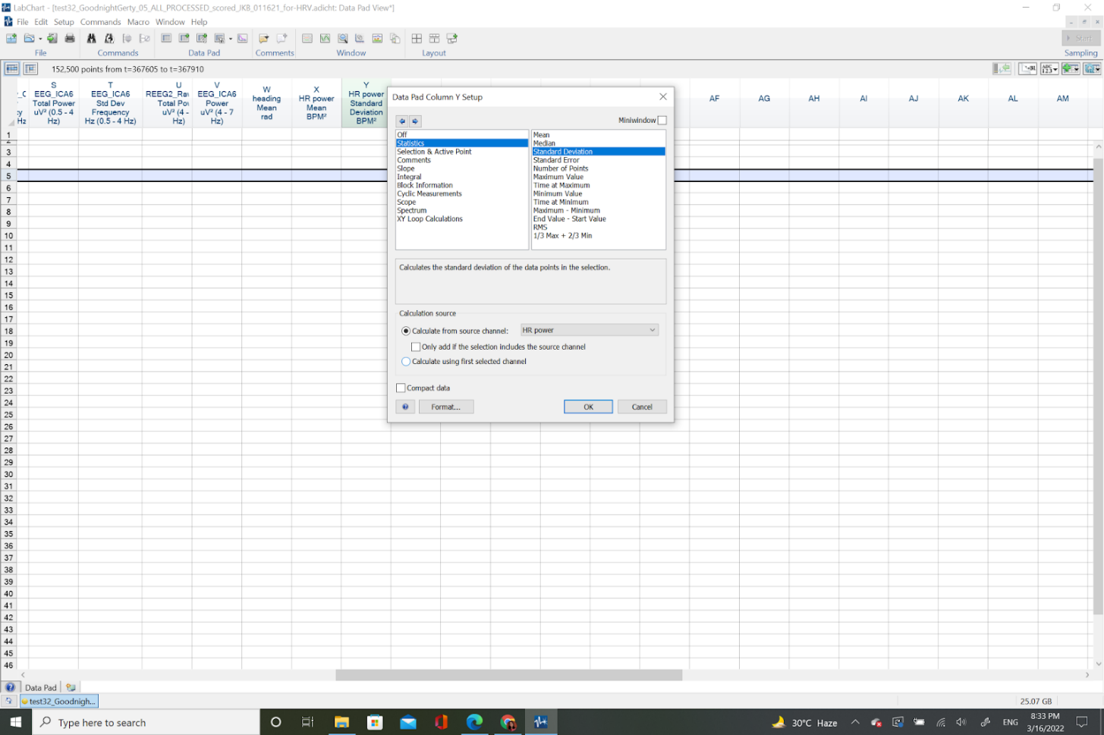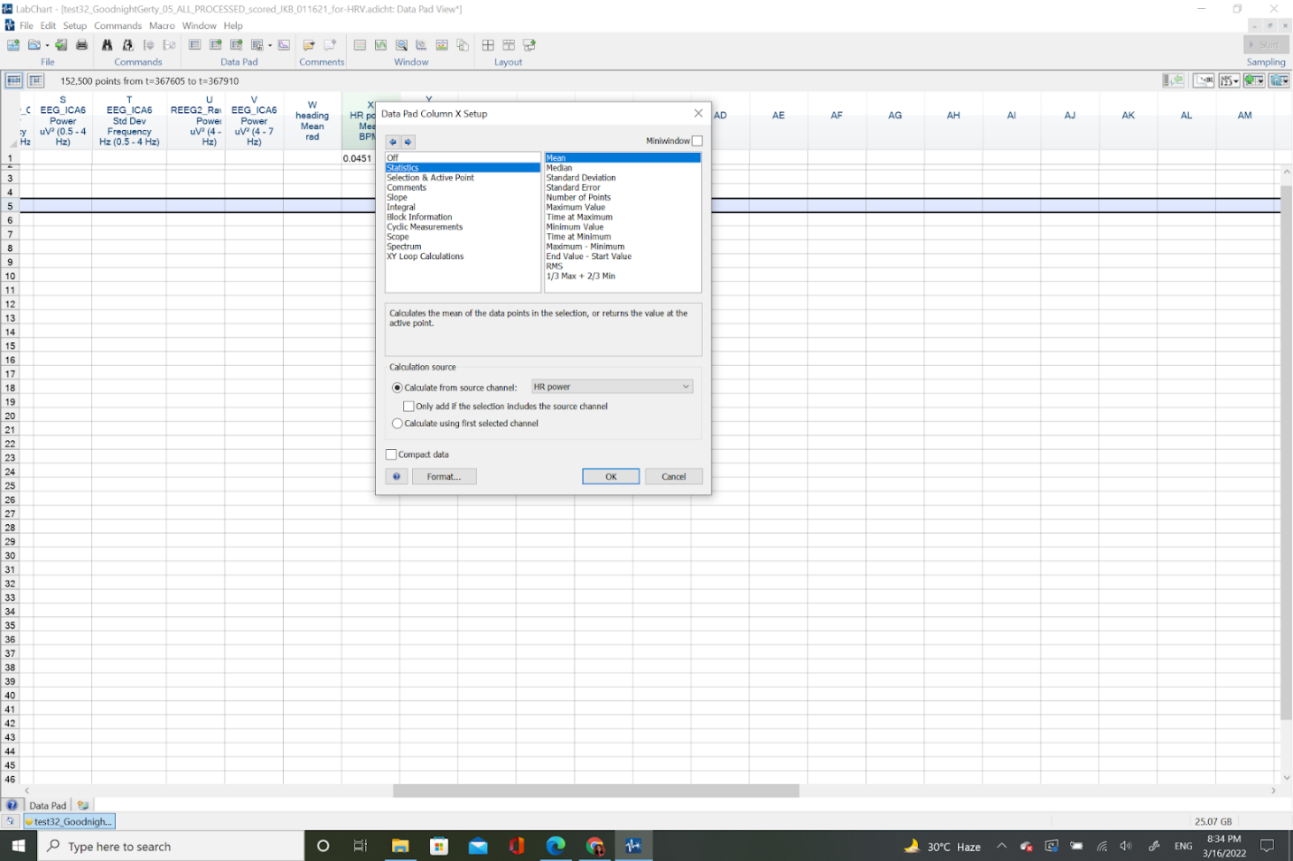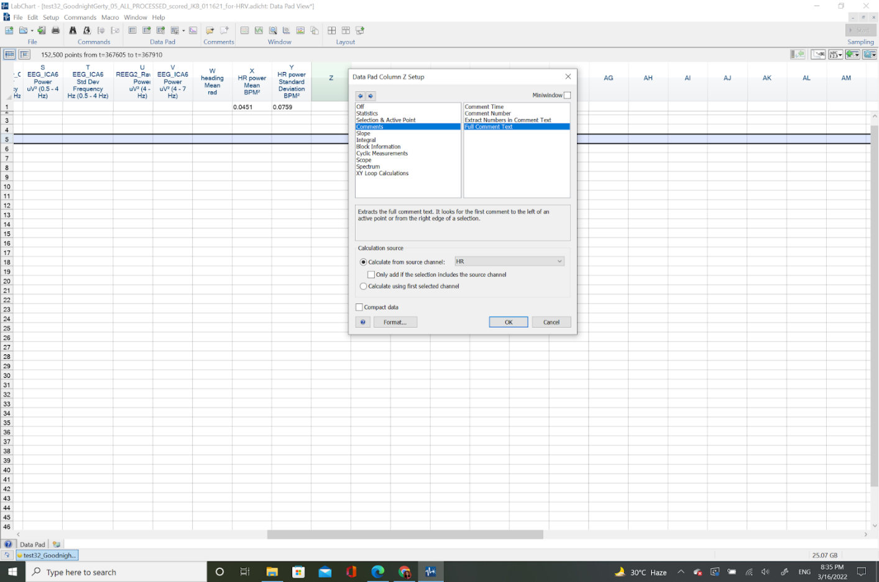

* 1. Change the Time Mode (by right-clicking in the timeline on the bottom of the Chart View in LabChart) to **“Show as time of day”** and **uncheck** Show time as seconds.

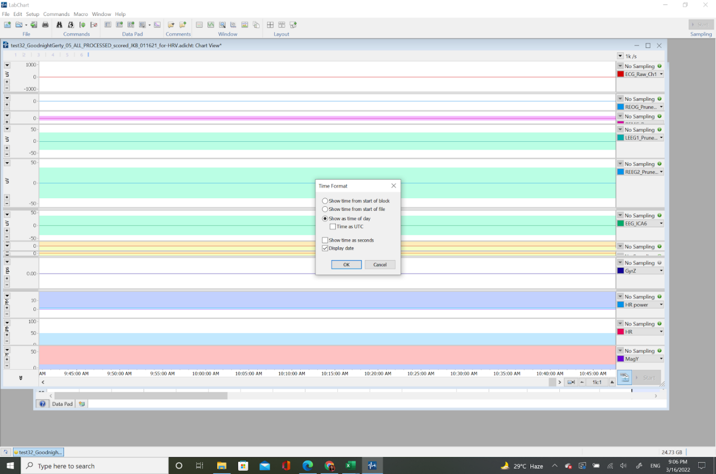

* 1. Click on **Multiple Add to Data Pad** keeping the following settings –

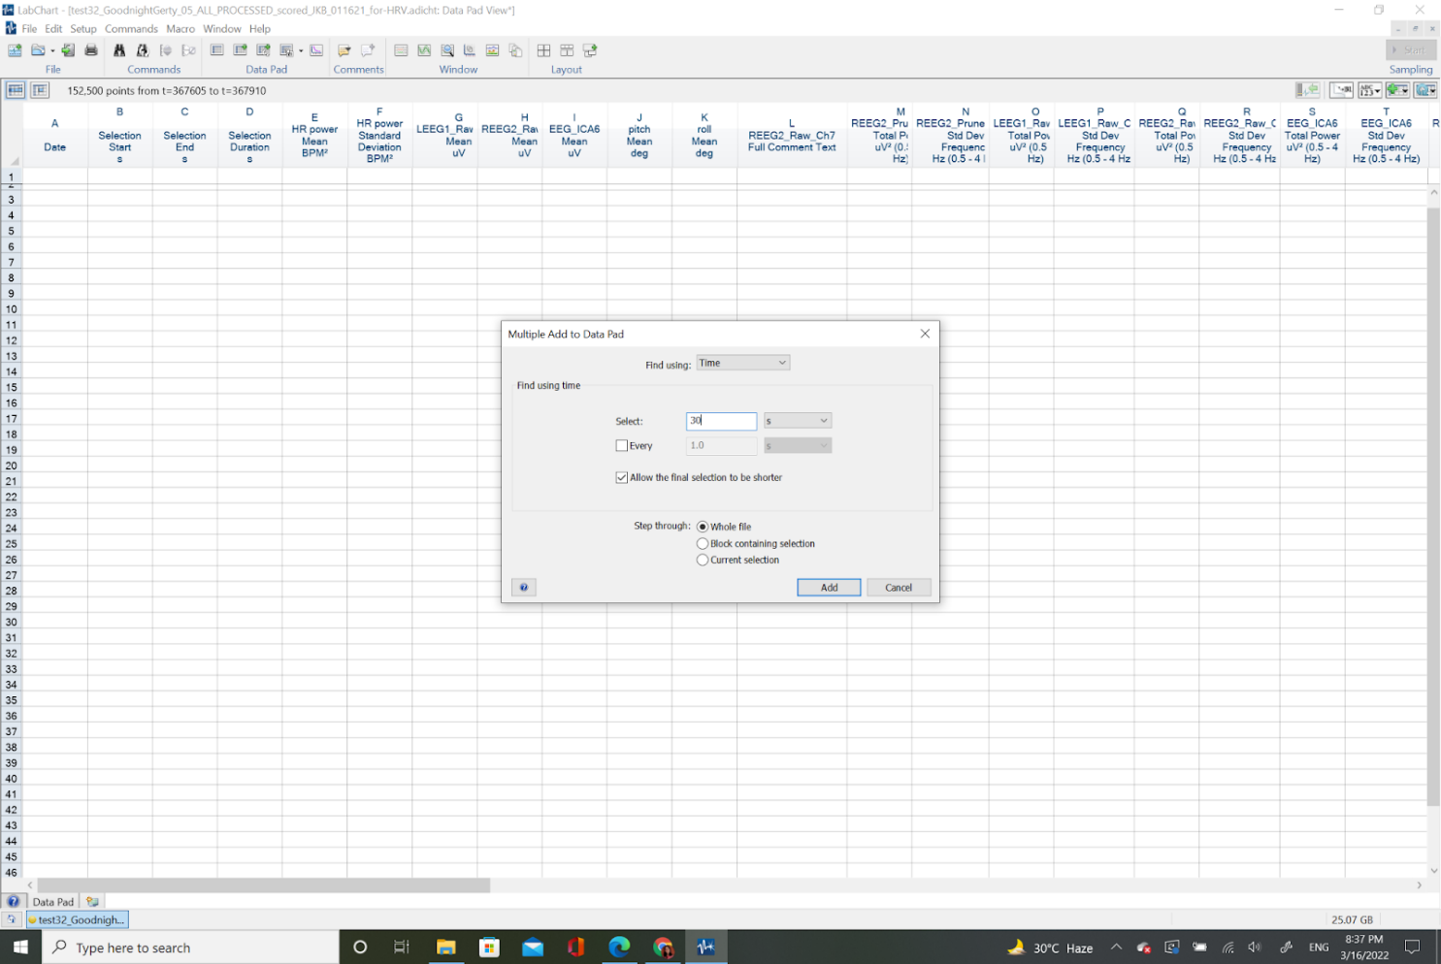

* 1. Wait while it generates the data
  2. Copy paste all generated data onto a blank Excel file
  3. Add columns for Seal_ID and Date_Time, format timestamps to ‘mm/dd/yyyy hh:mm:ss’
  4. Save your data as:

### RPA Robotic Process Automation icon PNG and SVG Vector Free Download Estimate speed from processed data

* 1. **Overview:** Use Processing Step 08.B in **08_Speed-Estimation.m**  to estimate speed manually using 1Hz Stroke Rate data exported from LabChart and pitch, roll, heading.
     1. **Script:**  **08_Speed_Estimation.m** 
     2. **Input:** **testNN_Nickname_06_ALL_PROCESSED_Trimmed_withRATES_POWER.txt** Exported LabChart Text File (downsampled 500X from original) 
     3. **Outputs:** Speed vector to be used in CATS Processing
  2. Instructions:

### RPA Robotic Process Automation icon PNG and SVG Vector Free Download Return to CATS Processing for 3D

* 1. **Overview:** Processing Step 02.H Return to Section 9 in CATS toolbox (should be able to re-import ‘…truncate.mat’ file and it will recognize your progress based on the ‘…Info.mat’ file.
     1. **Script:**  **MainCATSprhTool_JKB.m**
     2. **Input:** Previous PRH .mat file, additional manual speed variable, and GPS hits spreadsheet 
     3. **Outputs:** Pseudotrack & Geo-referenced pseudotrack based on speed estimates

### Review track generation ArcGIS logo



* 1. **Overview:** Manual inspection of the generated tracks in ArcGIS and/or Matlab. Remove and/or adjust inaccurate GPS points (making notes of any manipulation/justification in the “Notes” column).
     1. **Script:**  **MainCATSprhTool_JKB.m**  **& Review in Google Maps or ArcGIS**
     2. **Input:** testNN_Nickname_GPShits.xlsx  & testNN_Nickname_08_5HzgeoPtrackLatLong.csv 
     3. **Outputs:** testNN_Nickname_GPShits**_UserModified**.xlsx 
  2. **Instructions:**
     1. Open generated track **testNN_Nickname_08_5HzgeoPtrackLatLong.csv** in ArcGIS Pro (drag & drop CSV into Contents panel).
     2. Convert **XY Point Data**:   
        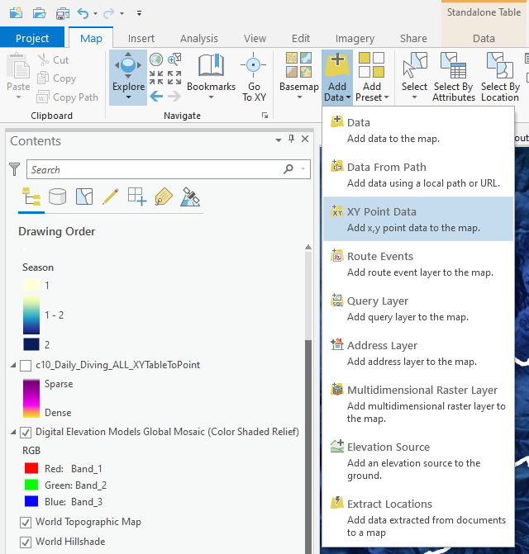
     3. **Drag & drop geoPtrack CSV** from Contents panel to “Input Table” field.   
        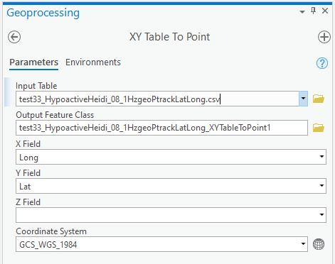
     4. Press “Run”
     5. Click on a point to see what time it was recorded at. Use ArcGIS or Google Maps to re-associate that point in time to a more accurate GPS point based on animal observations or landmasses (nearest coastal interface for inland points).

### RPA Robotic Process Automation icon PNG and SVG Vector Free Download Rerun with corrected GPS points

* 1. **Overview:** Re-run section 13b and import corrected GPS points to re-generate track.
     1. **Script:**  **MainCATSprhTool_JKB.m**
     2. **Input:** Previous PRH .mat file, additional manual speed variable, and corrected GPS hits spreadsheet: testNN_Nickname_GPShits**_UserModified**.xlsx 
     3. **Outputs: testNN_Nickname_08_5HzgeoPtrackLatLong_manualspeed_manualGPScorrection.csv** 

Pseudotrack & Geo-referenced pseudotrack based on speed estimates

### RPA Robotic Process Automation icon PNG and SVG Vector Free DownloadGlasses Icon | Line Iconset | IconsMind Hypnotrack Visualizations RStudio logo ArcGIS logo

### RPA Robotic Process Automation icon PNG and SVG Vector Free Download Generate Hypnotrack

* 1. **Overview:** Processing Step 09.A; After generating a pseudotrack and geo-referenced pseudotrack, you are ready to link sleep and motion data to a 3D track to visualize and interpret.
     1. **Script:**  **09_Hypnotracks.m**
     2. **Inputs:**
        1. **Motion Data:** testNN_Nickname_08_PRH_file_5Hzprh.mat
        2. **Hypnogram:** testNN_Nickname_06_Hypnogram_JKB_5Hz.csv
        3. LatLongs:
        4. Ptrack & geoPtrack variables from CATS Processing 
     3. **Outputs:** CSV with Ptrack & geoPtrack variables to be matched with hypnogram data later on.
        1. **Rename output:** testNN_Nickname_1HzgeoPtrackLatLong_manualspeed_manualGPScorrection.csv
           1. Rename with ‘_manualspeed’ if speed was calculated based on stroke rate manually.
           2. Rename with ‘_manualGPScorrection’ if GPS positions were checked and eliminated or adjusted to fit the contour of the coast manually
        2. **Rename output:**
           1. Make copy of prh mat file and rename: “testNN_Nickname_08_PRH_file_5Hzprh.mat”

### RPA Robotic Process Automation icon PNG and SVG Vector Free DownloadGlasses Icon | Line Iconset | IconsMind 3D Sleep Maps in ArcGIS ArcGIS logo

* 1. **Overview:** Import CSV; transform XY table to Point (with Z field = Depth); style based on categorical sleep variable; enable time and export as 3D animation if desired.
     1. **Script:** none; manual.
     2. **Input:** 1Hz hypnotrack file.
     3. **Outputs:** 3D maps (pngs).

### RPA Robotic Process Automation icon PNG and SVG Vector Free DownloadGlasses Icon | Line Iconset | IconsMind 3D Sleep Animations in Maya yt3.ggpht.com/ytc/AKedOLRdV5MlSLrSmsfaXoLAREOkH...

* 1. **Overview:** Follow [Visualizing Life in the Deep animation/visualization pipeline](https://github.com/jmkendallbar/VisualizingLifeintheDeep) to visualize underwater behavior and physiology.
     1. **Scripts:** Github repository: <https://github.com/jmkendallbar/VisualizingLifeintheDeep>
     2. **Input:** 25Hz, 5Hz, and 1Hz hypnotrack data.
     3. **Outputs:** 3D animations (mp4s).

### Data Aggregation & Standardization



### RPA Robotic Process Automation icon PNG and SVG Vector Free DownloadGlasses Icon | Line Iconset | IconsMind Generate standardized raw files

* 1. **Overview:** Create standardized raw data files for kami kami and stroke raw data to be used in Costa lab elephant seal dive analysis pipeline.
     1. **Script:**  ***10_Merge-Stroke-Kami-Data.m*** 
     2. **Input:** raw Kami & Stroke text files
     3. **Outputs:** Raw data CSVs to be used in our dive analysis pipeline.

### Restimates: quantifying measures of behavioral sleep



* 1. **Overview:** Estimate sleep time for northern elephant seals based on behavioral estimates of rest (cessation of stroking and flattening of vertical speed).
     1. **Script:**  ***11_Restimates.m*** 
     2. **Inputs:** MAT files, raw CSV dive data for Sleep, Kami/Stroke, or TDR-only recordings.
     3. **Outputs:** Behavioral Restimates! Images & CSVs:

### RPA Robotic Process Automation icon PNG and SVG Vector Free Download Load Data

* 1. **Overview:**
     1. Loads in and previews data.
     2. **Loads** in and previews EEG data
     3. **Check timestamps** are continuous
     4. **Down-samples 1Hz data** to sampling interval = 10s.
     5. **Standardize resolution** of pressure sensor (ours is more sensitive than typical depth sensors used in adult female deployments, so we rounded to the nearest meter)
  2. **Inputs:** MAT files, raw CSV dive data for Sleep, Kami/Stroke, or TDR-only recordings.
     + 1. ***Sleep Data:****SealID_09_sleep_raw_data_Hypnotrack_JKB_1Hz.csv*  *(SealID: testNN_Nickname)*
       2. ***Stroke Data:****SealID_stroke_raw_data.csv*  *(SealID example: 2012-PM_X106 post-molt trip)*
       3. ***Dive Data:*** *SealID_iknos_raw_data.csv (SealID example: varied)*
     1. **Outputs:** Preview images & NewRaw 

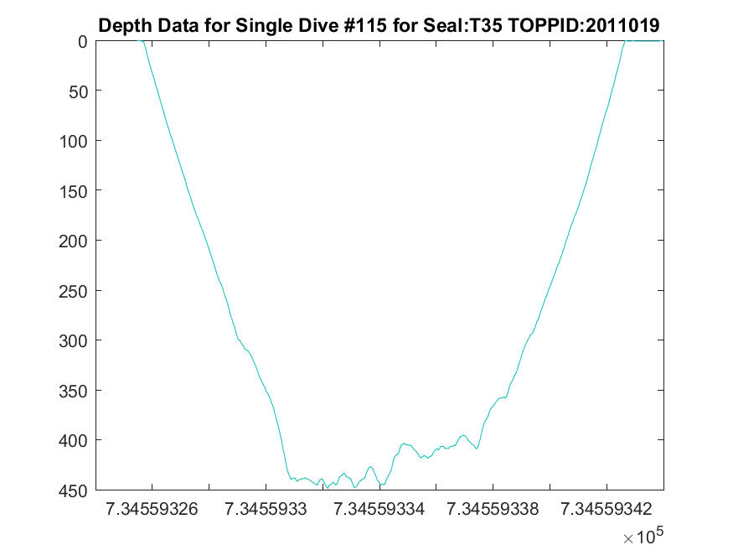 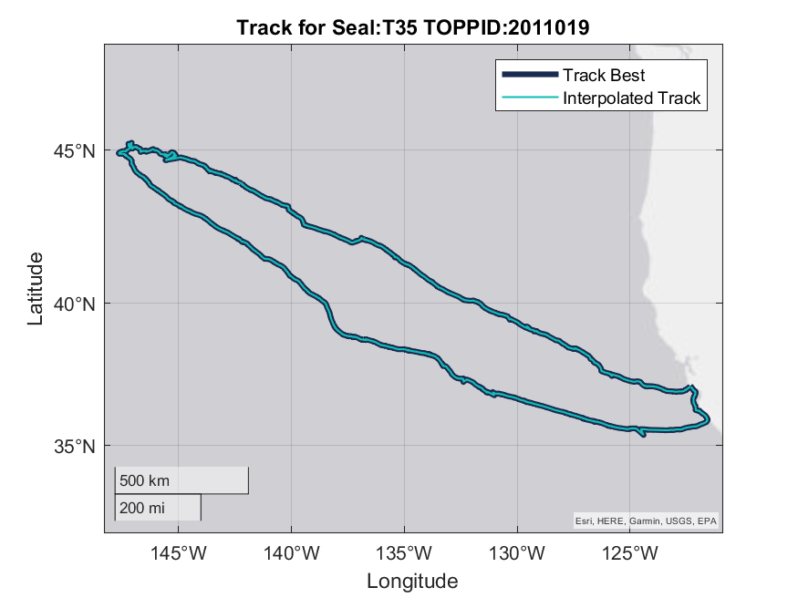

### RPA Robotic Process Automation icon PNG and SVG Vector Free Download Process Depth Data

### **Depth Correction**

* + 1. **Overview:** Corrects depth data for uncorrected Stroke data, other dive data is already zero-offset corrected using IKNOS dive analysis package.
       1. Find surface intervals:
          1. Look for consecutive sections where the first derivative < 0.1 m/s
          2. Filter out chunks where median depth is more than 40 (finds likely surface intervals)
       2. Place this depth recorded during shallow flat chunks in NewRaw.DepthCorrection in the original dataset.
       3. Use this depth correction to adjust depth values.
    2. **Inputs:** Uncorrected StrokeRaw.CorrectedDepth 
    3. **Outputs:** Corrected StrokeRaw.CorrectedDepth 
    4. **Instructions:** If you like the depth correction, run the next section. If not, adjust settings or inspect variables.

### **Data Truncation**

* + 1. **Overview:** Removes (sometimes very long) flat sections before and after diving data using corrected depth data and removing long flat chunks at beginning and end of the recording. Creates a list of flat chunks (combines potential dives and surface intervals because sometimes depth sensor will hang on a large positive or negative value). This step also generates a list of potential dives with which to perform data alignment (next step).
       1. Find potential dives / surface intervals:
          1. Look for consecutive sections where the depth < or > 2 meters
          2. Generate stats for potential dives & potential surface intervals
       2. Concatenate potential dives / surface intervals (to find longest last one whether recognized as a dive or a surface interval).
       3. Truncate data by removing the first and last chunk of flat data. Include 1000 samples on either side to avoid truncating data.
       4. Inspect results.
    2. **Inputs:** Untruncated StrokeRaw 
    3. **Outputs:** Truncated StrokeRaw 
    4. **Instructions:** If you like the truncation, run the next section. If not, adjust settings or inspect variables.

### **Data Alignment**

* + 1. **Overview:** Attempts to find the potential offset between NewRaw (mk10 dive data) and StrokeRaw (Kami/Stroke loggers) by matching up the time of the second deepest dive in the first 50 dives. We used second deepest dive to avoid occasional.
       1. Find potential dives / surface intervals:
          1. Look for consecutive sections where the depth < or > 2 meters
          2. Generate stats for potential dives & potential surface intervals
       2. Concatenate potential dives / surface intervals (to find longest last one whether recognized as a dive or a surface interval).
       3. Truncate data by removing the first and last chunk of flat data. Include 1000 samples on either side to avoid truncating data.
       4. Inspect results.
    2. **Inputs:** Untruncated StrokeRaw 
    3. **Outputs:** Truncated StrokeRaw 
    4. **Instructions:** If you like the depth correction, run the next section. If not, adjust settings or inspect variables.

### **Inputs:** MAT files, raw CSV dive data for Sleep, Kami/Stroke, or TDR-only recordings.

* + - 1. ***Sleep Data:****SealID_09_sleep_raw_data_Hypnotrack_JKB_1Hz.csv*  *(SealID: testNN_Nickname)*
      2. ***Stroke Data:****SealID_stroke_raw_data.csv*  *(SealID example: 2012-PM_X106 post-molt trip)*
      3. ***Dive Data:*** *SealID_iknos_raw_data.csv (SealID example: varied)*
    1. **Outputs:** Preview images & NewRaw 
       - 1. TOPPID_SEALID_00_**Dive-Example.png**
         2. TOPPID_SEALID_00_**Track.png***Snapshots of diving data and track allow a quick assessment of whether raw diving data is aligned with MAT files. If diving data is not aligned with MAT file, a 0 will be placed in* ***Seals_Used.Dive_data_aligned_with_MAT_file(k).***

* + - * 1. TOPPID_SEALID_01_**StrokeRaw-NewRaw_Alignment-Check.png**
        2. TOPPID_SEALID_02_**Dive-Smooth.png**
        3. TOPPID_SEALID_03_**Drift-Dive-Output.png**
        4. TOPPID_SEALID_03_**Drift-Dive-Ouput_Trip-percent-NNN_24h.png**
        5. TOPPID_SEALID_03_**Drift-Dive-Stats.png**
      1. Summary Statistics:
         1. TOPPID_SEALID_10_**Daily Stats.csv**
         2. TOPPID_SEALID_10_**Dive Stats.csv**
         3. TOPPID_SEALID_10_**Drifts_with_Stats.csv**
         4. TOPPID_SEALID_10_**SleepStats.csv**

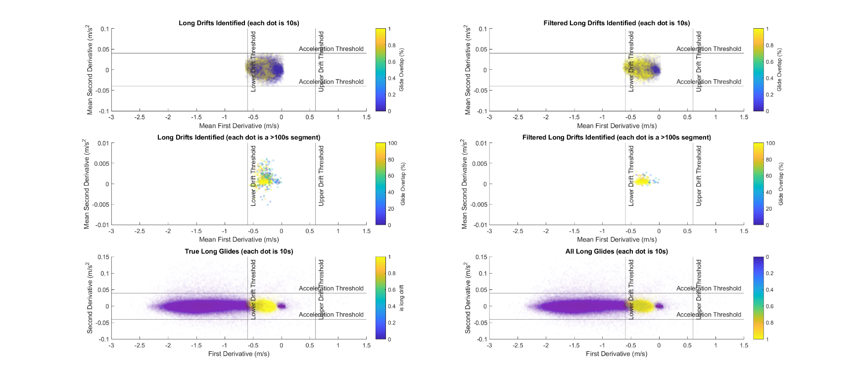

* + - * 1. TOPPID_SEALID_03_**Drift-Rate-Smoothed.png**

### RPA Robotic Process Automation icon PNG and SVG Vector Free DownloadGlasses Icon | Line Iconset | IconsMind Load Data

### Appendix: Additional Sleep Scoring Examples

CALM > SWS1 > SWS2 example

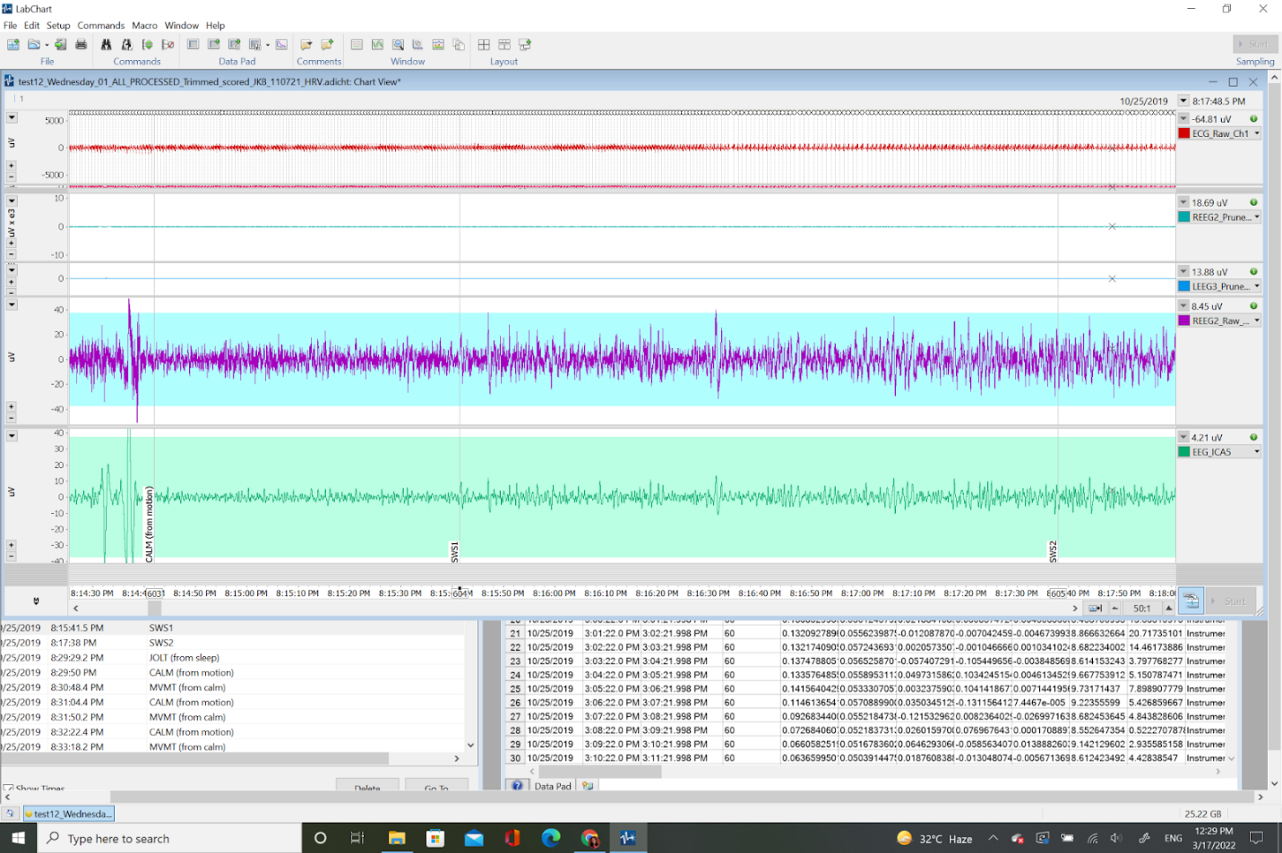

CALM > SWS1 > REM1 example

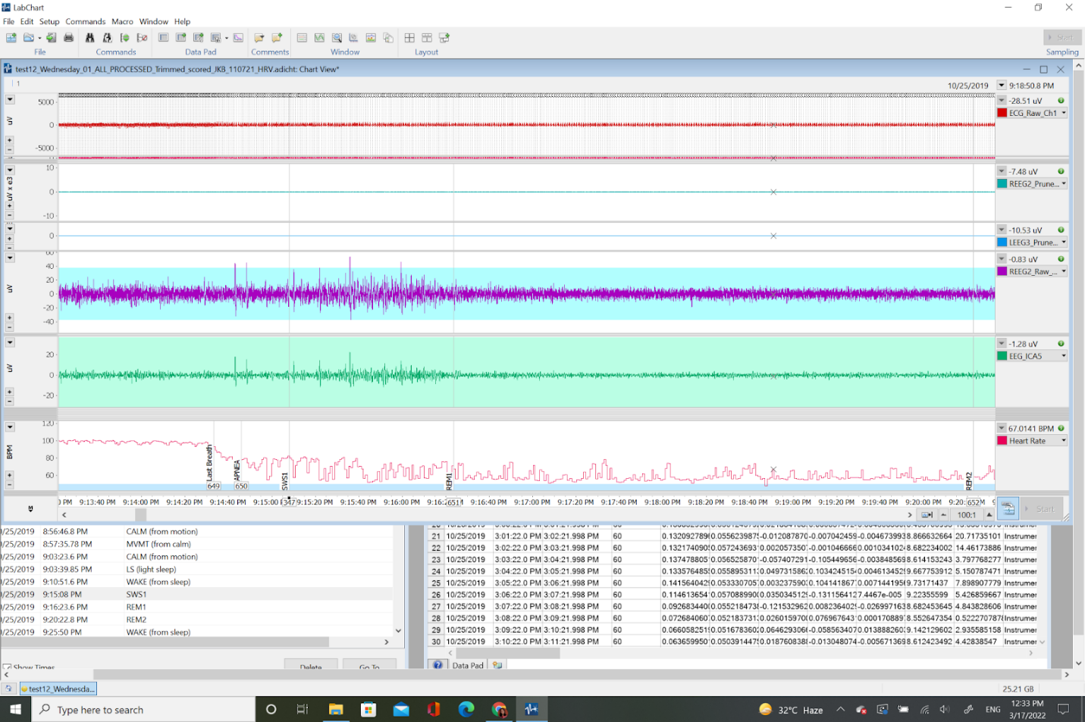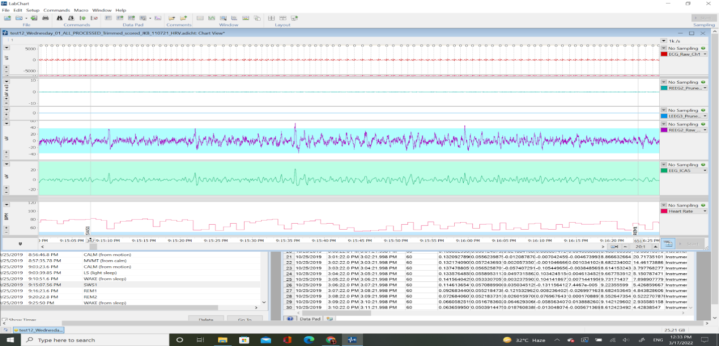

1. (add sleep spindle example)
2. <https://docs.google.com/spreadsheets/d/1ZG0uv0oxD3FXibsADBd3E5qt3RTyfqIA/edit#gid=639986253>

# Part II: Tagging Protocol

Steps for preparing for a procedure including configuring, turning on tags, and attaching tags.

### Procedure Prep Checklist

Logger configuration

“Upside-down configuration”:

RHD2216_Oversampling = [

0x0F00, #was 0x3000 - temperature sensor

0x0E00,

0x0D00,

0x0C00,

0x0F00,

0x0B00,

0x0A00,

0x0900,

0x0F00,

0x0E00,

0x0D00,

0x0800,

0x0F00,

0x0B00,

0x0A00,

0x0700,

0x0F00, #was 0x3000 - temperature sensor

0x0E00,

0x0D00,

0x0C00,

0x0F00,

0x0B00,

0x0A00,

0x0900,

0x0F00,

0x0E00,

0x0D00,

0x0800,

0x0F00,

0x0B00,

0x0A00,

0x0700,

]

Change this in config.py by running: q.LgrScript_setup_Int32ch250Hz_I2C36Hz_IR8K_IPT_eSD()

Setup logger with new configuration using:

Mk10 protocol:

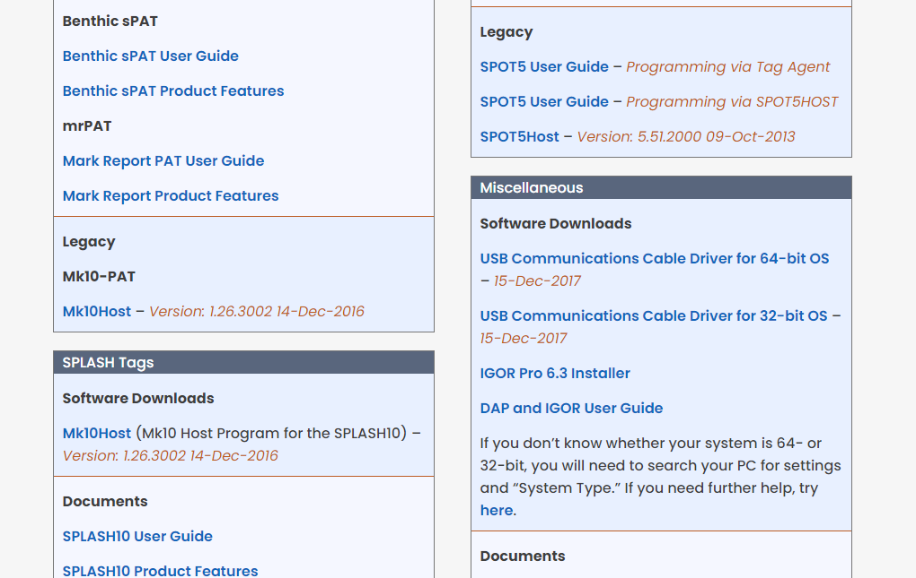

Download Mk10Host and USB Comms driver (if first time using)

Plug in cable

Open mk10 host

Configure

Make sure to NOT transmit for first 5 days of recording with sleep recording device

Pass for mk10 in mk10host is mk10

Check argos: https://argos-system.clsamerica.com/argos-cwi2/login.html

### Procedure Prep Checklist

Make a copy and follow along in the steps outlined in ‘testNN_Nickname_00_Notes.xlsx’. A sample is shown below:

|  |  |  |  |
| --- | --- | --- | --- |
| **Sleep Study Metadata Entry Sheet** | | | *NN* |
| ***Logger Prep Checklist*** | |  | *testNN_Nickname* |
| ***A. SET REAL TIME CLOCK*** | |  |  |
| 1. Connect to battery | | |  | | --- | |  | |  |
| 2. Connect serial comm USB | |  |  |
| 3. Open TimeSync.exe | |  |  |
| 4. Sync comp time with internet | |  |  |
| 5. Open COM for USB | |  |  |
| 6. Set time in logger | |  |  |
| 7. Get logger time & compare | |  |  |
| *Sync time:* | | 3/24/2022 19:56:25.000 | *mm/dd/yyyy HH:MM:SS* |
| *Logger time - Current time (s):* | | -0.010000 | *Ex. 0.513000* |
| 8. Close COM port. | |  |  |
|  | |  |  |
| ***B. CHECK LOGGER MODE*** | |  |  |
| 1. Open RealTerm | |  |  |
| 2. Enter Baud: 2666 COM: # | |  |
| stop + ENTER pauses clock | |  |
| mode + ENTER gives mode | |  |
| set_m = 0 to enter mode 0 | |  |
| **\*start + ENTER to restart clock\*** | |  |
|  | |  |
| ***C. CLEAR MEMORY*** | |  |  |
| 1. Open IDLE Python Shell | |  |  |
| 2. Plug in Bluetooth dongle | |  |
| 3. Turn on logger (SHORT mag) | |  |
| 4. Run python module LGR_GUI | |  |
| 5. Press Script Stop | |  |
| 6. Clear memory, confirm. | |  |
| 7. Close LGR_GUI. | |  |
|  | |  |
| ***D. START RECORDING*** | |  |  |
| 1. Return to RealTerm | | |  | | --- | |  | |  |
| 2. Type: "set_m = 2" to start | | *THIS STARTS LOGGER* |  |
| logger in configuration mode 2. | |  |  |
| ***Start Time:*** | | 3/24/2022 20:53:00.000 | *mm/dd/yyyy HH:MM:SS* |
| 3. Restart LGR_GUI to verify. | | *logger turns on ~1min later.* |  |
| 4. check mode = 2 in RealTerm, then close | | |  | | --- | |  | |  |
| 5. Get logger time in TimeSync | |  |  |
| ***Sync Time:*** | | 3/24/2022 20:54:41.000 | *mm/dd/yyyy HH:MM:SS* |
| ***Logger time - Current time (s):*** | | |  | | --- | | 0.187000 | | *Ex. 0.513000* |
| *6. Snapshot Channel 1.* | |  |  |
| 7. Unplug serial comm USB. | |  |  |
| 8. Unplug Bluetooth dongle. | |  |  |
|  | |  |  |
| ***E. CLOSE & WRAP TAG*** | |  |  |
| 1. Tape memory card. | | |  | | --- | |  | |  |
| 2. Add O-ring grease. | |  |  |
| 3. Insert into capsule. | |  |  |
| 4. Feed in ortman key. | |  |  |
| 5. Wrap with tesa tape. | |  |  |
| 6. Attach to mesh with | |  |  |
| metal zip ties. | |  |  |
|  | |  |  |
| ***F. SYNCHRONIZATION SHAKES*** | |  | *Shake for 10 seconds.* |
| Shake Time Start: | | 3/24/2022 21:02:00.000 | *mm/dd/yyyy HH:MM:SS* |
| Shake Time End: | | 3/24/2022 21:02:10 AM | *mm/dd/yyyy HH:MM:SS* |
|  | |  |  |
| ***G. UPON RECOVERY*** | |  | *Shake for 10 seconds.* |
| Shake Time Start: | | 4/1/2021 15:20:00.000 | *mm/dd/yyyy HH:MM:SS* |
| Shake Time End: | | 4/1/2021 15:20:10.000 | *mm/dd/yyyy HH:MM:SS* |
| 1. Rinse with fresh H2O. | |  |  |
| 2. Remove ortman key. | |  |  |
| 3. Remove logger from capsule. | | |  |
| 4. Inspect for flashing LED: | |  |  |
| Failed? | | *No - not blinking* | *"Yes - blinking" or "No".* |
| 5. If blinking, attempt to switch off with magnet. | | |  |
|  |
| 8. Get logger time in TimeSync. | |  |  |
| **Time:** | | *ENTER LOGGER TIME* | *mm/dd/yyyy HH:MM:SS* |
| **Diff:** | | *ENTER LOGGER OFFSET* | *Ex. 0.513000* |
| 10. See red "Busy"? Y/N | | *Y* |  |
| **TIME OFF WITH MAGNET:** | | *ENTER TIME OFF* | *mm/dd/yyyy HH:MM:SS* |
| 13. Open ReadDisk.exe and read data. | | |  |
| Saved as (filename): | | *Enter Filename* | *test##_Nickname_01.dat* |

### Procedure Checklist

|  |  |  |  |  |  |  |
| --- | --- | --- | --- | --- | --- | --- |
| ***1*** | *Check MK10 light: should be blinking at 1Hz.* | | |  |  | |
| ***2*** | *Remove magnet from VHF tag (keep magnet far from MK10)* | | |  |  | |
| ***3*** | *Check Neurologger status with Bluetooth dongle - should be "Busy"* | |  | | |
| ***4*** | *Sign into Año Nuevo kiosk for all crew members.* | | |  |  | |
| ***5*** | *Fill out Symptom Checker for CBB + Año Nuevo* | | |  |  | |
| ***6*** | *Double check gear list (below)* |  | |  |  | |
| ***7*** | Drive to Año Nuevo |  | |  |  | |
| ***8*** | Grab walkies and find candidate seal | | |  |  | |
|  | (weanling: F, fat, known age, <50 days post wean; juvie: F, known age, good fur [not starting to molt]) | | | | |
| ***9*** | Double check status of MK10 and verify magnet off of VHF | |  | | |
| ***10*** | Get tripod, sling, and rest of gear. | | |  |  | |
| ***11*** | Setup both weighing and camera tripods, attach webcam to tripod, set to record. | | | | |
| ***12*** | Sedate seal |  | |  |  | |
| ***13*** | Weigh seal in sling |  | |  | **PARALLEL TASKS** | |
| ***14*** | Mark outlines on fur (make sure use logger + frontend) | | |  | Get blood | |
| ***15*** | Shave fur |  | |  | Mark tag outlines | |
| ***16*** | Ultrasound spot on head |  | |  | Clean spots | |
| ***17*** | Clean with alcohol |  | |  | Attach with epoxy | |
| ***18*** | Attach headcap and patches with neoprene cement | | |  | Fasten all bridges | |
| ***19*** | Let seal recover |  | |  |  | |
| ***20*** | JKB observe with video for 1.5 hrs post procedure | | |  |  | |

### Gear Checklist

**For Lead Researcher to bring:**

* + - 1. Wrapped Neurologger (logger and front-end)
      2. Wrapped MK10 (no magnets nearby)
      3. Wrapped VHF (no magnets nearby)
      4. Splicing tape, electrical tape, and NexCare tape
      5. Superglue & E6000
      6. Extra clipper blades
      7. Neoprene cement (bottles and tubes)
      8. Silicone templates (headcap & patch)
      9. Camera (charged with blank SD card)
      10. Tripod for camera (with extra tape)
      11. Webcam (with blank SD card), USB, & powerbank
      12. Snips of all shapes and sizes
      13. Datasheets and clipboard
      14. Watch with seconds, attached to clipboard

**Gear Checklist (for animal handler to bring):**

* + - 1. Scale & Come-along
      2. Drugging supplies
      3. Blood collection supplies
      4. Girth rope & measuring tape
      5. Ultrasound: gel, brush, phone
      6. Clippers (2), extra battery
      7. Alcohol and rags
      8. Epoxy (~10X/procedure)
      9. Extra sharpies
      10. Printed procedure datasheets
      11. Printed candidate list

### Detailed Attachment Protocol

***All animal procedures were approved at the federal and institutional levels under National Marine Fisheries Permits #19108, #23188, and #18786 (TMMC), and by the Institutional Animal Care and Use Committee (IACUC) of University of California Santa Cruz (Costd1709 and Costd2009-2) and The Marine Mammal Center (TMMC #2019-2).***

***Instrument Attachment:*** The electrode configuration during free-ranging recordings will match the configuration outlined above for stationary recordings. Surface electrodes (Genuine Grass reusable gold-cup electrodes) will be applied to dry, clean, and shaved skin. During shaving and attachment of electrodes, the supraorbital vibrissae will be secured out of the way. The electrodes are seated in a piece of 3mm thick neoprene, which will be glued to the surface of the skin (with skin-compliant Neoprene Cement) and to the animal’s fur along the periphery of the swim cap. A second layer of neoprene will be glued on top of the first layer to provide waterproofing for the electrodes. The footprint of this swim cap will extend from ~3cm away from the outer canthus of one eye to the opposite side of the head, and from 4cm away from the supraorbital vibrissae back about 10cm, depending on the size of the animal’s head (Figure 4). In addition to the swim cap, small patches measuring about 3-4 cm in diameter will be placed on either side of the neck, above the nuchal muscles, for the electromyography signals as well as just anterior to the right axilla and just posterior to the left axilla to obtain electrocardiogram signals. Cables will connect the electrodes to a datalogger secured to the animal’s back. Small wire conduits will be glued to the fur to allow the cables to slide while preventing snagging (Figure 3). The datalogger itself will be attached using established methods (see standard attachment procedure above) to the animal’s back (Figure 4). The exact configuration of datalogger and cables may vary slightly depending on the size of the animal. The attachment procedure duration is constrained by the time required for the neoprene cement adhesive to cure (~20-30 minutes from first application). The rigidity of faster adhesives, such as epoxy, are ill-suited to this particular application, where the adhesive is used along the footprint of flexible neoprene patches. The attachment procedure for the EEG logger typically takes ~90 minutes and may be paired with an additional stationary recording such that the total procedure duration is less than two hours.

***Instrument Removal***: We will sedate the animal to remove the logger (according to the standard removal protocol outlined above) and the electrodes. When removing the electrodes, we will cut through the neoprene along the electrode cables with rounded sewing shears until all electrodes are removed from the animal. We will remove as much neoprene residue as possible without injuring the skin of the animal and leave a thin footprint of neoprene on the animal, which the animal will molt off in the coming season.

### Data Entry

### Enter sleep datasheet information into individual datasheets “testNN_Nickname_00_Notes.xlsx”

* + 1. Enter important timestamps and metadata.
    2. Sample datasheet: 🗀 Data > testNN_Nickname_00_Notes-TEMPLATE.xlsx 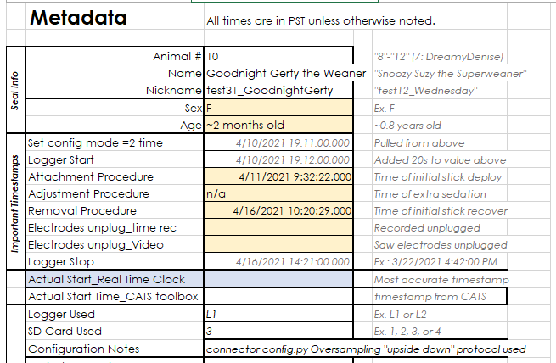

This information can be entered directly (as a linked value) in “00_Sleep_Study_Metadata.xlsx”.

Other metadata entry required (as part of the Costa Lab):

* + 1. **Enter Procedure** info into [Procedure Data Checklist google spreadsheet](https://docs.google.com/spreadsheets/d/1JDiyOYE63IqDgs77ScaxwWnz0gYPMJggAZVtmyK5iwA/edit#gid=0).
    2. **Upload Procedure sheets** here%09https:\drive.google.com\drive\u\1\folders\1GJuCwx8oqhPB0pwymBE6ThFzc_QGq3LB).
    3. **Enter Resight data** with Deployment info (for deployment and recovery), example:   
       Jessie Kendall-Bar Sleep tag deployment on April 25 2020 juvenile pre-molt. TOPPID 2020046.
    4. Enter into [**Bird & Mammal Database**](http://lml-research-app-1.ucsc.edu/web/entryform/) with correct TOPPID.

Update “00_Sleep_Study_Metadata.xlsx” & individual animal notes “testNN_Nickname_00_Notes.xlsx” in Dissertation Sleep> Data with all ID’s.

